**Plutonium-0.3 SNL**

ChopStick (Hand Game)



[GENRE: Combinatorial Games]

**Project Report**

Developed By Sahill N Lalani

**Void Matrix[:] Studio**



**NOTE: I’ve made this all by myself nobody has helped or guided.**

**(Degree)**

**Bachelor Of Computer Applications (BCA)**

**Supervised By Vilas Vadher**

**Principal: dr. Jigar Raval**

**Submitted To-**

**Shree k.m. savjani & smt. k.k. savjani college Veraval**



**Affiliated With**



**October 2022(BCA Sem 5)**

Certificate Of Originality

This is to certify that the project report entitled **ChopStick(Hand Game)** submitted to **km & kk savjani college affiliated with BKNMU** in partial fulfilment of the requirement for the award of the degree of **Bachelor Of Computer Application(BCA)** , is an authentic and original work carried out by **Sahil N Lalani** ,SPU ID-**2020001747**.

This project is a genuine work done by the student and has not been submitted to any other university/institute for the fulfilment of the requirement of any course of study.



**Statement Of Originality**

**I, the undersigned**

**Name: Sahil Naushadali Lalani**

**SPU ID: 2020001747**

**Certify that this project was made all by myself and isn’t copied or plagiarized from any people if it would be proven that this project was plagiarized or copied from other’s then I will be ready to accept a sanction**



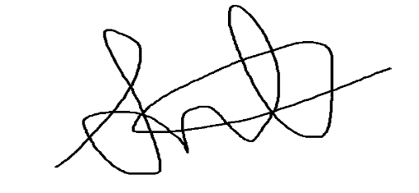

**Acknowledgments**

**First of all, I would like to thank my parents who always support me and then I would like to thank my friends Ghanshyam and Hardik and one of my college professors Bhavik sir for providing me valuable feedback during my game development, and thanks to this college so that I got a chance to create the game like this.**

**Preface**

**The aim of this project is to improve the reasoning power of people it is a game that is played in physically but by the implementation of my logic now it can be played on computer** **as well**. **I am inspired by Mojang studio’s “MINECARFT” game.**

**Chopsticks is a hand game for two or more players, in which players extend a number of fingers from each hand and transfer those scores by taking turns to tap one hand against another. Chopsticks is an example of a combinatorial game, and is solved in the sense that with perfect play, an optimal strategy from any point is known.**

**Purely java programming is used to make this game, for the front-end AWT, swing and window-builder, for back-end mysql, JAVA mail service - apache common mails and to create an exe file I have used Launch4j, eclipse IDE for development and db4free.net website for remote MySQL server.**

**Abstract**

**I am fond of playing games I never had a console game like xbox or play station or Nintendo but I definitely have been playing android games although I have played on console at my friend’s, this chopstick game I started playing in my 11 the grade, this is a game played physically through our hands.**

**This my very first game that I have made and this will be very helpful for my future steps into game development.**

**I am so glad to introduce a physical game that now can be played on computer which I have implemented by myself.**

**I have used java programming language for making this game, the swing utility and window builder is used for designing and for game logic core java and some advanced java concepts like java mail API and jdbc. For sprites and some images I have used flaticon website and bing browser respectively and for editing them MS picture manager.**

**Contents**

Section 1: Introduction 9

1.1 Gaming in the Field of Software Engineering 9

1.2 Background of this Project 9

1.3 Game overview 10

1.4 About the Game Project 11

Section 2: Technical Overview 12

2.1 Introduction to JAVA 12

2.2 Introduction to AWT 14

2.3 Introduction to swing 16

2.4 introduction to MySQL 17

2.5 introduction JDBC 19

2.6 introduction to JAVA Mail API 20

Section 3: Software Requirement Specification (SRC) 21

2.1 Introduction 21

**2.1.1 Purpose of this Chapter** 21

**2.1.2 Intended Audience and Reading Suggestions** 21

2.2 General Description 22

**2.2.1 Hardware requirements** 22

**2.2.2 Software requirements** 22

2.3 System Environment 22

**2.3.1. Software Interface** 23

**2.3.2 User Characteristics for the System** 24

2.4 Analysis Model of Our Game Project 24

**2.4.1 Scenario Based Model** 24

2.5 Requirement Change Management of my System 24

**2.5.1 Bugs and Glitches** 25

Section 3: Game Development Life Cycle (GDLC) 26

3.1 Initiation phase 26

3.2 Pre-Production 26

3.3 Production phase 27

3.4 Testing phase 27

3.5 Beta Phase 28

3.6 Release Phase 28

Section 4: Graphics, Sound and Implementation of “ChopStick” game 29

4.1 Implementation Tools Required 29

4.2 Graphics for my game(sprites and images) 30

Section 5: Data dictionary & Diagrams 34

5.1 Data Dictionary 35

5.2 diagrams 35

**5.2.1 Entity Relationship Diagram (ERD)** 35

**5.2.2 Data Flow Diagram (DFD)** 36

**5.2.3 Flowchart** 38

**5.2.5 class diagram** 38

Section 6: Code of ChopStick game 40

Launch.java 40

Void_matrix_account.java 43

ChopStick.java 62

PWC.java 75

PVP.java 123

How_To_Play.java 167

Settings.java 181

About_Game.java 198

Mails.java 200

202

Section 7: Testing of “ChopStick” game 203

Section 8: User manual of “ChopStick” game with Snapshots 204

207

Section 9: Conclusion 213

Limitations 213

Future enhancements 213

Section Appendix 214

Appendix A: Abbreviation & Acronyms 214

# **Section 1: Introduction**

**This chapter covers the project proposal and feasibility of the proposal along with background study, product and business perspective, the scopes and some preliminary idea of our game.**

## **1.1 Gaming in the Field of Software Engineering**

**In the fast growing field of software engineering and development and even more rapidly growing sector of game development the future is hard to predict. I am working with this game as my software project is a 3 credit course and as part of our degree we choose this type of work for doing better with development cycle, development period, graphics, scripting, adopting new technology, animation.**

**In general software project is a project focusing on the creation of software. Consequently,**

**Success can be measured by taking a look at the resulting software.**

**In a game project, the product is a game. But and here comes the point: A game is much more than just its software. It has to provide content to become enjoyable. Just like a web server. Without content the server is useless, and the quality cannot be measured. This has an important effect on the game project as a whole. The software part of the project is not the only one, and it must be considered in connection to all other parts: The environment of the game, the story, characters, game plays, the artwork, and so on.**

## **1.2 Background of this Project**

**Background is a set of events invented for a plot, presented as preceding and leading up to that plot. It is a literary device of a narrative history all chronologically earlier than the narrative of primary interest. In our project it’s a single and dual player strategy game emphasizing logical thinking and planning. They often stress resource and time management, Tactical organization and execution are necessary, and the game creators usually place the decision-making skills and delivery of commands in the player’s hands.**

## **1.3 Game overview**

**Chopsticks is a game of strategy as well as basic math. It has roots in Japan and can also called Finger Chess, Swords, Split, Magic Fingers, Chinese Fingers, Cherries, Sticks, and Twiddly Dinks. Though there are many variations of rules and different names, the overall theory and spirit of the game remains the same. This game is not the widely known beginner's piano song though it shares the same name.**

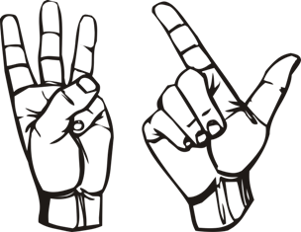

**Rules**

**This official set of rules is called rollover where five fingers are subtracted should a hand's sum exceeds 5 as described below.**

1. **A hand is live if it has at least one finger, and this is indicated by raising at least one finger. If a hand has zero fingers, the hand is dead, and this is indicated by raising zero fingers (i.e. a closed fist).**
2. **If any hand of any player reaches exactly five fingers, then the hand is dead.**
3. **Each player begins with one finger raised on each hand. After the first player turns proceed clockwise.**
4. **On a player's turn, they must either attack or split. There are two types of splits, transfers and divisions.**
5. **To attack, a player uses one of their live hands to strike an opponent's live hand. The number of fingers on the opponent's struck hand will increase by the number of fingers on the hand used to strike.**
6. **To transfer, a player strikes their own two hands together, and transfers raised fingers from one hand to the other as desired. However, a player cannot transfer fingers to make a hand have more than 4 fingers.**
7. **If a player has a dead hand, the player can divide the fingers between the other hand and the dead hand by transferring fingers from the other hand to the dead hand. However, players are required to attack at least once during the game.**
8. **A player with two dead hands is eliminated from the game.**
9. **A player wins once all opponents are eliminated.**
10. **If you go over 5 you subtract the sum of all of the numbers by 5**

## **1.4 About the Game Project**

**In this the players will get two buttons for controlling their hands’ fingers according to various contexts, players can also create account for saving status of work and delete it whenever they want. Players can also play without creating account as a guest user player will receive an email after creating the Void Matrix[:] account.**

**After they will get to the main frame where they will be seeing several options which are “play against computer”, ”player vs player”, “settings”, “how to play”, “profile”, “about game”, “feedback” and “sign out”.**

# **Section 2: Technical Overview**

## **2.1 Introduction to JAVA**

**The language used for developing this project is JAVA**

**What is JAVA?**

**It is an object-oriented language similar to C++, but with advanced and simplified features. Java is free to access and can run on all platforms.**

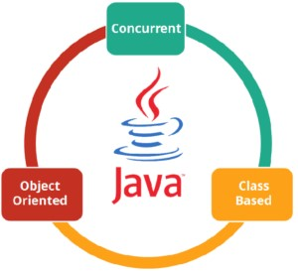

**In simple words, it is a computing platform where you can develop applications.**

**What Can JAVA Do?**

**Development Tools: The development tools provide everything you'll need for compiling, running, monitoring, debugging, and documenting your applications. As a new developer, the main tools you'll be using are the javac compiler, the java launcher, and the javadoc documentation tool.**

**Application Programming Interface (API): The API provides the core functionality of the Java programming language. It offers a wide array of useful classes ready for use in your own applications**

**Deployment Technologies: The JDK software provides standard mechanisms such as the Java Web Start software and Java Plug-In software for deploying your applications to end users.**

**User Interface Toolkits: The JavaFX, Swing, and Java 2D toolkits make it possible to create sophisticated Graphical User Interfaces (GUIs).**

**Integration Libraries: Integration libraries such as the Java IDL API, JDBC**

**API, Java Naming and Directory Interface (JNDI) API, Java RMI, and Java Remote Method Invocation over Internet Inter-ORB Protocol Technology (Java RMI-IIOP Technology) enable database access and manipulation of remote objects.**

**• Why JAVA?**

* **Object Oriented**

**In Java, everything is an Object. Java can be easily extended since it is based on the Object model.**

* **Platform Independent**

**Unlike many other programming languages including C and C++, when Java is compiled, it is not compiled into platform specific machine, rather into platformindependent byte code. This byte code is distributed over the web and interpreted by the Virtual Machine (JVM) on whichever platform it is being run on.**

* **Simple**

**Java is designed to be easy to learn. If you understand the basic concept of OOP Java, it would be easy to master.**

* **Secure**

**With Java's secure feature it enables to develop virus-free, tamper-free systems. Authentication techniques are based on public-key encryption.**

* **Architecture-neutral**

**Java compiler generates an architecture-neutral object file format, which makes the compiled code executable on many processors, with the presence of Java runtime system.**

* **Portable**

**Being architecture-neutral and having no implementation dependent aspects of the specification makes Java portable. The compiler in Java is written in ANSI C with a clean portability boundary, which is a POSIX subset.**

* **Robust**

**Java makes an effort to eliminate error-prone situations by emphasizing mainly on compile time error checking and runtime checking.**

* **Multithreaded**

**With Java's multithreaded feature it is possible to write programs that can perform many tasks simultaneously. This design feature allows the developers to construct interactive applications that can run smoothly.**

* **Interpreted**

**Java byte code is translated on the fly to native machine instructions and is not stored anywhere. The development process is more rapid and analytical since the linking is an incremental and light-weight process.**

* **High Performance**

**With the use of Just-In-Time compilers, Java enables high performance.**

* **Distributed**

**Java is designed for the distributed environment of the internet.**

* **Dynamic**

**Java is considered to be more dynamic than C or C++ since it is designed to adapt to an evolving environment. Java programs can carry an extensive amount of run-time information that can be used to verify and resolve accesses to objects at run-time.**

## **2.2 Introduction to AWT**

**AWT stands for Abstract Window Toolkit. It is a toolkit of classes with which a programmer can develop** [**Graphics**](http://way2java.com/awt-graphics/graphics-introduction/) **and Graphical User Interface components. AWT gives a front-end technology to Java using which a user can interact with a running process; the old style is scanf. Usage of GUI environment is easier even for a non-computer background person. A business man or an elementary school student is able to use email system and all the credit goes to GUI, which Java supports very extensively.**

**All the classes required for developing graphics and GUI are placed in the package java.awt and the classes required for event handling are placed separately in the sub package java.awt.event. These two are very big packages and contains lot of classes doing different functionalities. To study these classes, the whole tutorial can be divided into the following topics.**

* **Drawing** [**graphics**](http://way2java.com/awt-graphics/all-geometrical-figures/)
* **Studying** [**layout managers**](http://way2java.com/awt-components/java-layout-managers/)
* **Developing** [**GUI components**](http://way2java.com/awt-components/all-awt-components-%E2%80%93-at-a-glance/)
* **Handling events –** [**Event handling**](http://way2java.com/awt-events/java-event-handling/)
* **The java.awt package contains the core AWT graphics classes: GUI Component classes, such as Button, TextField, and Label. GUI Container classes, such as Frame and Panel. Layout managers, such as FlowLayout, BorderLayout and GridLayout.**
* **Custom graphics classes, such as Graphics, Color and Font.**

**The java.awt.event package supports event handling:**

**Event classes, such as ActionEvent, MouseEvent, KeyEvent and WindowEvent,**

**Event Listener Adapter classes, such as MouseAdapter,KeyAdapter and Window Adapter.**

**AWT provides a platform-independent and device-independent interface to develop graphic programs that runs on all platforms, including Windows, Mac OS X, and Unixes.**

**Swing in java is part of Java foundation class which is lightweight and platform independent. It is used for creating window based applications. It includes components like button, scroll bar, text field etc. Putting together all these components makes a graphical user interface. In this article, we will go through the concepts involved in the process of building applications using swing in**[**Java**](https://www.edureka.co/java-j2ee-training-course)**. Following are the concepts discussed in this article:**

## **2.3 Introduction to swing**

**Swing in Java is a lightweight GUI toolkit which has a wide variety of widgets for building optimized window based applications. It is a part of the JFC( Java Foundation Classes). It is build on top of the AWT API and entirely written in**[**java**](https://www.edureka.co/blog/java-tutorial/)**. It is platform independent unlike AWT and has lightweight components.**

**It becomes easier to build applications since we already have GUI components like button, checkbox etc. This is helpful because we do not have to start from the scratch.**

**Container Class:**

**Any**[**class**](https://www.edureka.co/blog/java-tutorial/#obj) **which has other components in it is called as a container class. For building GUI applications at least one container class is necessary.**

**Following are the three types of container classes:**

* **Panel – It is used to organize components on to a window**
* **Frame – A fully functioning window with icons and titles**
* **Dialog – It is like a pop up window but not fully functional like the frame**

**Difference Between AWT and Swing**

|  |  |
| --- | --- |
| **AWT** | **SWING** |
| **Platform Dependent** | **Platform Independent** |
| **Does not follow MVC** | **Follows MVC** |
| **Lesser Components** | **More powerful components** |
| **Does not support pluggable look and feel** | **Supports pluggable look and feel** |
| **Heavyweight** | **Lightweight** |

**Java Swing Class Hierarchy**

## hierarchy-swing in java-edureka

**Explanation: All the components in swing like JButton, JComboBox, JList, JLabel are inherited from the JComponent class which can be added to the container classes. Containers are the windows like frame and dialog boxes. Basic swing components are the building blocks of any gui application. Methods like setLayout override the default layout in each container. Containers like JFrame and JDialog can only add a component to itself, swing provides Layout manager.**

## **2.4 introduction to MySQL**

**MySQL is an open-source, fast reliable, and flexible relational database management system, typically used with PHP. This chapter is an introductory chapter about MySQL, what is MySQL, and the main features of MySQL are described here.**

**What is MySQL?**

**MySQL is a database system used for developing web-based software applications.**

**MySQL used for both small and large applications.**

**MySQL is a relational database management system (RDBMS).**

**MySQL is fast, reliable, and flexible and easy to use.**

**MySQL supports standard SQL (Structured Query Language).**

**MySQL is free to download and use.**

**MySQL was developed by Michael Widenius and David Axmark in 1994.**

**MySQL is presently developed, distributed, and supported by Oracle Corporation.**

**MySQL Written in C, C++.**

**Main Features of MySQL:**

**MySQL server design is multi-layered with independent modules.**

**MySQL is fully multithreaded by using kernel threads. It can handle multiple CPUs if they are available.**

**MySQL provides transactional and non-transactional storage engines.**

**MySQL has a high-speed thread-based memory allocation system.**

**MySQL supports in-memory heap table.**

**MySQL Handles large databases.**

**MySQL Server works in client/server or embedded systems.**

**MySQL Works on many different platforms.**

**Who Uses MySQL**

**Some of the most famous websites like Facebook, Wikipedia, Google (not for search), YouTube, Flickr.**

**Content Management Systems (CMS) like WordPress, Drupal, Joomla, phpBB etc.**

**A large number of web developers worldwide are using MySQL to develop web applications.**

## **2.5 introduction JDBC**

**JDBC stands for Java Database Connectivity. JDBC is a Java API to connect and execute the query with the database. It is a part of JavaSE (Java Standard Edition). JDBC API uses JDBC drivers to connect with the database. There are four types of JDBC drivers:**

* **JDBC-ODBC Bridge Driver,**
* **Native Driver,**
* **Network Protocol Driver, and**
* **Thin Driver**

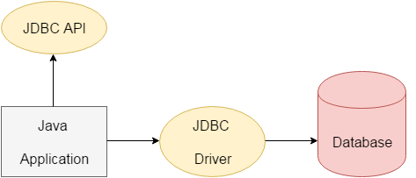**We can use JDBC API to access tabular data stored in any relational database. By the help of JDBC API, we can save, update, delete and fetch data from the database. It is like Open Database Connectivity (ODBC) provided by Microsoft.**

**Why Should We Use JDBC**

**Before JDBC, ODBC API was the database API to connect and execute the query with the database. But, ODBC API uses ODBC driver which is written in C language (i.e. platform dependent and unsecured). That is why Java has defined its own API (JDBC API) that uses JDBC drivers (written in Java language).**

**We can use JDBC API to handle database using Java program and can perform the following activities:**

* **Connect to the database**
* **Execute queries and update statements to the database**
* **Retrieve the result received from the database.**

**What is API**

**API (Application programming interface) is a document that contains a description of all the features of a product or software. It represents classes and interfaces that software programs can follow to communicate with each other. An API can be created for applications, libraries, operating systems, etc.**

## **2.6 introduction to JAVA Mail API**

**The JavaMail is an API that is used to compose, write and read electronic messages (emails).**

**The JavaMail API provides protocol-independent and plateform-independent framework for sending and receiving mails.**

**The javax.mail and javax.mail.activation packages contains the core classes of JavaMail API.**

**The JavaMail facility can be applied to many events. It can be used at the time of registering the user (sending notification such as thanks for your interest to my site), forgot password (sending password to the users email id), sending notifications for important updates etc. So there can be various usage of java mail api.**

**SMTP**

**SMTP is an acronym for Simple Mail Transfer Protocol. It provides a mechanism to deliver the email. I have used Apache common mails as an SMTP server. If we use the SMTP server provided by the host provider, authentication is required for sending and receiving emails.**

# **Section 3: Software Requirement Specification (SRC)**

**This chapter covers the requirements specification of my game “ChopStick”. It includes the specification of this documentation with general description, specific requirements, and analysis of models. It also includes changes management of this requirement specification in case of any change.**

## **2.1 Introduction**

**In this section the documentation of this report is specified. It specifies the document convention, document scope and also provides a suggestion for the readers of the document.**

### **2.1.1 Purpose of this Chapter**

**This Software Requirements Specification (SRS) part is intended to give a complete overview of my Project the game “ChopStick” including the action flow, initial user interface and story therein. The SRS document details all features upon which we have currently decided with reference to the manner and importance of their implementation.**

### **2.1.2 Intended Audience and Reading Suggestions**

**The SRS document also gives project managers a way to ensure the game’s adherence to our original vision. Although the document may be read from front to back for a complete understanding of the project, it was written in sections and hence can be read as such. For an overview of the document and the project itself, see Overall Description. For a detailed description of the game-play elements and their interaction with the player, read System Features. Readers interested in the game-play interface and navigation between different front-end menus should go through External Interface Requirements. Technical standards to which I will hold the project, it is laid out in Other Nonfunctional Requirements. The development schedule, meanwhile, will be maintained in the Key Milestones.**

## **2.2 General Description**

**This section includes the perspective of my game, requirements and the system environment.**

### **2.2.1 Hardware requirements**

* **INTEL I3 Processor or higher.**
* **4 GB RAM &above**
* **Hard disk 6 GB &above**

### **2.2.2 Software requirements**

* **Operating system: windows/mac/ubuntu**
* **Language: JAVA SE 1.7, J2EE**
* **Front-end: AWT, Swing, Window-builder**
* **Back-end: MySQL DB, File DB**
* **IDE: Eclipse**
* **for creating .exe file: Launch4j**

## **2.3 System Environment**

**Gamer can interact with system by giving input (click to start game) to the system. System gives those inputs to script, if any change occurs (if the value is changed) this object is sent to render to display the things.**

**Below is the diagram to represent how the game works:**

**Input manager**

**(mouse click)**

**script**

**(compile)**

**renders**

**(display)**

**Gamer**

### **2.3.1. Software Interface**

**"ChopStick" has been developed using some pretty good development stuff.**

**Working tools and platform**

* **Eclipse IDE (J2EE Developers) for whole game development**
* **Window builder plugin of eclipse for designing**
* **JDBC Driver for database connection**
* **Apache common mails API for email**
* **Flaticon.com for creating sprites**
* **Images from Bing.com**
* **MS picture manager for sprites and background-images**
* **Launch4j for creating exe file**

### **2.3.2 User Characteristics for the System**

**There could be one user or two at a time in this software and the user interacts with the game (system) in different manner.**

**So, Gamer is the only one who communicates with the system through playing the game. And this gamer can be any person. The primary requirement is that, the gamer must read the playing procedure provided by me (developers).**

## **2.4 Analysis Model of Our Game Project**

**This section describes the Software Requirements Specification of my project by analyzing the proper models of requirement engineering.**

### **2.4.1 Scenario Based Model**

**This Model depicts how the user interacts with the system and the specific sequence of activities that occur as the software is used.**

## **2.5 Requirement Change Management of my System**

**I as a developer intend to release a complete and fully functional game that follows the guidelines mentioned in the SRS document. updates will likely be required. These updates would consist of any bug fixes that are necessary, compatibility patches for all of the current PCs that support windows/mac/ubuntu and expansions of the content. If the players find any issues or have any comments then they would be able to contact the developers through the official support by providing the review from the “feedback” option of game’s main menu.**

**The current version of my game is “Plutonium-0.3SNL”.**

### **2.5.1 Bugs and Glitches**

**The players would be able to contact the developers through “feedback” option in game. This is where they would present any bugs or glitches they have detected and if they have any beliefs that the game is not functioning properly. General concerns or comments would also need to be submitted here.**

# **Section 3: Game Development Life Cycle (GDLC)**

**The Phases**

**The GDLC typically consists of six phases shown below:**

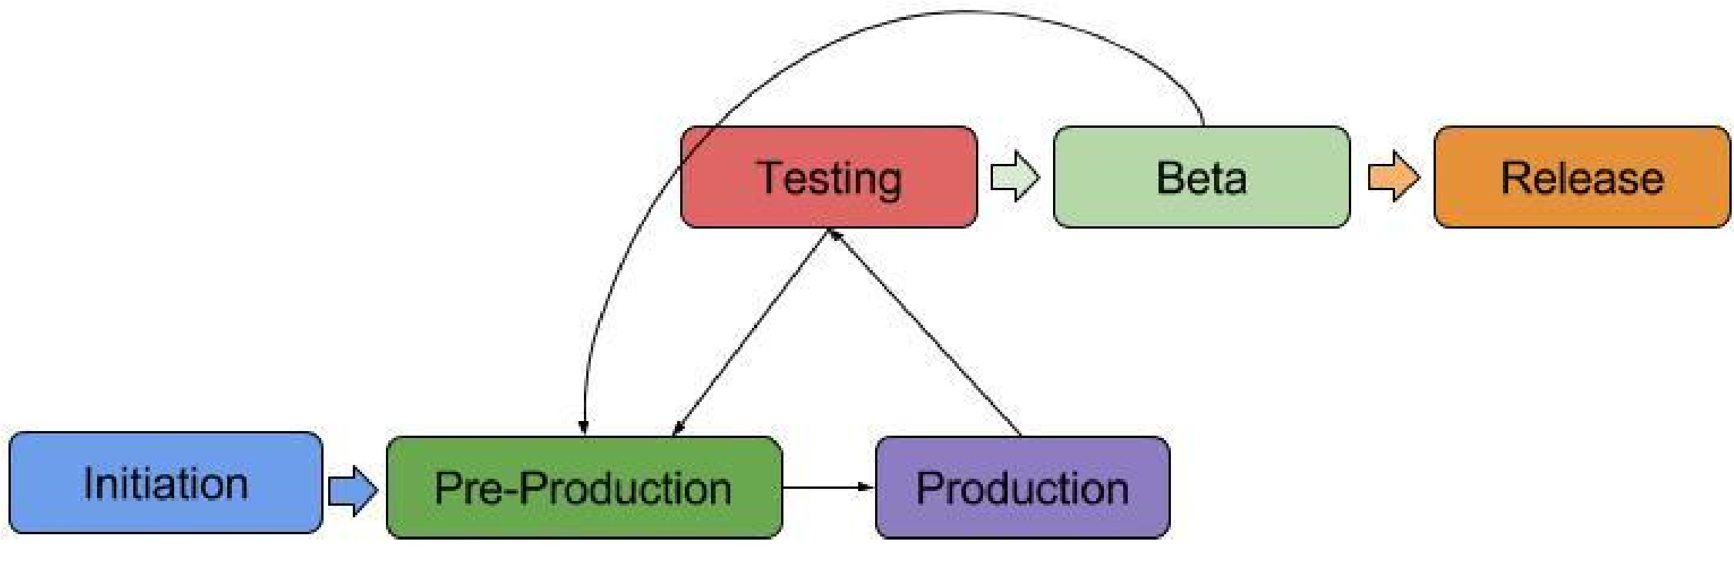

## **3.1 Initiation phase**

**The developer decides what kind of game they will make.**

## **3.2 Pre-Production**

**Before the real production begins.**

**First pre-production:**

**● Game Design Document**

**● First prototype - shows gameplay (has to be fun)**

**Next cycles -> bug fixing and balancing**

## **3.3 Production phase**

**The game assets and source code are made.**

**The result of production is the playable game in form of:**

**● Formal Details prototype - a playable game, has win-lose rules, co-relations between features, runs well.**

**● Refinement prototype - most mature prototype which only needs more polishing. Should be feature complete and almost ready to ship.**

## **3.4 Testing phase**

**Evaluation of game features, value, concept and design.**

**Task: which questions should the testing answer?**

**Evaluation of game features, value, concept and design.**

**Test report -> all the bugs, thing that should be omitted, included or changed.**

**The test result should decide whether to reiterate or advance to beta testing.**

**Task: which questions should the testing answer?**

**Evaluation of game features, value, concept and design.**

**Some questions the testing should be answer:**

**1. Is the game still buggy?**

**2. Is it possible to get stuck in the game?**

**3. Is there any sign of exploits/glitch?**

**4. Is the game too easy/hard to beat?**

**5. Is there any feature missing?**

**6. Does the game run well on every platform?**

## **3.5 Beta Phase**

**The beta test is testing cycle conducted by third party:**

**● publisher,**

**● potential buyer,**

**● game reviewer**

**Result should be a test report.**

**Decide whether the game is ready for shipping.**

## **3.6 Release Phase**

**Work may seem to be done but it is not!**

**● Bugfixing, patching**

**● Aditions, special events**

**● Marketing**

**● Community management**

**Sub-phases**

**There are multiple sub-phases that help the game development in the long run.**

# **Section 4: Graphics, Sound and Implementation of “ChopStick” game**

**This chapter covers the project design phases, the system features and also the implementation of the features.**

## **4.1 Implementation Tools Required**

|  |  |  |  |  |
| --- | --- | --- | --- | --- |
| ~~~~ | Product of | Tool | Platform type | usage |
|  | **Eclipse foundation** | **Eclipse** | **IDE** | **To develop** |
| **Window builder** | **Plug in** | **For front-end designing** |
|  | **Flaticon** | **Flaticon vector icons and stickers** | **website** | **For creating sprites** |
|  | **Microsoft** | **Picture manager** | **image editor** | **For editing images** |
|  | **bing** | **Web browser** | **For getting background images** |
|  | **apache** | **Common mails** | **API** | **For working with emails** |

## **4.2 Graphics for my game(sprites and images)**





**Logo of my “Void Matrix[:]” Logo of my “ChopStick”**

**Studio game**



**Default and unchangeable picture of player/user**

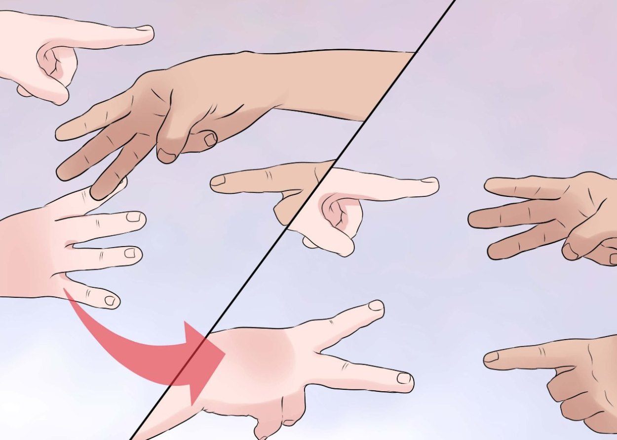

**Background image of my loading screen**

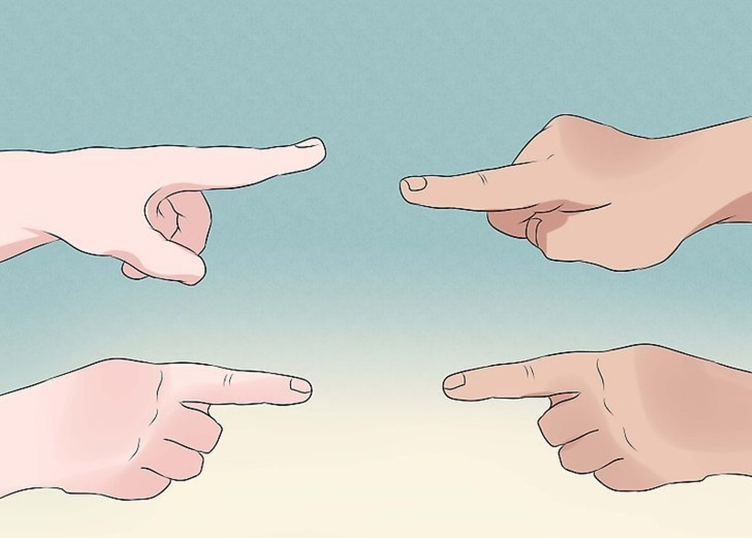

**Background image of my main menu/frame**

**Player & player 1’s left hand**

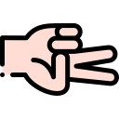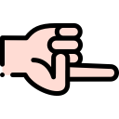

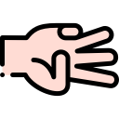

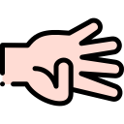

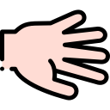

**Player & player 1’s right hand**

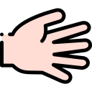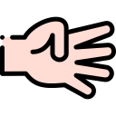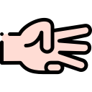

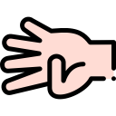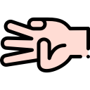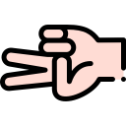**computer & player 2’s right hand** 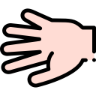



# **Section 5: Data dictionary & Diagrams**

**Music: We Got What You Want by Nine one nine**

**Computer and player 2’s left hands**

## **5.1 Data Dictionary**

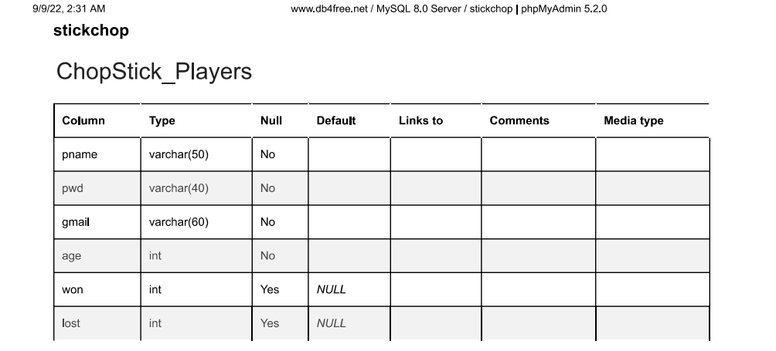

## 5.2 diagrams

### **5.2.1 Entity Relationship Diagram (ERD)**

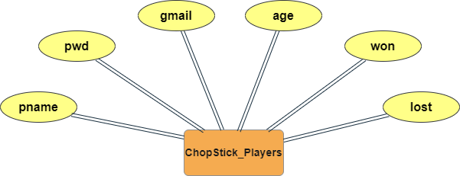

### **5.2.2 Data Flow Diagram (DFD)**

**Level 0**

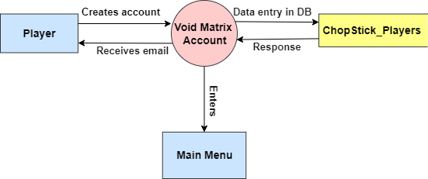

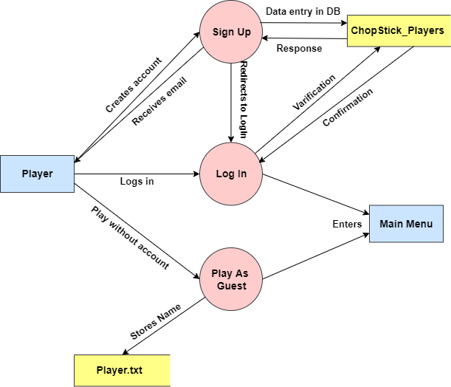**Level 1**

**Level 2**

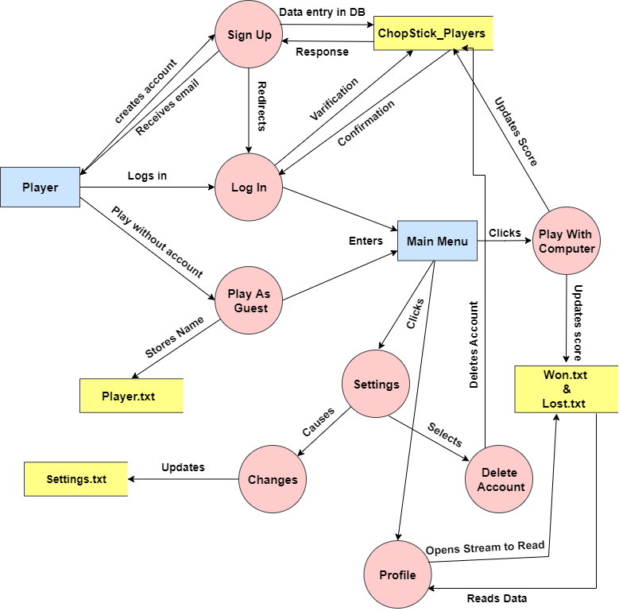

### **5.2.3 Flowchart**

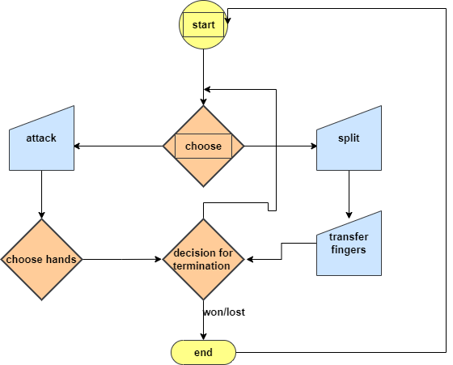

### **5.2.5 class diagram**

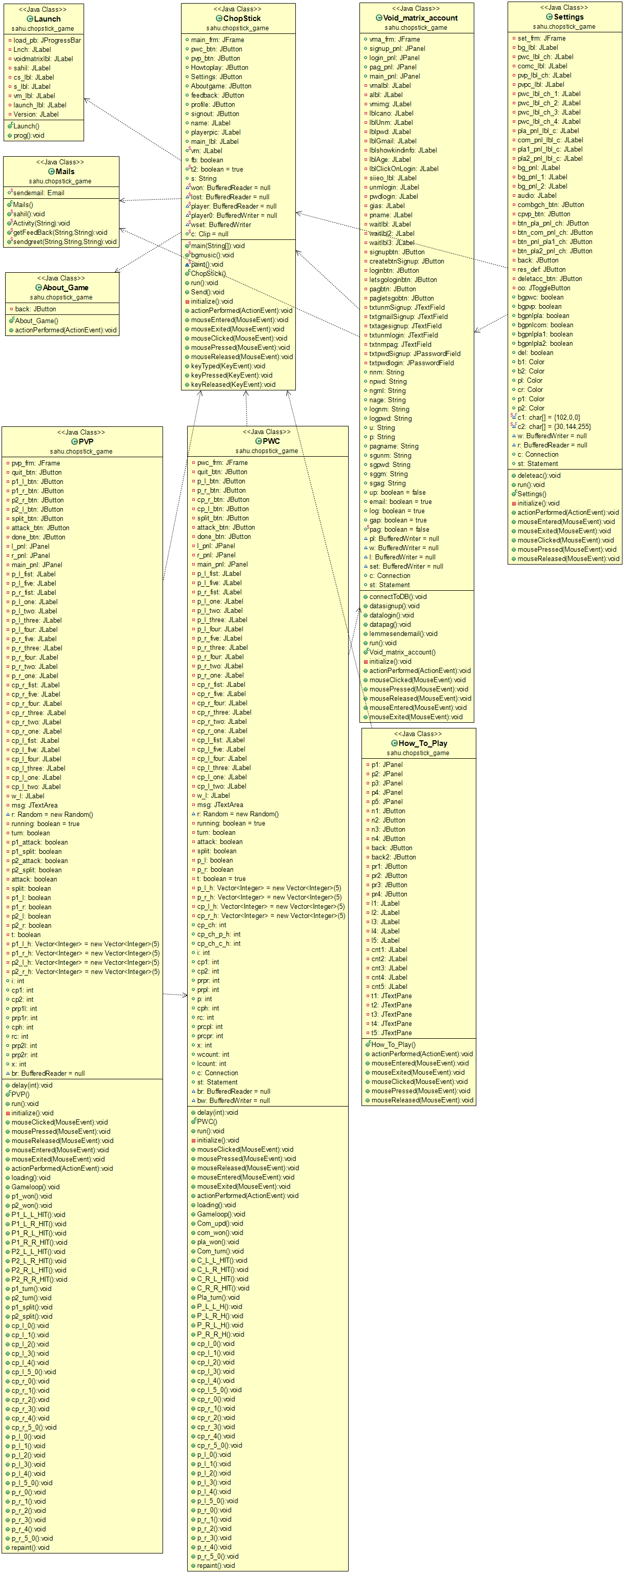

# **Section 6: Code of ChopStick game**

## **Launch.java**

**package** sahu.chopstick_game;

**import** javax.swing.JFrame;

**import** javax.swing.JLabel;

**import** java.awt.Font;

**import** javax.swing.JProgressBar;

**import** java.awt.Color;

**import** javax.swing.ImageIcon;

**import** javax.swing.SwingConstants;

**import** java.awt.Toolkit;

**import** java.io.BufferedReader;

**import** java.io.FileReader;

**import** java.io.InputStream;

**import** java.io.InputStreamReader;

**import** javax.swing.border.BevelBorder;

**import** javax.swing.border.SoftBevelBorder;

**import** javax.swing.border.EtchedBorder;

**import** javax.swing.border.LineBorder;

**import** javax.swing.border.MatteBorder;

@SuppressWarnings({ "serial", "unused" })

**public** **class** Launch **extends** JFrame {

**private** JProgressBar load_pb;

**private** JLabel Lnch,

voidmatrixlbl,

sahil,

cs_lbl,

s_lbl,

vm_lbl,

launch_lbl;

**private** JLabel Version;

**public** Launch() {

setIconImage(Toolkit.*getDefaultToolkit*().getImage(getClass().getResource("logo_F.png")));

setTitle("ChopStick");

getContentPane().setBackground(**new** Color(204, 204, 255));

getContentPane().setLayout(**null**);

setDefaultCloseOperation(JFrame.***EXIT_ON_CLOSE***);

setBounds(150, 20, 1250, 785);

voidmatrixlbl = **new** JLabel();

voidmatrixlbl.setBorder(**new** BevelBorder(BevelBorder.***RAISED***, **null**, **null**, **null**, **null**));

voidmatrixlbl.setBounds(1010, 187, 105, 82);

voidmatrixlbl.setIcon(**new** ImageIcon(getClass().getResource("team1.png")));

getContentPane().add(voidmatrixlbl);

sahil = **new** JLabel("sAhiL lALaNi");

sahil.setBorder(**new** BevelBorder(BevelBorder.***RAISED***, **null**, **null**, **null**, **null**));

sahil.setHorizontalAlignment(SwingConstants.***CENTER***);

sahil.setForeground(**new** Color(102, 0, 0));

sahil.setFont(**new** Font("Tahoma", Font.***BOLD***, 40));

sahil.setBounds(457, 0, 340, 90);

getContentPane().add(sahil);

load_pb = **new** JProgressBar();

load_pb.setBorder(**new** EtchedBorder(EtchedBorder.***RAISED***, **null**, **null**));

load_pb.setFont(**new** Font("Tahoma", Font.***BOLD***, 30));

load_pb.setForeground(**new** Color(153, 0, 102));

load_pb.setStringPainted(**true**);

load_pb.setBounds(294, 528, 689, 62);

getContentPane().add(load_pb);

cs_lbl = **new** JLabel("ChopStick");

cs_lbl.setBorder(**null**);

cs_lbl.setForeground(**new** Color(102, 0, 51));

cs_lbl.setHorizontalAlignment(SwingConstants.***CENTER***);

cs_lbl.setFont(**new** Font("Tahoma", Font.***BOLD***, 90));

cs_lbl.setBounds(395, 249, 468, 175);

getContentPane().add(cs_lbl);

s_lbl = **new** JLabel("Studio");

s_lbl.setBorder(**new** BevelBorder(BevelBorder.***RAISED***, **null**, **null**, **null**, **null**));

getContentPane().add(s_lbl);

s_lbl.setForeground(**new** Color(102, 42, 0));

s_lbl.setFont(**new** Font("Tahoma", Font.***BOLD***, 30));

s_lbl.setHorizontalAlignment(SwingConstants.***CENTER***);

s_lbl.setBounds(989, 136, 144, 51);

Lnch = **new** JLabel("...Launching...");

Lnch.setBorder(**new** SoftBevelBorder(BevelBorder.***LOWERED***, **null**, **null**, **null**, **null**));

Lnch.setForeground(**new** Color(153, 0, 0));

Lnch.setHorizontalAlignment(SwingConstants.***CENTER***);

Lnch.setFont(**new** Font("Tahoma", Font.***BOLD***, 15));

Lnch.setBounds(562, 592, 139, 32);

getContentPane().add(Lnch);

vm_lbl = **new** JLabel("Void_Matrix[:]\r\n");

vm_lbl.setBorder(**new** BevelBorder(BevelBorder.***RAISED***, **null**, **null**, **null**, **null**));

getContentPane().add(vm_lbl);

vm_lbl.setForeground(**new** Color(102, 0, 0));

vm_lbl.setHorizontalAlignment(SwingConstants.***CENTER***);

vm_lbl.setFont(**new** Font("Tahoma", Font.***BOLD***, 40));

vm_lbl.setBounds(894, 53, 332, 82);

Version = **new** JLabel("Plutonium-0.3SNL");

Version.setHorizontalAlignment(SwingConstants.***CENTER***);

Version.setForeground(**new** Color(102, 0, 0));

Version.setFont(**new** Font("Tahoma", Font.***BOLD***, 40));

Version.setBorder(**new** BevelBorder(BevelBorder.***RAISED***, **null**, **null**, **null**, **null**));

Version.setBounds(10, 699, 380, 39);

getContentPane().add(Version);

launch_lbl = **new** JLabel();

launch_lbl.setBorder(**new** SoftBevelBorder(BevelBorder.***RAISED***, **null**, **null**, **null**, **null**));

launch_lbl.setHorizontalTextPosition(JLabel.***CENTER***);

launch_lbl.setIcon(**new** ImageIcon(getClass().getResource("csm.jpg")));

launch_lbl.setVerticalAlignment(SwingConstants.***TOP***);

launch_lbl.setForeground(**new** Color(0, 0, 255));

launch_lbl.setFont(**new** Font("Tahoma", Font.***BOLD***, 99));

launch_lbl.setBounds(0, 0, 1238, 750);

getContentPane().add(launch_lbl);

}

**public** **void** prog() **throws** Exception

{

**int** n=0;

**while**(n<=100)

{

load_pb.setValue(n);

n+=1;

Thread.*sleep*(20);

}

}

}

## Void_matrix_account.java

**package** sahu.chopstick_game;

**import** java.awt.Color;

**import** java.awt.EventQueue;

**import** java.awt.Font;

**import** java.awt.Toolkit;

**import** javax.swing.JFrame;

**import** javax.swing.JDesktopPane;

**import** javax.swing.JMenuBar;

**import** javax.swing.JOptionPane;

**import** javax.swing.JMenu;

**import** javax.swing.JSeparator;

**import** javax.swing.JTabbedPane;

**import** javax.swing.border.MatteBorder;

**import** javax.swing.JPanel;

**import** java.awt.ComponentOrientation;

**import** javax.swing.JButton;

**import** javax.swing.JLabel;

**import** javax.swing.SwingConstants;

**import** javax.swing.JTextField;

**import** javax.swing.border.EtchedBorder;

**import** javax.swing.border.LineBorder;

**import** java.awt.event.ActionListener;

**import** java.awt.event.MouseEvent;

**import** java.awt.event.MouseListener;

**import** java.io.BufferedWriter;

**import** java.io.FileWriter;

**import** java.sql.Connection;

**import** java.sql.DriverManager;

**import** java.sql.PreparedStatement;

**import** java.sql.ResultSet;

**import** java.sql.SQLException;

**import** java.sql.Statement;

**import** java.awt.event.ActionEvent;

**import** javax.swing.JPasswordField;

**import** javax.swing.border.BevelBorder;

**import** java.awt.Insets;

**import** javax.swing.DropMode;

**import** javax.swing.Icon;

**import** javax.swing.ImageIcon;

**import** javax.swing.border.SoftBevelBorder;

**import** org.apache.commons.mail.EmailException;

**import** javax.swing.border.CompoundBorder;

**import** java.awt.SystemColor;

**import** javax.swing.UIManager;

@SuppressWarnings({"unused","deprecation"})

**public** **class** Void_matrix_account **implements** MouseListener,Runnable,ActionListener{

**public** JFrame vma_frm;

**public** JPanel signup_pnl,login_pnl,pag_pnl,main_pnl;

**private** JLabel vmalbl,albl,vmimg,

lblcano,lblUnm,lblpwd,lblGmail,lblshowkindinfo,lblAge,lblClickOnLogin,

siieo_lbl,unmlogin,pwdlogin,

gias,pname,waitlbl,waitlbl2,waitlbl3;

**private** JButton signupbtn,createbtnSignup,

loginbtn,letsgologinbtn,

pagbtn,pagletsgobtn;

**private** JTextField txtunmSignup, txtgmailSignup, txtagesignup,

txtunmlogin,

txtnmpag;

**private** JPasswordField txtpwdSignup,txtpwdlogin;

**public** String nnm,npwd,ngml,nage,

lognm,logpwd, u,p,

pagname,

sgunm,sgpwd,sggm,sgag;

**public** **boolean** up=**false**,email=**true**,log=**true**,gap=**true**;

**public** **static** **boolean** *pag*=**false**;

BufferedWriter pl=**null**,w=**null**,l=**null**,set=**null**;

**public** Connection c;

**public** Statement st;

**public** **void** connectToDB() {

String url="jdbc:mysql://db4free.net:3306/stickchop?useSSL=false";

String usr="voidmatrix";

String s="voidmatrix2002";

**try** {

Class.*forName*("com.mysql.cj.jdbc.Driver");

c= DriverManager.*getConnection*(url,usr,s);

st=c.createStatement();

} **catch** (Exception e) {

e.printStackTrace();

JOptionPane.*showMessageDialog*(signup_pnl,

"So Sorry, some errors occurred\nBut you can still play\nErr: "+e.getMessage(),

"DBConnection failure", JOptionPane.***ERROR_MESSAGE***);

}

}

**public** **void** datasignup() {

**try** {

PreparedStatement p=c.prepareStatement("insert into ChopStick_Players values(?,?,?,?,?,?)");

p.setString(1, sgunm);

p.setString(2, sgpwd);

p.setString(3, sggm);

p.setInt(4, Integer.*parseInt*(sgag));

p.setInt(5, 0);

p.setInt(6, 0);

p.execute();

w=**new** BufferedWriter(**new** FileWriter("won.txt"));

l=**new** BufferedWriter(**new** FileWriter("lost.txt"));

w.write(0);

l.write(0);

l.close();

w.close();

}**catch**(Exception e) {

e.printStackTrace();

JOptionPane.*showMessageDialog*(signup_pnl,

"So Sorry, some errors occurred\nBut you can still play\nErr: "+e.getMessage(),

"Failed to sign up", JOptionPane.***WARNING_MESSAGE***);

**try** {

w=**new** BufferedWriter(**new** FileWriter("won.txt"));

l=**new** BufferedWriter(**new** FileWriter("lost.txt"));

w.write(0);

l.write(0);

l.close();

w.close();

}**catch**(Exception e1) {

e1.printStackTrace();

}

}

}

**public** **void** datalogin() {

**try** {

ResultSet rs=st.executeQuery("select * from signuChopStick_Players");

**while**(rs.next()){

**if**(lognm.equals(rs.getString(1)) && logpwd.equals(rs.getString(2))) {

up=**true**;

pl=**new** BufferedWriter(**new** FileWriter("player.txt"));

w=**new** BufferedWriter(**new** FileWriter("won.txt"));

l=**new** BufferedWriter(**new** FileWriter("lost.txt"));

pl.write(lognm);

w.write(rs.getInt(5));

l.write(rs.getInt(6));

pl.close();

w.close();

l.close();

**break**;

}

}

}**catch**(Exception e) {

e.printStackTrace();

JOptionPane.*showMessageDialog*(login_pnl,

"So Sorry, some errors occurred\nBut you can still play\nErr: "+e.getMessage(),

"Failed to login", JOptionPane.***ERROR_MESSAGE***);

**try** {

pl=**new** BufferedWriter(**new** FileWriter("player.txt"));

w=**new** BufferedWriter(**new** FileWriter("won.txt"));

l=**new** BufferedWriter(**new** FileWriter("lost.txt"));

pl.write(lognm);

w.write(0);

l.write(0);

pl.close();

w.close();

l.close();

vma_frm.dispose();

c.close();

ChopStick cs=**new** ChopStick();

cs.name.setText(lognm);

cs.main_frm.setVisible(**true**);

}**catch**(Exception e1) {

e1.printStackTrace();

}

}

**if**(!up) {

JOptionPane.*showMessageDialog*(login_pnl,

"Invalid Username or Password","Error Logging in",

JOptionPane.***ERROR_MESSAGE***);

}

**else** {

vma_frm.dispose();

**try** {

c.close();

ChopStick cs=**new** ChopStick();

cs.name.setText(lognm);

cs.main_frm.setVisible(**true**);

}

**catch**(Exception e) {

e.printStackTrace();

}

}

}

**public** **void** datapag() {

**try** {

pl=**new** BufferedWriter(**new** FileWriter("player.txt"));

w=**new** BufferedWriter(**new** FileWriter("won.txt"));

l=**new** BufferedWriter(**new** FileWriter("lost.txt"));

w.write(0);

l.write(0);

pl.write(pagname);

pl.close();

w.close();

l.close();

PreparedStatement p=c.prepareStatement("insert into pag values(?)");

p.setString(1, pagname);

p.execute();

}

**catch**(Exception e) {

JOptionPane.*showMessageDialog*(pag_pnl, e.getMessage()+"\nbut You can still play",

"Connection Failure", JOptionPane.***ERROR_MESSAGE***);

**try** {

vma_frm.dispose();

ChopStick cs=**new** ChopStick();

cs.name.setText(pagname);

cs.main_frm.setVisible(**true**);

ChopStick.*t2*=**false**;

set=**new** BufferedWriter(**new** FileWriter("settings.txt"));

set.close();

}**catch**(Exception e1) {

e1.printStackTrace();

}

}

}

**public** **void** lemmesendemail() **throws** Exception {

email=**true**;

**while**(email) {

Thread.*sleep*(1000);

}

Mails.*sendgreet*(sggm, sgunm, sgpwd);

Mails.*Activity*(sgunm);

lemmesendemail();

}

@Override

**public** **void** run() {

**try** {

connectToDB();

lemmesendemail();

} **catch** (Exception e) {

e.printStackTrace();

}

}

**public** Void_matrix_account() {

initialize();

**new** Thread(**this**).start();

}

**private** **void** initialize() {

vma_frm= **new** JFrame();

vma_frm.setResizable(**false**);

vma_frm.setForeground(Color.***BLACK***);

vma_frm.setIconImage(Toolkit.*getDefaultToolkit*().getImage(getClass().getResource("logo_F.png")));

vma_frm.setBackground(Color.***BLACK***);

vma_frm.setFont(**new** Font("Dialog", Font.***BOLD***, 20));

vma_frm.setTitle("ChopStick");

vma_frm.setBounds(150, 20, 1250, 785);

vma_frm.setDefaultCloseOperation(JFrame.***EXIT_ON_CLOSE***);

vma_frm.getContentPane().setLayout(**null**);

main_pnl = **new** JPanel();

main_pnl.setBackground(**new** Color(0, 255, 0));

main_pnl.setBorder(**new** EtchedBorder(EtchedBorder.***LOWERED***, **null**, **null**));

main_pnl.setBounds(0, 0, 319, 748);

vma_frm.getContentPane().add(main_pnl);

main_pnl.setLayout(**null**);

signupbtn = **new** JButton("Sign Up");

signupbtn.setBorder(**new** BevelBorder(BevelBorder.***RAISED***, **null**, **null**, **null**, **null**));

signupbtn.addMouseListener(**this**);

signupbtn.setForeground(**new** Color(0, 0, 51));

signupbtn.addActionListener(**this**);

signupbtn.setFocusable(**false**);

signupbtn.setBackground(**new** Color(255, 153, 153));

signupbtn.setFont(**new** Font("Tahoma", Font.***BOLD***, 25));

signupbtn.setBounds(83, 278, 146, 55);

main_pnl.add(signupbtn);

loginbtn = **new** JButton("Log In");

loginbtn.setBorder(**new** BevelBorder(BevelBorder.***RAISED***, **null**, **null**, **null**, **null**));

loginbtn.addMouseListener(**this**);

loginbtn.setForeground(**new** Color(0, 0, 51));

loginbtn.addActionListener(**this**);

loginbtn.setFocusable(**false**);

loginbtn.setFont(**new** Font("Tahoma", Font.***BOLD***, 25));

loginbtn.setBackground(**new** Color(255, 153, 153));

loginbtn.setBounds(83, 389, 146, 55);

main_pnl.add(loginbtn);

pagbtn = **new** JButton("Play As Guest");

pagbtn.setBorder(**new** BevelBorder(BevelBorder.***RAISED***, **null**, **null**, **null**, **null**));

pagbtn.addMouseListener(**this**);

pagbtn.setForeground(**new** Color(0, 0, 51));

pagbtn.addActionListener(**this**);

pagbtn.setFocusable(**false**);

pagbtn.setFont(**new** Font("Tahoma", Font.***BOLD***, 25));

pagbtn.setBackground(**new** Color(255, 153, 153));

pagbtn.setBounds(48, 500, 212, 55);

main_pnl.add(pagbtn);

vmalbl = **new** JLabel("Void_Matrix[:]");

vmalbl.setBorder(**new** SoftBevelBorder(BevelBorder.***RAISED***, **null**, **null**, **null**, **null**));

vmalbl.setForeground(**new** Color(0, 0, 204));

vmalbl.setFont(**new** Font("Tahoma", Font.***BOLD***, 35));

vmalbl.setHorizontalAlignment(SwingConstants.***CENTER***);

vmalbl.setBounds(20, 140, 274, 56);

main_pnl.add(vmalbl);

albl = **new** JLabel("Account");

albl.setBorder(**new** SoftBevelBorder(BevelBorder.***RAISED***, **null**, **null**, **null**, **null**));

albl.setHorizontalAlignment(SwingConstants.***CENTER***);

albl.setForeground(**new** Color(0, 0, 204));

albl.setFont(**new** Font("Tahoma", Font.***BOLD***, 35));

albl.setBounds(60, 199, 197, 43);

main_pnl.add(albl);

vmimg = **new** JLabel();

vmimg.setBorder(**new** BevelBorder(BevelBorder.***RAISED***, **null**, **null**, **null**, **null**));

vmimg.setBounds(104, 42, 101, 96);

vmimg.setIcon(**new** ImageIcon(getClass().getResource("team1.png")));

main_pnl.add(vmimg);

signup_pnl = **new** JPanel();

signup_pnl.setBorder(**new** EtchedBorder(EtchedBorder.***RAISED***, **null**, **null**));

signup_pnl.setBackground(**new** Color(255, 255, 51));

signup_pnl.setBounds(318, 0, 918, 748);

vma_frm.getContentPane().add(signup_pnl);

signup_pnl.setLayout(**null**);

lblcano = **new** JLabel("Create A New One");

lblcano.setBorder(**new** BevelBorder(BevelBorder.***RAISED***, **null**, **null**, **null**, **null**));

lblcano.setHorizontalAlignment(SwingConstants.***CENTER***);

lblcano.setForeground(**new** Color(0, 0, 51));

lblcano.setFont(**new** Font("Tahoma", Font.***BOLD***, 30));

lblcano.setBounds(300, 30, 313, 71);

signup_pnl.add(lblcano);

lblUnm = **new** JLabel("Username\t \t :");

lblUnm.setBorder(**new** BevelBorder(BevelBorder.***RAISED***, **null**, **null**, **null**, **null**));

lblUnm.setBackground(Color.***LIGHT_GRAY***);

lblUnm.setOpaque(**true**);

lblUnm.setHorizontalAlignment(SwingConstants.***CENTER***);

lblUnm.setForeground(**new** Color(0, 0, 51));

lblUnm.setFont(**new** Font("Tahoma", Font.***BOLD***, 25));

lblUnm.setBounds(10, 131, 228, 54);

signup_pnl.add(lblUnm);

lblpwd = **new** JLabel("Password\t :");

lblpwd.setBorder(**new** BevelBorder(BevelBorder.***RAISED***, **null**, **null**, **null**, **null**));

lblpwd.setBackground(Color.***LIGHT_GRAY***);

lblpwd.setOpaque(**true**);

lblpwd.setHorizontalAlignment(SwingConstants.***CENTER***);

lblpwd.setForeground(**new** Color(0, 0, 51));

lblpwd.setFont(**new** Font("Tahoma", Font.***BOLD***, 25));

lblpwd.setBounds(10, 244, 228, 54);

signup_pnl.add(lblpwd);

lblGmail = **new** JLabel("Gmail Address\t :");

lblGmail.setOpaque(**true**);

lblGmail.setBorder(**new** BevelBorder(BevelBorder.***RAISED***, **null**, **null**, **null**, **null**));

lblGmail.setBackground(Color.***LIGHT_GRAY***);

lblGmail.setHorizontalAlignment(SwingConstants.***CENTER***);

lblGmail.setForeground(**new** Color(0, 0, 51));

lblGmail.setFont(**new** Font("Tahoma", Font.***BOLD***, 25));

lblGmail.setBounds(10, 365, 228, 54);

signup_pnl.add(lblGmail);

lblAge = **new** JLabel("age\t :");

lblAge.setBorder(**new** SoftBevelBorder(BevelBorder.***RAISED***, **null**, **null**, **null**, **null**));

lblAge.setOpaque(**true**);

lblAge.setBackground(Color.***LIGHT_GRAY***);

lblAge.setHorizontalAlignment(SwingConstants.***CENTER***);

lblAge.setForeground(**new** Color(0, 0, 51));

lblAge.setFont(**new** Font("Tahoma", Font.***BOLD***, 25));

lblAge.setBounds(10, 480, 228, 54);

signup_pnl.add(lblAge);

txtpwdSignup = **new** JPasswordField();

txtpwdSignup.setColumns(30);

txtpwdSignup.setBorder(**new** EtchedBorder(EtchedBorder.***RAISED***, **null**, **null**));

txtpwdSignup.setForeground(**new** Color(51, 255, 0));

txtpwdSignup.setFont(**new** Font("Tahoma", Font.***BOLD***, 25));

txtpwdSignup.setBounds(237, 245, 528, 54);

signup_pnl.add(txtpwdSignup);

txtunmSignup = **new** JTextField();

txtunmSignup.setBorder(**new** EtchedBorder(EtchedBorder.***LOWERED***, **null**, **null**));

txtunmSignup.setFont(**new** Font("Tahoma", Font.***BOLD***, 25));

txtunmSignup.setForeground(**new** Color(0, 255, 0));

txtunmSignup.setBounds(237, 131, 611, 54);

signup_pnl.add(txtunmSignup);

txtunmSignup.setColumns(40);

txtgmailSignup = **new** JTextField();

txtgmailSignup.setBorder(**new** EtchedBorder(EtchedBorder.***LOWERED***, **null**, **null**));

txtgmailSignup.setFont(**new** Font("Tahoma", Font.***BOLD***, 25));

txtgmailSignup.setForeground(**new** Color(0, 255, 0));

txtgmailSignup.setColumns(50);

txtgmailSignup.setBounds(237, 365, 671, 54);

signup_pnl.add(txtgmailSignup);

txtagesignup = **new** JTextField();

txtagesignup.setBorder(**new** EtchedBorder(EtchedBorder.***LOWERED***, **null**, **null**));

txtagesignup.setForeground(**new** Color(0, 255, 0));

txtagesignup.setFont(**new** Font("Tahoma", Font.***BOLD***, 25));

txtagesignup.setColumns(10);

txtagesignup.setBounds(237, 481, 213, 54);

signup_pnl.add(txtagesignup);

lblshowkindinfo = **new** JLabel("enter a valid gmail address for recieving mails");

lblshowkindinfo.setBorder(**new** EtchedBorder(EtchedBorder.***RAISED***, **null**, **null**));

lblshowkindinfo.setOpaque(**true**);

lblshowkindinfo.setBackground(Color.***BLUE***);

lblshowkindinfo.setFont(**new** Font("Tahoma", Font.***BOLD***, 15));

lblshowkindinfo.setForeground(Color.***GREEN***);

lblshowkindinfo.setHorizontalAlignment(SwingConstants.***CENTER***);

lblshowkindinfo.setBounds(237, 418, 671, 30);

signup_pnl.add(lblshowkindinfo);

createbtnSignup = **new** JButton("Create");

createbtnSignup.addActionListener(**this**);

createbtnSignup.addMouseListener(**this**);

createbtnSignup.setBorder(**new** BevelBorder(BevelBorder.***RAISED***,

**new** Color(0, 255, 0), **new** Color(0, 255, 51),

**new** Color(0, 255, 102), **new** Color(0, 255, 153)));

createbtnSignup.setFocusable(**false**);

createbtnSignup.setBackground(UIManager.*getColor*("Button.light"));

createbtnSignup.setForeground(**new** Color(0, 0, 51));

createbtnSignup.setFont(**new** Font("Tahoma", Font.***BOLD***, 30));

createbtnSignup.setBounds(393, 604, 160, 62);

signup_pnl.add(createbtnSignup);

lblClickOnLogin = **new** JLabel("Click on 'Log In' if you already have an account ");

lblClickOnLogin.setOpaque(**true**);

lblClickOnLogin.setHorizontalAlignment(SwingConstants.***CENTER***);

lblClickOnLogin.setForeground(Color.***YELLOW***);

lblClickOnLogin.setFont(**new** Font("Tahoma", Font.***BOLD***, 20));

lblClickOnLogin.setBorder(**new** EtchedBorder(EtchedBorder.***RAISED***, **null**, **null**));

lblClickOnLogin.setBackground(Color.***BLUE***);

lblClickOnLogin.setBounds(214, 718, 507, 30);

signup_pnl.add(lblClickOnLogin);

waitlbl = **new** JLabel("...Wait...");

waitlbl.setVisible(**false**);

waitlbl.setFont(**new** Font("Tahoma", Font.***BOLD***, 20));

waitlbl.setHorizontalAlignment(SwingConstants.***CENTER***);

waitlbl.setBounds(437, 668, 86, 30);

signup_pnl.add(waitlbl);

login_pnl = **new** JPanel();

login_pnl.setVisible(**false**);

login_pnl.setBackground(Color.***BLUE***);

login_pnl.setBorder(**new** SoftBevelBorder(BevelBorder.***RAISED***, **null**, **null**, **null**, **null**));

login_pnl.setBounds(318, 0, 918, 748);

vma_frm.getContentPane().add(login_pnl);

login_pnl.setLayout(**null**);

waitlbl2 = **new** JLabel("...Wait...");

waitlbl2.setForeground(Color.***YELLOW***);

waitlbl2.setVisible(**false**);

waitlbl2.setFont(**new** Font("Tahoma", Font.***BOLD***, 20));

waitlbl2.setHorizontalAlignment(SwingConstants.***CENTER***);

waitlbl2.setBounds(433, 546, 86, 30);

login_pnl.add(waitlbl2);

siieo_lbl = **new** JLabel("Sign In Into Existing One");

siieo_lbl.setBorder(**new** BevelBorder(BevelBorder.***RAISED***, **null**, **null**, **null**, **null**));

siieo_lbl.setFont(**new** Font("Tahoma", Font.***BOLD***, 35));

siieo_lbl.setForeground(**new** Color(255, 204, 0));

siieo_lbl.setHorizontalAlignment(SwingConstants.***CENTER***);

siieo_lbl.setBounds(179, 144, 579, 84);

login_pnl.add(siieo_lbl);

unmlogin = **new** JLabel("Username :");

unmlogin.setOpaque(**true**);

unmlogin.setBackground(Color.***LIGHT_GRAY***);

unmlogin.setBorder(**new** SoftBevelBorder(BevelBorder.***LOWERED***, **null**, **null**, **null**, **null**));

unmlogin.setFont(**new** Font("Tahoma", Font.***BOLD***, 30));

unmlogin.setForeground(**new** Color(0, 0, 0));

unmlogin.setHorizontalAlignment(SwingConstants.***CENTER***);

unmlogin.setBounds(79, 293, 195, 57);

login_pnl.add(unmlogin);

pwdlogin = **new** JLabel("Password :");

pwdlogin.setOpaque(**true**);

pwdlogin.setBackground(Color.***LIGHT_GRAY***);

pwdlogin.setBorder(**new** SoftBevelBorder(BevelBorder.***LOWERED***, **null**, **null**, **null**, **null**));

pwdlogin.setHorizontalAlignment(SwingConstants.***CENTER***);

pwdlogin.setForeground(**new** Color(0, 0, 0));

pwdlogin.setFont(**new** Font("Tahoma", Font.***BOLD***, 30));

pwdlogin.setBounds(79, 390, 195, 57);

login_pnl.add(pwdlogin);

txtpwdlogin = **new** JPasswordField();

txtpwdlogin.setBorder(**new** EtchedBorder(EtchedBorder.***RAISED***, **null**, **null**));

txtpwdlogin.setForeground(**new** Color(51, 255, 0));

txtpwdlogin.setFont(**new** Font("Tahoma", Font.***BOLD***, 30));

txtpwdlogin.setColumns(30);

txtpwdlogin.setBounds(284, 390, 540, 57);

login_pnl.add(txtpwdlogin);

txtunmlogin = **new** JTextField();

txtunmlogin.setBorder(**new** EtchedBorder(EtchedBorder.***RAISED***, **null**, **null**));

txtunmlogin.setForeground(**new** Color(51, 255, 0));

txtunmlogin.setFont(**new** Font("Tahoma", Font.***BOLD***, 30));

txtunmlogin.setBounds(284, 293, 540, 57);

login_pnl.add(txtunmlogin);

txtunmlogin.setColumns(40);

letsgologinbtn = **new** JButton("Let's Go");

letsgologinbtn.addActionListener(**this**);

letsgologinbtn.addMouseListener(**this**);

letsgologinbtn.setBorder(**new** BevelBorder(BevelBorder.***RAISED***,

**new** Color(0, 255, 0), **new** Color(0, 255, 51),

**new** Color(0, 255, 102), **new** Color(0, 255, 153)));

letsgologinbtn.setFont(**new** Font("Tahoma", Font.***BOLD***, 30));

letsgologinbtn.setBackground(UIManager.*getColor*("Button.light"));

letsgologinbtn.setForeground(**new** Color(0, 0, 0));

letsgologinbtn.setBounds(384, 486, 171, 57);

login_pnl.add(letsgologinbtn);

pag_pnl = **new** JPanel();

pag_pnl.setBorder(**new** SoftBevelBorder(BevelBorder.***RAISED***, **null**, **null**, **null**, **null**));

pag_pnl.setVisible(**false**);

pag_pnl.setLayout(**null**);

pag_pnl.setBackground(**new** Color(0, 255, 255));

pag_pnl.setBounds(318, 0, 918, 748);

vma_frm.getContentPane().add(pag_pnl);

waitlbl3 = **new** JLabel("...Wait...");

waitlbl3.setForeground(Color.***YELLOW***);

waitlbl3.setVisible(**false**);

waitlbl3.setFont(**new** Font("Tahoma", Font.***BOLD***, 20));

waitlbl3.setHorizontalAlignment(SwingConstants.***CENTER***);

waitlbl3.setBounds(418, 464, 86, 30);

pag_pnl.add(waitlbl3);

gias = **new** JLabel("Give It A Shot");

gias.setBorder(**new** BevelBorder(BevelBorder.***RAISED***, **null**, **null**, **null**, **null**));

gias.setForeground(**new** Color(0, 0, 51));

gias.setFont(**new** Font("Tahoma", Font.***BOLD***, 35));

gias.setHorizontalAlignment(SwingConstants.***CENTER***);

gias.setBounds(203, 115, 497, 88);

pag_pnl.add(gias);

pname = **new** JLabel("Player Name");

pname.setOpaque(**true**);

pname.setBackground(Color.***LIGHT_GRAY***);

pname.setForeground(**new** Color(0, 0, 51));

pname.setFont(**new** Font("Tahoma", Font.***BOLD***, 25));

pname.setHorizontalAlignment(SwingConstants.***CENTER***);

pname.setBounds(352, 244, 213, 51);

pag_pnl.add(pname);

txtnmpag = **new** JTextField();

txtnmpag.setBorder(**new** SoftBevelBorder(BevelBorder.***LOWERED***, **null**, **null**, **null**, **null**));

txtnmpag.setForeground(**new** Color(51, 255, 0));

txtnmpag.setFont(**new** Font("Tahoma", Font.***BOLD***, 25));

txtnmpag.setBounds(235, 305, 431, 51);

pag_pnl.add(txtnmpag);

txtnmpag.setColumns(10);

pagletsgobtn = **new** JButton("Let's Go");

pagletsgobtn.addMouseListener(**this**);

pagletsgobtn.addActionListener(**this**);

pagletsgobtn.setForeground(**new** Color(0, 0, 51));

pagletsgobtn.setFocusable(**false**);

pagletsgobtn.setBorder(**new** BevelBorder(BevelBorder.***LOWERED***,

**new** Color(0, 255, 0), **new** Color(0, 255, 51),

**new** Color(0, 255, 102), **new** Color(0, 255, 153)));

pagletsgobtn.setBackground(UIManager.*getColor*("Button.light"));

pagletsgobtn.setFont(**new** Font("Tahoma", Font.***BOLD***, 30));

pagletsgobtn.setBounds(379, 397, 155, 57);

pag_pnl.add(pagletsgobtn);

vma_frm.setVisible(**true**);

}

@Override

**public** **void** actionPerformed(ActionEvent e) {

**if**(e.getSource()==signupbtn) {

signup_pnl.setVisible(**true**);

login_pnl.setVisible(**false**);

pag_pnl.setVisible(**false**);

}

**if**(e.getSource()==createbtnSignup) {

sgunm=txtunmSignup.getText();

sgpwd=txtpwdSignup.~~getText~~();

sggm=txtgmailSignup.getText();

sgag=txtagesignup.getText();

**if**((sgunm.length()==0) || (sgpwd.length()==0) ||

(sggm.length()==0) || (sgag.length()==0)) {

JOptionPane.*showMessageDialog*(signup_pnl,

"Please fill all the fields", "Short Name",

JOptionPane.***ERROR_MESSAGE***);

}

**else** **if**(sgpwd.length()<5) {

JOptionPane.*showMessageDialog*(signup_pnl,

"Password Length Must Be At Least 5 Characters",

"Short Password", JOptionPane.***ERROR_MESSAGE***);

}

**else** {

waitlbl.setVisible(**true**);

datasignup();

email=**false**;

JOptionPane.*showMessageDialog*(signup_pnl, "Created Successfully");

signup_pnl.setVisible(**false**);

login_pnl.setVisible(**true**);

txtunmSignup.setText(**null**);

txtpwdSignup.setText(**null**);

txtgmailSignup.setText(**null**);

txtagesignup.setText(**null**);

waitlbl.setVisible(**false**);

}

}

**if**(e.getSource()==loginbtn) {

signup_pnl.setVisible(**false**);

login_pnl.setVisible(**true**);

pag_pnl.setVisible(**false**);

}

**if**(e.getSource()==letsgologinbtn) {

waitlbl2.setVisible(**true**);

lognm=txtunmlogin.getText();

logpwd=txtpwdlogin.~~getText~~();

**if**(lognm.length()==0 || logpwd.length()==0) {

JOptionPane.*showMessageDialog*(pag_pnl, "Please fill both of the fields",

"null field", JOptionPane.***ERROR_MESSAGE***);

}

**else** {

ChopStick.*t2*=**false**;

datalogin();

**try** {

set=**new** BufferedWriter(**new** FileWriter("settings.txt"));

set.close();

}

**catch**(Exception e1) {

e1.printStackTrace();

}

waitlbl2.setVisible(**false**);

}

}

**if**(e.getSource()==pagbtn) {

signup_pnl.setVisible(**false**);

login_pnl.setVisible(**false**);

pag_pnl.setVisible(**true**);

}

**if**(e.getSource()==pagletsgobtn) {

waitlbl3.setVisible(**true**);

pagname=txtnmpag.getText();

**if**(pagname.length()==0) {

JOptionPane.*showMessageDialog*(pag_pnl, "Field can not be empty", "Short Name",

JOptionPane.***WARNING_MESSAGE***);

}

**else** {

datapag();

*pag*=**true**;

**try** {

vma_frm.dispose();

ChopStick cs=**new** ChopStick();

cs.name.setText(pagname);

cs.main_frm.setVisible(**true**);

ChopStick.*t2*=**false**;

set=**new** BufferedWriter(**new** FileWriter("settings.txt"));

set.close();

}**catch**(Exception e1) {

e1.printStackTrace();

}

waitlbl3.setVisible(**false**);

}

}

}

@Override

**public** **void** mouseClicked(MouseEvent e) {

}

@Override

**public** **void** mousePressed(MouseEvent e) {

}

@Override

**public** **void** mouseReleased(MouseEvent e) {

}

@Override

**public** **void** mouseEntered(MouseEvent e) {

**if**(e.getSource()==signupbtn) {

signupbtn.setBackground(UIManager.*getColor*("Button.light"));

}

**if**(e.getSource()==loginbtn) {

loginbtn.setBackground(UIManager.*getColor*("Button.light"));

}

**if**(e.getSource()==pagbtn) {

pagbtn.setBackground(UIManager.*getColor*("Button.light"));

}

**if**(e.getSource()==createbtnSignup) {

createbtnSignup.setBackground(Color.***LIGHT_GRAY***);

}

**if**(e.getSource()==letsgologinbtn) {

letsgologinbtn.setBackground(Color.***LIGHT_GRAY***);

}

**if**(e.getSource()==pagletsgobtn) {

pagletsgobtn.setBackground(Color.***LIGHT_GRAY***);

}

}

@Override

**public** **void** mouseExited(MouseEvent e) {

**if**(e.getSource()==signupbtn) {

signupbtn.setBackground(**new** Color(255, 153, 153));

}

**if**(e.getSource()==loginbtn) {

loginbtn.setBackground(**new** Color(255, 153, 153));

}

**if**(e.getSource()==pagbtn) {

pagbtn.setBackground(**new** Color(255, 153, 153));

}

**if**(e.getSource()==createbtnSignup) {

createbtnSignup.setBackground(UIManager.*getColor*("Button.light"));

}

**if**(e.getSource()==letsgologinbtn) {

letsgologinbtn.setBackground(UIManager.*getColor*("Button.light"));

}

**if**(e.getSource()==pagletsgobtn) {

pagletsgobtn.setBackground(UIManager.*getColor*("Button.light"));

}

}

}

## ChopStick.java

**package** sahu.chopstick_game;

**import** javax.swing.JFrame;

**import** javax.swing.JButton;

**import** java.awt.Font;

**import** java.awt.HeadlessException;

**import** java.awt.MediaTracker;

**import** java.awt.event.ActionListener;

**import** java.awt.event.MouseAdapter;

**import** java.awt.event.MouseEvent;

**import** java.awt.event.MouseListener;

**import** java.io.BufferedInputStream;

**import** java.io.BufferedReader;

**import** java.io.BufferedWriter;

**import** java.io.File;

**import** java.io.FileNotFoundException;

**import** java.io.FileReader;

**import** java.io.FileWriter;

**import** java.io.IOException;

**import** java.io.InputStream;

**import** java.net.URL;

**import** java.util.Random;

**import** java.awt.event.ActionEvent;

**import** java.applet.~~Applet~~;

**import** java.applet.~~AudioClip~~;

**import** java.awt.Color;

**import** java.awt.Component;

**import** java.awt.Toolkit;

**import** javax.swing.JLabel;

**import** javax.swing.JOptionPane;

**import** javax.print.attribute.standard.Media;

**import** javax.sound.sampled.AudioInputStream;

**import** javax.sound.sampled.AudioSystem;

**import** javax.sound.sampled.Clip;

**import** javax.swing.BorderFactory;

**import** javax.swing.ImageIcon;

**import** javax.swing.border.BevelBorder;

**import** javax.swing.UIManager;

**import** javax.swing.border.SoftBevelBorder;

**import** org.apache.commons.mail.EmailException;

**import** javax.swing.SwingConstants;

**import** javax.swing.JPanel;

**import** javax.swing.border.EtchedBorder;

**import** javax.swing.border.LineBorder;

**import** java.awt.event.KeyEvent;

**import** java.awt.event.KeyListener;

**import** java.awt.*;

@SuppressWarnings({ "unused", "removal" })

**public** **class** ChopStick **implements** MouseListener,Runnable,ActionListener,KeyListener {

**public** JFrame main_frm;

**public** JButton pwc_btn,

pvp_btn,

Howtoplay,

Settings,

Aboutgame,

feedback,

profile,

signout;

**public** JLabel name,

playerpic,

main_lbl;

**public** **static** JLabel *vm*;

**public** **boolean** fb;//send feedback

**public** **static** **boolean** *t2*=**true**;//label text animation

**public** String s;//feedback string

**static** BufferedReader *won*=**null**,*lost*=**null**,*player*=**null**;

**static** BufferedWriter *player0*=**null**,*wset*;

**public** **static** Clip *c*=**null**;

**public** **static** **void** main(String[] args) **throws** Exception{

Launch l=**new** Launch();

**try** {

ChopStick.*bgmusic*();

}**catch**(Exception e) {

JOptionPane.*showMessageDialog*(l, e.getMessage());

}

Thread.*sleep*(10);

l.setVisible(**true**);

*wset*=**new** BufferedWriter(**new** FileWriter("settings.txt"));

l.prog();

Thread.*sleep*(10);

l.dispose();

File f=**new** File("player.txt");

**if**(f.exists()) {

*t2*=**false**;

**new** ChopStick().main_frm.setVisible(**true**);

}

**else** {

**new** Void_matrix_account();

}

**while**(*t2*) {

Thread.*sleep*(1);

}

*paint*();

}

**public** **static** **void** bgmusic() **throws** Exception{

InputStream f=ChopStick.**class**.getResourceAsStream("We Got What You Want.wav");

InputStream bf=**new** BufferedInputStream(f);

AudioInputStream ai=AudioSystem.*getAudioInputStream*(bf);

*c*=AudioSystem.*getClip*();

*c*.open(ai);

*c*.start();

*c*.loop(100);

}

**static** **void** paint() **throws** Exception{

Random r=**new** Random();

**while**(**true**) {

**int** n1=r.nextInt(256);

**int** n2=r.nextInt(256);

**int** n3=r.nextInt(256);

*vm*.setForeground(**new** Color(n1,n2,n3));

Thread.*sleep*(100);

}

}

**public** ChopStick() **throws** Exception {

initialize();

**new** Thread(**this**).start();

}

@Override

**public** **void** run() {

Send();

}

**public** **void** Send() {

fb=**true**;

**while**(fb) {

**try** { Thread.*sleep*(1000); } **catch**(Exception e) { e.printStackTrace(); }

}

**try** {

Mails.*getFeedBack*(s,name.getText());

Send();

}**catch**(Exception e) {

e.printStackTrace();

}

}

**private** **void** initialize() **throws** Exception {

main_frm = **new** JFrame();

main_frm.setResizable(**false**);

main_frm.getContentPane().setBackground(**new** Color(153, 102, 255));

main_frm.getContentPane().setLayout(**null**);

main_frm.setForeground(Color.***BLACK***);

main_frm.setIconImage(Toolkit.*getDefaultToolkit*().getImage(getClass().getResource("logo_F.png")));

main_frm.setBackground(Color.***BLACK***);

main_frm.setFont(**new** Font("Dialog", Font.***BOLD***, 20));

main_frm.setTitle("ChopStick");

main_frm.setBounds(150, 20, 1250, 785);

main_frm.getContentPane().setFocusable(**true**);

main_frm.setDefaultCloseOperation(JFrame.***EXIT_ON_CLOSE***);

pwc_btn = **new** JButton("Play Against Computer");

pwc_btn.addActionListener(**this**);

pwc_btn.addMouseListener(**this**);

pwc_btn.addKeyListener(**this**);

pwc_btn.setToolTipText("by clicking on this you will have the game started playing against computer");

pwc_btn.setForeground(**new** Color(0, 0, 0));

pwc_btn.setFont(**new** Font("Tahoma", Font.***BOLD***, 20));

pwc_btn.setBackground(UIManager.*getColor*("Button.light"));

pwc_btn.setBounds(98, 76, 253, 76);

pwc_btn.setFocusable(**false**);

pwc_btn.setBorder(**new** BevelBorder(BevelBorder.***RAISED***,

**new** Color(0, 153, 255), **new** Color(0, 255, 255),

**new** Color(51, 153, 255), **new** Color(51, 255, 255)));

main_frm.getContentPane().add(pwc_btn);

pvp_btn = **new** JButton("Two Players");

pvp_btn.addActionListener(**this**);

pvp_btn.addMouseListener(**this**);

pvp_btn.addKeyListener(**this**);

pvp_btn.setToolTipText("by clicking on this two players can play against each other");

pvp_btn.setForeground(**new** Color(0, 0, 0));

pvp_btn.setFont(**new** Font("Tahoma", Font.***BOLD***, 20));

pvp_btn.setBackground(UIManager.*getColor*("Button.light"));

pvp_btn.setBounds(98, 336, 253, 76);

pvp_btn.setFocusable(**false**);

pvp_btn.setBorder(**new** BevelBorder(BevelBorder.***RAISED***,

**new** Color(0, 153, 255), **new** Color(0, 255, 255),

**new** Color(51, 153, 255), **new** Color(51, 255, 255)));

main_frm.getContentPane().add(pvp_btn);

Howtoplay = **new** JButton("How To Play");

Howtoplay.addActionListener(**this**);

Howtoplay.addMouseListener(**this**);

Howtoplay.addKeyListener(**this**);

Howtoplay.setToolTipText("give a look at rules for better understanding of gameplay");

Howtoplay.setForeground(Color.***BLACK***);

Howtoplay.setFont(**new** Font("Tahoma", Font.***BOLD***, 20));

Howtoplay.setFocusable(**false**);

Howtoplay.setBorder(**new** BevelBorder(BevelBorder.***RAISED***,

**new** Color(0, 153, 255), **new** Color(0, 255, 255),

**new** Color(51, 153, 255), **new** Color(51, 255, 255)));

Howtoplay.setBackground(UIManager.*getColor*("Button.light"));

Howtoplay.setBounds(98, 591, 253, 76);

main_frm.getContentPane().add(Howtoplay);

feedback = **new** JButton("Feedback");

feedback.addActionListener(**this**);

feedback.addMouseListener(**this**);

feedback.addKeyListener(**this**);

feedback.setForeground(Color.***BLACK***);

feedback.setFont(**new** Font("Tahoma", Font.***BOLD***, 20));

feedback.setFocusable(**false**);

feedback.setBorder(**new** BevelBorder(BevelBorder.***RAISED***,

**new** Color(0, 153, 255), **new** Color(0, 255, 255),

**new** Color(51, 153, 255), **new** Color(51, 255, 255)));

feedback.setBackground(UIManager.*getColor*("Button.light"));

feedback.setBounds(878, 591, 253, 76);

feedback.setToolTipText("let me know what i can improve");

main_frm.getContentPane().add(feedback);

Settings = **new** JButton("Settings");

Settings.addActionListener(**this**);

Settings.addMouseListener(**this**);

Settings.addKeyListener(**this**);

Settings.setForeground(Color.***BLACK***);

Settings.setFont(**new** Font("Tahoma", Font.***BOLD***, 20));

Settings.setFocusable(**false**);

Settings.setBorder(**new** BevelBorder(BevelBorder.***RAISED***,

**new** Color(0, 153, 255), **new** Color(0, 255, 255),

**new** Color(51, 153, 255), **new** Color(51, 255, 255)));

Settings.setBackground(UIManager.*getColor*("Button.light"));

Settings.setBounds(878, 76, 253, 76);

main_frm.getContentPane().add(Settings);

Aboutgame = **new** JButton("About Game");

Aboutgame.addActionListener(**this**);

Aboutgame.addMouseListener(**this**);

Aboutgame.addKeyListener(**this**);

Aboutgame.setToolTipText("let's get your hands dirty in exploring this game");

Aboutgame.setForeground(Color.***BLACK***);

Aboutgame.setFont(**new** Font("Tahoma", Font.***BOLD***, 20));

Aboutgame.setFocusable(**false**);

Aboutgame.setBorder(**new** BevelBorder(BevelBorder.***RAISED***,

**new** Color(0, 153, 255), **new** Color(0, 255, 255),

**new** Color(51, 153, 255), **new** Color(51, 255, 255)));

Aboutgame.setBackground(UIManager.*getColor*("Button.light"));

Aboutgame.setBounds(877, 336, 253, 76);

main_frm.getContentPane().add(Aboutgame);

profile = **new** JButton("Profile");

profile.addActionListener(**this**);

profile.addMouseListener(**this**);

profile.addKeyListener(**this**);

profile.setForeground(Color.***BLACK***);

profile.setFont(**new** Font("Tahoma", Font.***BOLD***, 20));

profile.setFocusable(**false**);

profile.setBorder(**new** BevelBorder(BevelBorder.***RAISED***,

**new** Color(0, 153, 255), **new** Color(0, 255, 255),

**new** Color(51, 153, 255), **new** Color(51, 255, 255)));

profile.setBackground(UIManager.*getColor*("Button.light"));

profile.setBounds(485, 444, 253, 76);

profile.setToolTipText("let's see what you're up to");

main_frm.getContentPane().add(profile);

signout = **new** JButton("Sign Out");

signout.addActionListener(**this**);

signout.addMouseListener(**this**);

signout.addKeyListener(**this**);

signout.setToolTipText("");

signout.setForeground(Color.***BLACK***);

signout.setFont(**new** Font("Tahoma", Font.***BOLD***, 20));

signout.setFocusable(**false**);

signout.setBorder(**new** BevelBorder(BevelBorder.***RAISED***,

**new** Color(0, 153, 255), **new** Color(0, 255, 255),

**new** Color(51, 153, 255), **new** Color(51, 255, 255)));

signout.setBackground(UIManager.*getColor*("Button.light"));

signout.setBounds(485, 30, 253, 76);

main_frm.getContentPane().add(signout);

*player*=**new** BufferedReader(**new** FileReader("player.txt"));

name = **new** JLabel(*player*.readLine());

*player*.close();

name.setFont(**new** Font("Tahoma", Font.***BOLD***, 25));

name.setHorizontalAlignment(SwingConstants.***CENTER***);

name.setBounds(354, 196, 502, 86);

main_frm.getContentPane().add(name);

playerpic = **new** JLabel();

playerpic.setIcon(**new** ImageIcon(getClass().getResource("user3.png")));

playerpic.setHorizontalAlignment(SwingConstants.***CENTER***);

playerpic.setBounds(502, 261, 212, 182);

main_frm.getContentPane().add(playerpic);

*vm* = **new** JLabel("Void_Matrix[:]");

*vm*.setFont(**new** Font("Tahoma", Font.***BOLD***, 27));

*vm*.setForeground(Color.***BLACK***);

*vm*.setHorizontalAlignment(SwingConstants.***CENTER***);

*vm*.setBounds(485, 659, 263, 61);

main_frm.getContentPane().add(*vm*);

main_lbl = **new** JLabel();

main_lbl.setBorder(**new** SoftBevelBorder(BevelBorder.***RAISED***, **null**, **null**, **null**, **null**));

main_lbl.setForeground(**new** Color(153, 0, 102));

main_lbl.setIcon(**new** ImageIcon(getClass().getResource("chopstick_main_cs.jpg")));

main_lbl.setBounds(0, 0, 1236, 750);

main_lbl.addMouseListener(**this**);

main_frm.getContentPane().add(main_lbl);

}

@Override

**public** **void** actionPerformed(ActionEvent e) {

**if**(e.getSource()==pwc_btn)

{

main_frm.dispose();

**try** {

**new** PWC();

} **catch** (Exception e1) {

e1.printStackTrace();

}

}

**if**(e.getSource()==pvp_btn)

{

main_frm.dispose();

**try** {

**new** PVP();

} **catch** (Exception e1) {

e1.printStackTrace();

}

}

**if**(e.getSource()==Howtoplay)

{

main_frm.dispose();

**new** How_To_Play();

}

**if**(e.getSource()==Settings)

{

main_frm.dispose();

**new** Settings();

}

**if**(e.getSource()==Aboutgame)

{

main_frm.dispose();

**new** About_Game();

}

**if**(e.getSource()==feedback)

{

s=JOptionPane.*showInputDialog*(feedback,

"Tell us about your experience\n or any suggetion", "Feedback",

JOptionPane.***QUESTION_MESSAGE***);

fb=**false**;

}

**if**(e.getSource()==profile)

{

**try** {

*won*=**new** BufferedReader(**new** FileReader("won.txt"));

*lost*=**new** BufferedReader(**new** FileReader("lost.txt"));

**int** iw=(**int**)*won*.read(),il=(**int**)*lost*.read(),it=iw+il;

String w=String.*valueOf*(iw),l=String.*valueOf*(il),t=String.*valueOf*(it);

JOptionPane.*showMessageDialog*(profile, name.getText()+

"\n(Against Computer)\nWon: "+w+"\nLost: "+l+"\nTotal: "+t, "Profile",

JOptionPane.***INFORMATION_MESSAGE***);

*won*.close();

*lost*.close();

} **catch**(Exception e1) {

e1.printStackTrace();

}

}

**if**(e.getSource()==signout)

{

**int** x=JOptionPane.*showConfirmDialog*(main_frm,

"Are You Sure You wanna Sign Out!", "Sign Out",

JOptionPane.***YES_NO_OPTION***, JOptionPane.***QUESTION_MESSAGE***);

**if**(x==0) {

main_frm.dispose();

**new** Void_matrix_account();

}

}

}

@Override

**public** **void** mouseEntered(MouseEvent e) {

**if**(e.getSource()==pwc_btn)

{

pwc_btn.setBackground(Color.***black***);

pwc_btn.setForeground(Color.***green***);

}

**if**(e.getSource()==pvp_btn)

{

pvp_btn.setBackground(Color.***black***);

pvp_btn.setForeground(Color.***green***);

}

**if**(e.getSource()==Howtoplay)

{

Howtoplay.setBackground(Color.***black***);

Howtoplay.setForeground(Color.***green***);

}

**if**(e.getSource()==Settings)

{

Settings.setBackground(Color.***black***);

Settings.setForeground(Color.***green***);

}

**if**(e.getSource()==Aboutgame)

{

Aboutgame.setBackground(Color.***black***);

Aboutgame.setForeground(Color.***green***);

}

**if**(e.getSource()==profile)

{

profile.setBackground(Color.***black***);

profile.setForeground(Color.***green***);

}

**if**(e.getSource()==feedback)

{

feedback.setBackground(Color.***black***);

feedback.setForeground(Color.***green***);

}

**if**(e.getSource()==signout)

{

signout.setBackground(Color.***black***);

signout.setForeground(Color.***green***);

}

}

@Override

**public** **void** mouseExited(MouseEvent e) {

**if**(e.getSource()==pwc_btn)

{

pwc_btn.setBackground(UIManager.*getColor*("Button.light"));

pwc_btn.setForeground(Color.***black***);

}

**if**(e.getSource()==pvp_btn)

{

pvp_btn.setBackground(UIManager.*getColor*("Button.light"));

pvp_btn.setForeground(Color.***black***);

}

**if**(e.getSource()==Howtoplay)

{

Howtoplay.setBackground(UIManager.*getColor*("Button.light"));

Howtoplay.setForeground(Color.***black***);

}

**if**(e.getSource()==Settings)

{

Settings.setBackground(UIManager.*getColor*("Button.light"));

Settings.setForeground(Color.***black***);

}

**if**(e.getSource()==Aboutgame)

{

Aboutgame.setBackground(UIManager.*getColor*("Button.light"));

Aboutgame.setForeground(Color.***black***);

}

**if**(e.getSource()==profile)

{

profile.setBackground(UIManager.*getColor*("Button.light"));

profile.setForeground(Color.***black***);

}

**if**(e.getSource()==feedback)

{

feedback.setBackground(UIManager.*getColor*("Button.light"));

feedback.setForeground(Color.***black***);

}

**if**(e.getSource()==signout)

{

signout.setBackground(UIManager.*getColor*("Button.light"));

signout.setForeground(Color.***black***);

}

}

@Override

**public** **void** mouseClicked(MouseEvent e) {

}

@Override

**public** **void** mousePressed(MouseEvent e) {

}

@Override

**public** **void** mouseReleased(MouseEvent e) {

}

@Override

**public** **void** keyTyped(KeyEvent e) {

}

@Override

**public** **void** keyPressed(KeyEvent e) {

}

@Override

**public** **void** keyReleased(KeyEvent e) {

}

}

## PWC.java

**package** sahu.chopstick_game;

**import** javax.swing.JFrame;

**import** javax.swing.JButton;

**import** java.awt.Font;

**import** java.awt.event.ActionListener;

**import** java.awt.event.MouseAdapter;

**import** java.awt.event.MouseEvent;

**import** java.awt.event.MouseListener;

**import** java.io.BufferedReader;

**import** java.io.BufferedWriter;

**import** java.io.FileReader;

**import** java.io.FileWriter;

**import** java.sql.Connection;

**import** java.sql.DriverManager;

**import** java.sql.PreparedStatement;

**import** java.sql.ResultSet;

**import** java.sql.SQLException;

**import** java.sql.Statement;

**import** java.awt.event.ActionEvent;

**import** javax.swing.JPanel;

**import** java.awt.Toolkit;

**import** java.awt.Color;

**import** javax.swing.JLabel;

**import** javax.swing.JOptionPane;

**import** javax.swing.ImageIcon;

**import** javax.swing.border.CompoundBorder;

**import** org.apache.commons.mail.EmailException;

**import** javax.swing.border.BevelBorder;

**import** javax.swing.SwingConstants;

**import** java.util.Random;

**import** java.util.Vector;

**import** javax.swing.JTextArea;

@SuppressWarnings("unused")

**public** **class** PWC **implements** ActionListener,MouseListener,Runnable{

**private** JFrame pwc_frm;

**private** JButton quit_btn,

p_l_btn,

p_r_btn,

cp_r_btn,

cp_l_btn,

split_btn,

attack_btn,

done_btn;

**private** JPanel l_pnl,

r_pnl,

main_pnl;

**private** JLabel p_l_fist,

p_l_five,

p_r_fist,

p_l_one,

p_l_two,

p_l_three,

p_l_four,

p_r_five,

p_r_three,

p_r_four,

p_r_two,

p_r_one,

cp_r_fist,

cp_r_five,

cp_r_four,

cp_r_three,

cp_r_two,

cp_r_one,

cp_l_fist,

cp_l_five,

cp_l_four,

cp_l_three,

cp_l_one,

cp_l_two,

w_l;

**private** JTextArea msg;

Random r=**new** Random();

**private** **boolean** running=**true**,turn,attack,split,p_l,p_r,t=**true**;

**private** Vector<Integer> p_l_h=**new** Vector<Integer>(5),

p_r_h=**new** Vector<Integer>(5),

cp_l_h=**new** Vector<Integer>(5),

cp_r_h=**new** Vector<Integer>(5);

**public** **int** cp_ch,

cp_ch_p_h,

cp_ch_c_h,

i,cp1,cp2,prpr,prpl,p,

cph,rc,prcpl,prcpr,x,wcount,lcount;

**public** Connection c;

**public** Statement st;

BufferedReader br=**null**;

BufferedWriter bw=**null**;

**public** **void** delay(**int** n) {

**try** {

Thread.*sleep*(n);

} **catch** (InterruptedException e) {

e.printStackTrace();

}

}

**public** PWC() **throws** Exception{

br=**new** BufferedReader(**new** FileReader("settings.txt"));

initialize();

Thread t=**new** Thread(**this**);

t.start();

}

@Override

**public** **void** run() {

delay(1000);

**try** {

Gameloop();

} **catch** (InterruptedException e) {

e.printStackTrace();

}

}

**private** **synchronized** **void** initialize() **throws** Exception{

pwc_frm = **new** JFrame();

pwc_frm.setTitle("Playing With Computer");

pwc_frm.setIconImage(Toolkit.*getDefaultToolkit*().getImage(getClass().getResource("logo_F.png")));

pwc_frm.setResizable(**false**);

pwc_frm.setBounds(150, 20, 1250, 785);

pwc_frm.setDefaultCloseOperation(JFrame.***EXIT_ON_CLOSE***);

pwc_frm.setUndecorated(**true**);

pwc_frm.getContentPane().setLayout(**null**);

quit_btn = **new** JButton("Quit");

quit_btn.addActionListener(**this**);

quit_btn.setForeground(**new** Color(51, 0, 153));

quit_btn.setFont(**new** Font("Tahoma", Font.***BOLD***, 30));

quit_btn.setBackground(**new** Color(255, 204, 0));

quit_btn.setBounds(10, 721, 138, 56);

quit_btn.setFocusable(**false**);

quit_btn.addMouseListener(**this**);

pwc_frm.getContentPane().add(quit_btn);

r_pnl = **new** JPanel();

r_pnl.setBorder(**new** CompoundBorder(**new** BevelBorder(BevelBorder.***RAISED***,

**new** Color(0, 0, 128), **new** Color(0, 0, 205),

**new** Color(0, 0, 139), **new** Color(0, 0, 255)),

**new** BevelBorder(BevelBorder.***LOWERED***,

**new** Color(0, 0, 205), **new** Color(0, 0, 255),

**new** Color(0, 0, 128), **new** Color(0, 0, 139))));

r_pnl.setBounds(670, 50, 516, 447);

pwc_frm.getContentPane().add(r_pnl);

r_pnl.setLayout(**null**);

cp_r_btn = **new** JButton("Right");

cp_r_btn.setForeground(**new** Color(0, 255, 0));

cp_r_btn.addActionListener(**this**);

cp_r_btn.setEnabled(**false**);

cp_r_btn.setFont(**new** Font("Tahoma", Font.***BOLD***, 25));

cp_r_btn.setBackground(**new** Color(0, 0, 204));

cp_r_btn.setBounds(319, 100, 114, 45);

cp_r_btn.setFocusable(**false**);

cp_r_btn.addMouseListener(**this**);

r_pnl.add(cp_r_btn);

cp_l_btn = **new** JButton("Left");

cp_l_btn.setForeground(**new** Color(0, 255, 0));

cp_l_btn.addActionListener(**this**);

cp_l_btn.setEnabled(**false**);

cp_l_btn.setFont(**new** Font("Tahoma", Font.***BOLD***, 25));

cp_l_btn.setBackground(**new** Color(51, 51, 153));

cp_l_btn.setBounds(319, 291, 114, 45);

cp_l_btn.setFocusable(**false**);

cp_l_btn.addMouseListener(**this**);

r_pnl.add(cp_l_btn);

cp_r_fist = **new** JLabel("");

cp_r_fist.setIcon(**new** ImageIcon(getClass().getResource("cp_r_fist.png")));

cp_r_fist.setHorizontalAlignment(SwingConstants.***CENTER***);

cp_r_fist.setBounds(105, 61, 130, 128);

cp_r_fist.setVisible(**false**);

r_pnl.add(cp_r_fist);

cp_r_five = **new** JLabel("");

cp_r_five.setIcon(**new** ImageIcon(getClass().getResource("cp_r_five.png")));

cp_r_five.setHorizontalAlignment(SwingConstants.***CENTER***);

cp_r_five.setBounds(105, 61, 130, 128);

cp_r_five.setVisible(**false**);

r_pnl.add(cp_r_five);

cp_r_four = **new** JLabel("");

cp_r_four.setIcon(**new** ImageIcon(getClass().getResource("cp_r_four.png")));

cp_r_four.setHorizontalAlignment(SwingConstants.***CENTER***);

cp_r_four.setBounds(105, 61, 130, 128);

cp_r_four.setVisible(**false**);

r_pnl.add(cp_r_four);

cp_r_three = **new** JLabel("");

cp_r_three.setIcon(**new** ImageIcon(getClass().getResource("cp_r_three.png")));

cp_r_three.setHorizontalAlignment(SwingConstants.***CENTER***);

cp_r_three.setBounds(105, 61, 130, 128);

cp_r_three.setVisible(**false**);

r_pnl.add(cp_r_three);

cp_r_two = **new** JLabel("");

cp_r_two.setIcon(**new** ImageIcon(getClass().getResource("cp_r_two.png")));

cp_r_two.setHorizontalAlignment(SwingConstants.***CENTER***);

cp_r_two.setBounds(105, 61, 130, 128);

cp_r_two.setVisible(**false**);

r_pnl.add(cp_r_two);

cp_r_one = **new** JLabel("");

cp_r_one.setIcon(**new** ImageIcon(getClass().getResource("cp_r_one.png")));

cp_r_one.setHorizontalAlignment(SwingConstants.***CENTER***);

cp_r_one.setBounds(105, 61, 130, 128);

r_pnl.add(cp_r_one);

cp_l_fist = **new** JLabel("");

cp_l_fist.setIcon(**new** ImageIcon(getClass().getResource("cp_l_fist.png")));

cp_l_fist.setHorizontalAlignment(SwingConstants.***CENTER***);

cp_l_fist.setBounds(105, 252, 130, 128);

cp_l_fist.setVisible(**false**);

r_pnl.add(cp_l_fist);

cp_l_five = **new** JLabel("");

cp_l_five.setIcon(**new** ImageIcon(getClass().getResource("cp_l_five.png")));

cp_l_five.setHorizontalAlignment(SwingConstants.***CENTER***);

cp_l_five.setBounds(105, 252, 130, 128);

cp_l_five.setVisible(**false**);

r_pnl.add(cp_l_five);

cp_l_four = **new** JLabel("");

cp_l_four.setIcon(**new** ImageIcon(getClass().getResource("cp_l_four.png")));

cp_l_four.setHorizontalAlignment(SwingConstants.***CENTER***);

cp_l_four.setBounds(105, 252, 130, 128);

cp_l_four.setVisible(**false**);

r_pnl.add(cp_l_four);

cp_l_three = **new** JLabel("");

cp_l_three.setIcon(**new** ImageIcon(getClass().getResource("cp_l_three.png")));

cp_l_three.setHorizontalAlignment(SwingConstants.***CENTER***);

cp_l_three.setBounds(105, 252, 130, 128);

cp_l_three.setVisible(**false**);

r_pnl.add(cp_l_three);

cp_l_two = **new** JLabel("");

cp_l_two.setIcon(**new** ImageIcon(getClass().getResource("cp_l_two.png")));

cp_l_two.setHorizontalAlignment(SwingConstants.***CENTER***);

cp_l_two.setBounds(105, 252, 130, 128);

cp_l_two.setVisible(**false**);

r_pnl.add(cp_l_two);

cp_l_one = **new** JLabel("");

cp_l_one.setIcon(**new** ImageIcon(getClass().getResource("cp_l_one.png")));

cp_l_one.setHorizontalAlignment(SwingConstants.***CENTER***);

cp_l_one.setBounds(105, 252, 130, 128);

r_pnl.add(cp_l_one);

l_pnl = **new** JPanel();

l_pnl.setLayout(**null**);

l_pnl.setBorder(**new** CompoundBorder(**new** BevelBorder(BevelBorder.***RAISED***,

**new** Color(0, 0, 128), **new** Color(0, 0, 205),

**new** Color(0, 0, 139), **new** Color(0, 0, 255)),

**new** BevelBorder(BevelBorder.***LOWERED***,

**new** Color(0, 0, 205), **new** Color(0, 0, 255),

**new** Color(0, 0, 128), **new** Color(0, 0, 139))));

l_pnl.setBounds(50, 50, 516, 447);

pwc_frm.getContentPane().add(l_pnl);

p_l_btn = **new** JButton("Left");

p_l_btn.setForeground(**new** Color(0, 255, 0));

p_l_btn.addActionListener(**this**);

p_l_btn.setEnabled(**false**);

p_l_btn.setBackground(**new** Color(51, 51, 153));

p_l_btn.setFont(**new** Font("Tahoma", Font.***BOLD***, 25));

p_l_btn.setBounds(85, 100, 114, 45);

p_l_btn.setFocusable(**false**);

p_l_btn.addMouseListener(**this**);

l_pnl.add(p_l_btn);

p_r_btn = **new** JButton("Right");

p_r_btn.setForeground(**new** Color(0, 255, 0));

p_r_btn.addActionListener(**this**);

p_r_btn.setEnabled(**false**);

p_r_btn.setFont(**new** Font("Tahoma", Font.***BOLD***, 25));

p_r_btn.setBackground(**new** Color(0, 0, 204));

p_r_btn.setBounds(85, 291, 114, 45);

p_r_btn.setFocusable(**false**);

p_r_btn.addMouseListener(**this**);

l_pnl.add(p_r_btn);

p_l_fist = **new** JLabel("");

p_l_fist.setIcon(**new** ImageIcon(getClass().getResource("p_l_fist.png")));

p_l_fist.setHorizontalAlignment(SwingConstants.***CENTER***);

p_l_fist.setBounds(299, 61, 130, 128);

p_l_fist.setVisible(**false**);

l_pnl.add(p_l_fist);

p_l_five = **new** JLabel("");

p_l_five.setIcon(**new** ImageIcon(getClass().getResource("p_l_five.png")));

p_l_five.setHorizontalAlignment(SwingConstants.***CENTER***);

p_l_five.setBounds(299, 61, 130, 128);

p_l_five.setVisible(**false**);

l_pnl.add(p_l_five);

p_l_four = **new** JLabel("");

p_l_four.setIcon(**new** ImageIcon(getClass().getResource("p_l_four.png")));

p_l_four.setHorizontalAlignment(SwingConstants.***CENTER***);

p_l_four.setBounds(299, 61, 130, 128);

p_l_four.setVisible(**false**);

l_pnl.add(p_l_four);

p_l_three = **new** JLabel("");

p_l_three.setIcon(**new** ImageIcon(getClass().getResource("p_l_three.png")));

p_l_three.setHorizontalAlignment(SwingConstants.***CENTER***);

p_l_three.setBounds(299, 61, 130, 128);

p_l_three.setVisible(**false**);

l_pnl.add(p_l_three);

p_l_two = **new** JLabel("");

p_l_two.setIcon(**new** ImageIcon(getClass().getResource("p_l_two.png")));

p_l_two.setHorizontalAlignment(SwingConstants.***CENTER***);

p_l_two.setBounds(299, 61, 130, 128);

p_l_two.setVisible(**false**);

l_pnl.add(p_l_two);

p_l_one = **new** JLabel("");

p_l_one.setIcon(**new** ImageIcon(getClass().getResource("p_l_one.png")));

p_l_one.setHorizontalAlignment(SwingConstants.***CENTER***);

p_l_one.setBounds(299, 61, 130, 128);

l_pnl.add(p_l_one);

p_r_fist = **new** JLabel("");

p_r_fist.setIcon(**new** ImageIcon(getClass().getResource("p_r_fist.png")));

p_r_fist.setHorizontalAlignment(SwingConstants.***CENTER***);

p_r_fist.setBounds(299, 252, 130, 128);

p_r_fist.setVisible(**false**);

l_pnl.add(p_r_fist);

p_r_five = **new** JLabel("");

p_r_five.setIcon(**new** ImageIcon(getClass().getResource("p_r_five.png")));

p_r_five.setHorizontalAlignment(SwingConstants.***CENTER***);

p_r_five.setBounds(299, 252, 130, 128);

p_r_five.setVisible(**false**);

l_pnl.add(p_r_five);

p_r_four = **new** JLabel("");

p_r_four.setIcon(**new** ImageIcon(getClass().getResource("p_r_four.png")));

p_r_four.setHorizontalAlignment(SwingConstants.***CENTER***);

p_r_four.setBounds(299, 252, 130, 128);

p_r_four.setVisible(**false**);

l_pnl.add(p_r_four);

p_r_three = **new** JLabel("");

p_r_three.setIcon(**new** ImageIcon(getClass().getResource("p_r_three.png")));

p_r_three.setHorizontalAlignment(SwingConstants.***CENTER***);

p_r_three.setBounds(299, 252, 130, 128);

p_r_three.setVisible(**false**);

l_pnl.add(p_r_three);

p_r_two = **new** JLabel("");

p_r_two.setIcon(**new** ImageIcon(getClass().getResource("p_r_two.png")));

p_r_two.setHorizontalAlignment(SwingConstants.***CENTER***);

p_r_two.setBounds(299, 252, 130, 128);

p_r_two.setVisible(**false**);

l_pnl.add(p_r_two);

p_r_one = **new** JLabel("");

p_r_one.setIcon(**new** ImageIcon(getClass().getResource("p_r_one.png")));

p_r_one.setHorizontalAlignment(SwingConstants.***CENTER***);

p_r_one.setBounds(299, 252, 130, 128);

l_pnl.add(p_r_one);

JLabel player_lbl = **new** JLabel("Player");

player_lbl.setForeground(**new** Color(255, 215, 0));

player_lbl.setFont(**new** Font("Tahoma", Font.***BOLD***, 35));

player_lbl.setHorizontalAlignment(SwingConstants.***CENTER***);

player_lbl.setBounds(197, 0, 182, 50);

pwc_frm.getContentPane().add(player_lbl);

JLabel player_lbl_1 = **new** JLabel("Computer");

player_lbl_1.setHorizontalAlignment(SwingConstants.***CENTER***);

player_lbl_1.setForeground(**new** Color(255, 215, 0));

player_lbl_1.setFont(**new** Font("Tahoma", Font.***BOLD***, 35));

player_lbl_1.setBounds(848, 0, 182, 50);

pwc_frm.getContentPane().add(player_lbl_1);

JLabel vs_lbl = **new** JLabel("Vs");

vs_lbl.setHorizontalAlignment(SwingConstants.***CENTER***);

vs_lbl.setForeground(**new** Color(255, 215, 0));

vs_lbl.setFont(**new** Font("Tahoma", Font.***BOLD***, 30));

vs_lbl.setBounds(576, 261, 84, 40);

pwc_frm.getContentPane().add(vs_lbl);

main_pnl = **new** JPanel();

main_pnl.setLayout(**null**);

main_pnl.setBorder(**new** CompoundBorder(**new** BevelBorder(BevelBorder.***RAISED***,

**new** Color(0, 0, 128), **new** Color(0, 0, 205),

**new** Color(0, 0, 139), **new** Color(0, 0, 255)),

**new** BevelBorder(BevelBorder.***LOWERED***,

**new** Color(0, 0, 205), **new** Color(0, 0, 255),

**new** Color(0, 0, 128), **new** Color(0, 0, 139))));

main_pnl.setBackground(**new** Color(30, 144, 255));

main_pnl.setBounds(50, 521, 1136, 183);

pwc_frm.getContentPane().add(main_pnl);

msg = **new** JTextArea("Game Started");

msg.setWrapStyleWord(**true**);

msg.setForeground(Color.***YELLOW***);

msg.setFont(**new** Font("Tahoma", Font.***BOLD*** | Font.***ITALIC***, 32));

msg.setBounds(10, 10, 1116, 163);

msg.setVisible(**true**);

msg.setEditable(**false**);

msg.setOpaque(**false**);

main_pnl.add(msg);

attack_btn = **new** JButton("Attack");

attack_btn.setBackground(**new** Color(51, 102, 102));

attack_btn.setFocusable(**false**);

attack_btn.addActionListener(**this**);

attack_btn.setForeground(**new** Color(255, 255, 51));

attack_btn.setFont(**new** Font("Tahoma", Font.***BOLD***, 30));

attack_btn.setBounds(675, 90, 157, 59);

attack_btn.setVisible(**false**);

attack_btn.addMouseListener(**this**);

msg.add(attack_btn);

split_btn = **new** JButton("Split");

split_btn.setBackground(**new** Color(51, 102, 102));

split_btn.setFocusable(**false**);

split_btn.addActionListener(**this**);

split_btn.setFont(**new** Font("Tahoma", Font.***BOLD***, 30));

split_btn.setForeground(**new** Color(255, 255, 51));

split_btn.setBounds(291, 90, 157, 59);

split_btn.setVisible(**false**);

split_btn.addMouseListener(**this**);

msg.add(split_btn);

done_btn = **new** JButton("Done");

done_btn.setForeground(**new** Color(255, 255, 51));

done_btn.setBackground(**new** Color(51, 102, 102));

done_btn.addActionListener(**this**);

done_btn.setFont(**new** Font("Tahoma", Font.***BOLD***, 30));

done_btn.setBounds(493, 90, 139, 59);

done_btn.setFocusable(**false**);

done_btn.setVisible(**false**);

done_btn.addMouseListener(**this**);

msg.add(done_btn);

w_l = **new** JLabel("");

w_l.setFont(**new** Font("Microsoft Sans Serif", Font.***BOLD***, 45));

w_l.setOpaque(**true**);

w_l.setHorizontalAlignment(SwingConstants.***CENTER***);

w_l.setForeground(Color.***YELLOW***);

w_l.setBackground(Color.***BLACK***);

w_l.setBounds(382, 10, 371, 86);

w_l.setVisible(**false**);

main_pnl.add(w_l);

JPanel player_pnl = **new** JPanel();

player_pnl.setBounds(208, 0, 161, 50);

pwc_frm.getContentPane().add(player_pnl);

player_pnl.setLayout(**null**);

player_pnl.setBorder(**new** CompoundBorder(**new** BevelBorder(BevelBorder.***RAISED***,

**new** Color(0, 0, 128), **new** Color(0, 0, 205),

**new** Color(0, 0, 139), **new** Color(0, 0, 255)),

**new** BevelBorder(BevelBorder.***LOWERED***,

**new** Color(0, 0, 205), **new** Color(0, 0, 255),

**new** Color(0, 0, 128), **new** Color(0, 0, 139))));

player_pnl.setBackground(**new** Color(30, 144, 255));

JPanel com_pnl = **new** JPanel();

com_pnl.setLayout(**null**);

com_pnl.setBorder(**new** CompoundBorder(**new** BevelBorder(BevelBorder.***RAISED***,

**new** Color(0, 0, 128), **new** Color(0, 0, 205),

**new** Color(0, 0, 139), **new** Color(0, 0, 255)),

**new** BevelBorder(BevelBorder.***LOWERED***,

**new** Color(0, 0, 205), **new** Color(0, 0, 255),

**new** Color(0, 0, 128), **new** Color(0, 0, 139))));

com_pnl.setBackground(**new** Color(30, 144, 255));

com_pnl.setBounds(834, 0, 208, 50);

pwc_frm.getContentPane().add(com_pnl);

JPanel vs_pnl = **new** JPanel();

vs_pnl.setLayout(**null**);

vs_pnl.setBorder(**new** CompoundBorder(**new** BevelBorder(BevelBorder.***RAISED***,

**new** Color(0, 0, 128), **new** Color(0, 0, 205),

**new** Color(0, 0, 139), **new** Color(0, 0, 255)),

**new** BevelBorder(BevelBorder.***LOWERED***,

**new** Color(0, 0, 205), **new** Color(0, 0, 255),

**new** Color(0, 0, 128), **new** Color(0, 0, 139))));

vs_pnl.setBackground(**new** Color(30, 144, 255));

vs_pnl.setBounds(564, 261, 108, 40);

pwc_frm.getContentPane().add(vs_pnl);

**if**(!br.ready()) {

pwc_frm.getContentPane().setBackground(**new** Color(102, 0, 0));

l_pnl.setBackground(**new** Color(30, 144, 255));

r_pnl.setBackground(**new** Color(30, 144, 255));

br.close();

}

**else** {

pwc_frm.getContentPane().setBackground(**new** Color(br.read(), br.read(), br.read()));

br.skip(3);

l_pnl.setBackground(**new** Color(br.read(), br.read(), br.read()));

r_pnl.setBackground(**new** Color(br.read(), br.read(), br.read()));

br.close();

}

pwc_frm.setVisible(**true**);

}

@Override

**public** **void** mouseClicked(MouseEvent e) {

}

@Override

**public** **void** mousePressed(MouseEvent e) {

}

@Override

**public** **void** mouseReleased(MouseEvent e) {

}

@Override

**public** **void** mouseEntered(MouseEvent e) {

**if**(e.getSource()==quit_btn) {

quit_btn.setBackground(Color.***black***);

}

**if**(e.getSource()==split_btn) {

split_btn.setBackground(Color.***black***);

}

**if**(e.getSource()==attack_btn) {

attack_btn.setBackground(Color.***black***);

}

**if**(e.getSource()==done_btn) {

done_btn.setBackground(Color.***black***);

}

**if**(e.getSource()==p_l_btn) {

p_l_btn.setBackground(Color.***black***);

}

**if**(e.getSource()==p_r_btn) {

p_r_btn.setBackground(Color.***black***);

}

**if**(e.getSource()==cp_l_btn) {

cp_l_btn.setBackground(Color.***black***);

}

**if**(e.getSource()==cp_r_btn) {

cp_r_btn.setBackground(Color.***black***);

}

}

@Override

**public** **void** mouseExited(MouseEvent e) {

**if**(e.getSource()==quit_btn) {

quit_btn.setBackground(**new** Color(255, 204, 0));

}

**if**(e.getSource()==split_btn) {

split_btn.setBackground(**new** Color(51, 102, 102));

}

**if**(e.getSource()==attack_btn) {

attack_btn.setBackground(**new** Color(51, 102, 102));

}

**if**(e.getSource()==done_btn) {

done_btn.setBackground(**new** Color(51, 102, 102));

}

**if**(e.getSource()==p_l_btn) {

p_l_btn.setBackground(**new** Color(51, 51, 153));

}

**if**(e.getSource()==p_r_btn) {

p_r_btn.setBackground(**new** Color(0, 0, 204));

}

**if**(e.getSource()==cp_l_btn) {

cp_l_btn.setBackground(**new** Color(51, 51, 153));

}

**if**(e.getSource()==cp_r_btn) {

cp_r_btn.setBackground(**new** Color(0, 0, 204));

}

}

**public** **void** actionPerformed(ActionEvent e) {

**if**(e.getSource()==quit_btn) {

**int** Q=JOptionPane.*showConfirmDialog*(pwc_frm, "Sure want to quit?", "Quit",

JOptionPane.***YES_NO_OPTION***, JOptionPane.***QUESTION_MESSAGE***);

**if**(Q==0) {

pwc_frm.dispose();

**try** {

**new** ChopStick().main_frm.setVisible(**true**);

} **catch** (Exception e1) {

e1.printStackTrace();

}

}

}

**if**(e.getSource()==split_btn) {

split=**true**;

p_r_btn.setEnabled(**true**);

p_l_btn.setEnabled(**true**);

cp_l_btn.setEnabled(**false**);

cp_r_btn.setEnabled(**false**);

attack_btn.setVisible(**false**);

split_btn.setVisible(**false**);

msg.setText("Click on your either of the hand-buttons[right or left]\n"

+ "For splitting the fingers by one,\n"

+ "(One finger will be increased on the clicked hand-button,\n"

+ "hence it will decrease one finger on the opposite)");

prpr=p_l_h.size();

prpl=p_r_h.size();

p=prpr+prpl;

}

**if**(e.getSource()==attack_btn) {

attack=**true**;

**if**(p_l_h.size()==0) {

p_l_btn.setEnabled(**false**);

p_r_btn.setEnabled(**true**);

}

**else** **if**(p_r_h.size()==0) {

p_r_btn.setEnabled(**false**);

p_l_btn.setEnabled(**true**);

}

**else** {

p_r_btn.setEnabled(**true**);

p_l_btn.setEnabled(**true**);

}

attack_btn.setVisible(**false**);

split_btn.setVisible(**false**);

msg.setText("First click on either of your hand-buttons[right or left]\n"

+ "and then computer's for the attack");

}

**if**(e.getSource()==p_l_btn&&split) {

msg.setText(".....Splitting.....");

**if**(p_l_h.size()>=4)

JOptionPane.*showMessageDialog*(l_pnl,

"You can't kill your own hand!,\nIn splitting decrement of fingers isn't allowed",

"Fingers' Decrement", JOptionPane.***WARNING_MESSAGE***);

**else** **if**(p_r_h.size()==0) {

JOptionPane.*showMessageDialog*(l_pnl,

"No fingers left to transfer\nYou got a fist on right hand",

"No fingers", JOptionPane.***WARNING_MESSAGE***);

}

**else** {

p_l_h.add(1);

p_r_h.remove(p_r_h.lastElement());

**if**(p_l_h.size()==0) {

p_l_0();

}

**else** **if**(p_l_h.size()==1) {

p_l_1();

}

**else** **if**(p_l_h.size()==2) {

p_l_2();

}

**else** **if**(p_l_h.size()==3) {

p_l_3();

}

**else** **if**(p_l_h.size()==4) {

p_l_4();

}

**if**(p_r_h.size()==0) {

p_r_0();

}

**else** **if**(p_r_h.size()==1) {

p_r_1();

}

**else** **if**(p_r_h.size()==2) {

p_r_2();

}

**else** **if**(p_r_h.size()==3) {

p_r_3();

}

**else** **if**(p_r_h.size()==4) {

p_r_4();

}

}

done_btn.setVisible(**true**);

}

**if**(e.getSource()==p_r_btn&&split) {

msg.setText(".....Splitting.....");

**if**(p_r_h.size()>=4)

JOptionPane.*showMessageDialog*(l_pnl,

"You can't kill your own hand!,\nIn splitting decrement of fingers isn't allowed",

"Fingers' Decrement", JOptionPane.***WARNING_MESSAGE***);

**else** **if**(p_l_h.size()==0) {

JOptionPane.*showMessageDialog*(l_pnl,

"you already got a fist on left hand!", "Fist on left",

JOptionPane.***WARNING_MESSAGE***);

}

**else** {

p_r_h.add(1);

p_l_h.remove(p_l_h.lastElement());

**if**(p_r_h.size()==0) {

p_r_0();

}

**else** **if**(p_r_h.size()==1) {

p_r_1();

}

**else** **if**(p_r_h.size()==2) {

p_r_2();

}

**else** **if**(p_r_h.size()==3) {

p_r_3();

}

**else** **if**(p_r_h.size()==4) {

p_r_4();

}

**if**(p_l_h.size()==0) {

p_l_0();

}

**else** **if**(p_l_h.size()==1) {

p_l_1();

}

**else** **if**(p_l_h.size()==2) {

p_l_2();

}

**else** **if**(p_l_h.size()==3) {

p_l_3();

}

**else** **if**(p_l_h.size()==4) {

p_l_4();

}

}

done_btn.setVisible(**true**);

}

**if**(e.getSource()==done_btn) {

**if**(p_l_h.size()==prpr&&p_r_h.size()==prpl || p_l_h.size()==prpl&&p_r_h.size()==prpr) {

JOptionPane.*showMessageDialog*(l_pnl, "Splitting is same as previos State!",

"Identical states", JOptionPane.***WARNING_MESSAGE***);

}

**else** {

p_r_btn.setEnabled(**false**);

p_l_btn.setEnabled(**false**);

cp_r_btn.setEnabled(**false**);

cp_l_btn.setEnabled(**false**);

done_btn.setVisible(**false**);

split=**false**;

t=**false**;

}

}

**if**(e.getSource()==p_l_btn&&attack) {

**if**(cp_r_h.size()==0) {

cp_r_btn.setEnabled(**false**);

cp_l_btn.setEnabled(**true**);

}

**else** **if**(cp_l_h.size()==0) {

cp_l_btn.setEnabled(**false**);

cp_r_btn.setEnabled(**true**);

}

**else** {

cp_r_btn.setEnabled(**true**);

cp_l_btn.setEnabled(**true**);

}

msg.setText(".....Your left hand.....");

p_l=**true**;

p_r=**false**;

}

**if**(e.getSource()==p_r_btn&&attack) {

**if**(cp_r_h.size()==0) {

cp_r_btn.setEnabled(**false**);

cp_l_btn.setEnabled(**true**);

}

**else** **if**(cp_l_h.size()==0) {

cp_l_btn.setEnabled(**false**);

cp_r_btn.setEnabled(**true**);

}

**else** {

cp_r_btn.setEnabled(**true**);

cp_l_btn.setEnabled(**true**);

}

msg.setText(".....Your right hand.....");

p_r=**true**;

p_l=**false**;

}

**if**(e.getSource()==cp_l_btn&&p_l) {

msg.setText(".....Your left hand -> Computer's left hand.....");

p_l_btn.setEnabled(**false**);

p_r_btn.setEnabled(**false**);

cp_l_btn.setEnabled(**false**);

cp_r_btn.setEnabled(**false**);

x=p_l_h.size();

**for**(i=0;i<x;i++) {

**if**(cp_l_h.size()==5)

cp_l_h.removeAllElements();

cp_l_h.add(1);

}

**if**(cp_l_h.size()==5) {

cp_l_h.removeAllElements();

}

t=**false**;

}

**if**(e.getSource()==cp_r_btn&&p_l) {

msg.setText(".....Your left hand -> Computer's right hand.....");

p_l_btn.setEnabled(**false**);

p_r_btn.setEnabled(**false**);

cp_l_btn.setEnabled(**false**);

cp_r_btn.setEnabled(**false**);

x=p_l_h.size();

**for**(i=0;i<x;i++) {

**if**(cp_r_h.size()==5)

cp_r_h.removeAllElements();

cp_r_h.add(1);

}

**if**(cp_r_h.size()==5) {

cp_r_h.removeAllElements();

}

t=**false**;

}

**if**(e.getSource()==cp_l_btn&&p_r) {

msg.setText(".....Your right hand -> Computer's left hand.....");

p_l_btn.setEnabled(**false**);

p_r_btn.setEnabled(**false**);

cp_l_btn.setEnabled(**false**);

cp_r_btn.setEnabled(**false**);

x=p_r_h.size();

**for**(i=0;i<x;i++) {

**if**(cp_l_h.size()==5)

cp_l_h.removeAllElements();

cp_l_h.add(1);

}

**if**(cp_l_h.size()==5) {

cp_l_h.removeAllElements();

}

t=**false**;

}

**if**(e.getSource()==cp_r_btn&&p_r) {

msg.setText(".....Your right hand -> Computer's right hand.....");

p_l_btn.setEnabled(**false**);

p_r_btn.setEnabled(**false**);

cp_l_btn.setEnabled(**false**);

cp_r_btn.setEnabled(**false**);

x=p_r_h.size();

**for**(i=0;i<x;i++) {

**if**(cp_r_h.size()==5)

cp_r_h.removeAllElements();

cp_r_h.add(1);

}

**if**(cp_r_h.size()==5) {

cp_r_h.removeAllElements();

}

t=**false**;

}

}

**public** **void** loading() {

String s=".";

**for**(**int** i=0;i<5;i++) {

msg.setText(s);

s+=".";

delay(150);

}

}

**public** **synchronized** **void** Gameloop() **throws** InterruptedException {

p_l_h.add(1);

p_r_h.add(1);

cp_l_h.add(1);

cp_r_h.add(1);

delay(1000);

loading();

msg.setText("...Randomly Choosing the turn!...");

delay(2000);

loading();

**if**(r.nextInt(2)==1) {

msg.setText("Computer's turn");

delay(1000);

turn=**true**;

}

**else** {

msg.setText("Player's turn");

delay(1000);

turn=**false**;

}

**while**(running) {

**if**(cp_l_h.isEmpty() && cp_r_h.isEmpty()) {

pla_won();

}

**else** **if**(p_l_h.isEmpty() && p_r_h.isEmpty()) {

com_won();

}

**else** {

**if**(turn) {

Com_turn();

**if**(cp_l_h.isEmpty() && cp_r_h.isEmpty()) {

pla_won();

}

**else** **if**(p_l_h.isEmpty() && p_r_h.isEmpty()) {

com_won();

}

**else** {

turn=**false**;

}

repaint();

}

**else** {

Pla_turn();

**while**(t) {

delay(1000);

}

Com_upd();

**if**(cp_l_h.isEmpty() && cp_r_h.isEmpty()) {

pla_won();

}

**else** **if**(p_l_h.isEmpty() && p_r_h.isEmpty()) {

com_won();

}

**else** {

turn=**true**;

t=**true**;

}

repaint();

}

}

}

}

**public** **void** Com_upd() {

loading();

**if**(cp_l_h.size()==0) {

cp_l_5_0();

}

**else** **if**(cp_l_h.size()==1) {

cp_l_1();

}

**else** **if**(cp_l_h.size()==2) {

cp_l_2();

}

**else** **if**(cp_l_h.size()==3) {

cp_l_3();

}

**else** **if**(cp_l_h.size()==4) {

cp_l_4();

}

**if**(cp_r_h.size()==0) {

cp_r_5_0();

}

**else** **if**(cp_r_h.size()==1) {

cp_r_1();

}

**else** **if**(cp_r_h.size()==2) {

cp_r_2();

}

**else** **if**(cp_r_h.size()==3) {

cp_r_3();

}

**else** **if**(cp_r_h.size()==4) {

cp_r_4();

}

}

**public** **void** com_won() {

loading();

cp_l_btn.setVisible(**false**);

cp_r_btn.setVisible(**false**);

p_l_btn.setVisible(**false**);

p_r_btn.setVisible(**false**);

msg.setVisible(**false**);

w_l.setVisible(**true**);

w_l.setText("(: You Lost :)");

delay(1000);

**int** O=JOptionPane.*showConfirmDialog*(pwc_frm, "want to play again ?", "play with computer",

JOptionPane.***YES_NO_OPTION*** ,JOptionPane.***QUESTION_MESSAGE*** , **null**);

**if**(JOptionPane.***YES_OPTION***==O) {

running=**false**;

pwc_frm.dispose();

**try** {

**new** PWC();

} **catch** (Exception e) {

e.printStackTrace();

}

}

**else** **if**(JOptionPane.***NO_OPTION***==O) {

running=**false**;

pwc_frm.dispose();

**try** {

**new** ChopStick().main_frm.setVisible(**true**);

} **catch** (Exception e) {

e.printStackTrace();

}

}

**else** {

running=**false**;

}

**if**(Void_matrix_account.*pag*) {

lcount=0;

lcount++;

**try** {

bw=**new** BufferedWriter(**new** FileWriter("lost.txt"));

bw.write(lcount);

bw.close();

c.close();

} **catch** (Exception e) {

e.printStackTrace();

}

}

**else** {

String url="jdbc:mysql://db4free.net:3306/stickchop?useSSL=false";

String usr="voidmatrix";

String s="voidmatrix2002";

**try** {

Class.*forName*("com.mysql.cj.jdbc.Driver");

c= DriverManager.*getConnection*(url,usr,s);

st=c.createStatement();

} **catch** (Exception e) {

e.printStackTrace();

}

**int** l=0;

String name=**null**;

**try** {

br=**new** BufferedReader(**new** FileReader("player.txt"));

name=br.readLine();

br.close();

ResultSet rs=st.executeQuery("select *from signup where uname='"+name+"'");

rs.next();

l=rs.getInt(6);

} **catch** (SQLException e1) {

e1.printStackTrace();

} **catch** (Exception e1) {

e1.printStackTrace();

}

lcount=l;

lcount++;

**try** {

PreparedStatement p=c.prepareStatement("update signup set="+lcount+" where uname='"+name+"'");

bw=**new** BufferedWriter(**new** FileWriter("lost.txt"));

bw.write(lcount);

bw.close();

c.close();

} **catch** (Exception e) {

e.printStackTrace();

}

}

}

**public** **void** pla_won() {

loading();

cp_l_btn.setVisible(**false**);

cp_r_btn.setVisible(**false**);

p_l_btn.setVisible(**false**);

p_r_btn.setVisible(**false**);

msg.setVisible(**false**);

w_l.setVisible(**true**);

w_l.setText("(: You Won :)");

delay(1000);

**int** O=JOptionPane.*showConfirmDialog*(pwc_frm, "want to play again ?", "play with computer",

JOptionPane.***YES_NO_OPTION*** ,JOptionPane.***QUESTION_MESSAGE*** , **null**);

**if**(JOptionPane.***YES_OPTION***==O) {

running=**false**;

pwc_frm.dispose();

**try** {

**new** PWC();

} **catch** (Exception e) {

e.printStackTrace();

}

}

**else** **if**(JOptionPane.***NO_OPTION***==O) {

running=**false**;

pwc_frm.dispose();

**try** {

**new** ChopStick().main_frm.setVisible(**true**);

} **catch** (Exception e) {

e.printStackTrace();

}

}

**else** {

running=**false**;

}

**if**(Void_matrix_account.*pag*) {

wcount=0;

wcount++;

**try** {

bw=**new** BufferedWriter(**new** FileWriter("won.txt"));

bw.write(wcount);

bw.close();

c.close();

} **catch** (Exception e) {

e.printStackTrace();

}

}

**else** {

String url="jdbc:mysql://db4free.net:3306/matrixvoid02?useSSL=false";

String usr="chopstick02";

String s="15112002Chop";

**try** {

Class.*forName*("com.mysql.cj.jdbc.Driver");

c= DriverManager.*getConnection*(url,usr,s);

st=c.createStatement();

} **catch** (Exception e) {

e.printStackTrace();

}

**int** w=0;

String name=**null**;

**try** {

br=**new** BufferedReader(**new** FileReader("player.txt"));

name=br.readLine();

br.close();

ResultSet rs=st.executeQuery("select *from ChopStick_Players where pname='"+name+"'");

rs.next();

w=rs.getInt(5);

} **catch** (SQLException e1) {

e1.printStackTrace();

} **catch** (Exception e1) {

e1.printStackTrace();

}

wcount=w;

wcount++;

**try** {

PreparedStatement p=c.prepareStatement("update ChopStick_Players set="+wcount+" where pname='"+name+"'");

bw=**new** BufferedWriter(**new** FileWriter("won.txt"));

bw.write(wcount);

bw.close();

c.close();

} **catch** (Exception e) {

e.printStackTrace();

}

}

}

**public** **void** Com_turn() {

loading();

r_pnl.setBackground(Color.***white***);

delay(500);

r_pnl.setBackground(**new** Color(30, 144, 255));

msg.setText("Computer is making the move");

delay(1000);

**if**(cp_l_h.size()==1&&cp_r_h.size()==0)

{

loading();

msg.setText("Computer chose to attack");

delay(1000);

**if**(p_l_h.isEmpty()) {

loading();

msg.setText("Computer's left hand -> Your right hand");

delay(3000);

C_L_R_HIT();

}

**else** **if**(p_r_h.isEmpty()) {

loading();

msg.setText("Computer's left hand -> Your left hand");

delay(3000);

C_L_L_HIT();

}

**else** {

cp_ch_p_h=r.nextInt(2);//p : 0=l , 1=r

**if**(cp_ch_p_h==0)

{

loading();

msg.setText("Computer's left hand -> Your left hand");

delay(3000);

C_L_L_HIT();

}

**else**

{

loading();

msg.setText("Computer's left hand -> Your right hand");

delay(3000);

C_L_R_HIT();

}

}

}

**else** **if**(cp_l_h.size()==0&&cp_r_h.size()==1)

{

loading();

msg.setText("Computer chose to attack");

delay(1000);

**if**(p_l_h.isEmpty()) {

loading();

msg.setText("Computer's right hand -> Your right hand");

delay(3000);

C_R_R_HIT();

}

**else** **if**(p_r_h.isEmpty()) {

loading();

msg.setText("Computer's right hand -> Your left hand");

delay(3000);

C_R_L_HIT();

}

**else** {

cp_ch_p_h=r.nextInt(2);//p : 0=l , 1=r

**if**(cp_ch_p_h==0)

{

loading();

msg.setText("Computer's right hand -> Your left hand");

delay(3000);

C_R_L_HIT();

}

**else**

{

loading();

msg.setText("Computer's right hand -> Your right hand");

delay(3000);

C_R_R_HIT();

}

}

}

**else** **if**(cp_l_h.size()+cp_r_h.size()>4) {

cp_ch_c_h=r.nextInt(2);//c : 0=l , 1=r

cp_ch_p_h=r.nextInt(2);//p : 0=l , 1=r

loading();

msg.setText("Computer chose to attack");

delay(1000);

**if**(p_l_h.isEmpty()) {

**if**(cp_ch_c_h==0)

{

loading();

msg.setText("Computer's left hand -> Your right hand");

delay(3000);

C_L_R_HIT();

}

**else** {

loading();

msg.setText("Computer's right hand -> Your right hand");

delay(3000);

C_R_R_HIT();

}

}

**else** **if**(p_r_h.isEmpty()) {

**if**(cp_ch_c_h==0)

{

loading();

msg.setText("Computer's left hand -> Your left hand");

delay(3000);

C_L_L_HIT();

}

**else** {

loading();

msg.setText("Computer's right hand -> Your left hand");

delay(3000);

C_R_L_HIT();

}

}

**else** {

**if**(cp_ch_c_h==0 && cp_ch_p_h==0)

{

loading();

msg.setText("Computer's left hand -> Your left hand");

delay(3000);

C_L_L_HIT();

}

**else** **if**(cp_ch_c_h==0 && cp_ch_p_h==1)

{

loading();

msg.setText("Computer's left hand -> Your right hand");

delay(3000);

C_L_R_HIT();

}

**else** **if**(cp_ch_c_h==1 && cp_ch_p_h==0)

{

loading();

msg.setText("Computer's right hand -> Your left hand");

delay(3000);

C_R_L_HIT();

}

**else** **if**(cp_ch_c_h==1 && cp_ch_p_h==1)

{

loading();

msg.setText("Computer's right hand -> Your right hand");

delay(3000);

C_R_R_HIT();

}

}

}

**else** {

cp_ch=r.nextInt(4);//0=a , 1=s , 2=a, 3=s

**if**(cp_ch==0 || cp_ch==2)

{

cp_ch_c_h=r.nextInt(2);//c : 0=l , 1=r

cp_ch_p_h=r.nextInt(2);//p : 0=l , 1=r

loading();

msg.setText("Computer chose to attack");

delay(1000);

**if**(cp_l_h.isEmpty()) {

**if**(p_l_h.isEmpty()) {

loading();

msg.setText("Computer's right hand -> Your right hand");

delay(3000);

C_R_R_HIT();

}

**else** **if**(p_r_h.isEmpty()) {

loading();

msg.setText("Computer's right hand -> Your left hand");

delay(3000);

C_R_L_HIT();

}

**else** {

cp_ch_p_h=r.nextInt(2);//p : 0=l , 1=r

**if**(cp_ch_p_h==0)

{

loading();

msg.setText("Computer's right hand -> Your left hand");

delay(3000);

C_R_L_HIT();

}

**else**

{

loading();

msg.setText("Computer's right hand -> Your right hand");

delay(3000);

C_R_R_HIT();

}

}

}

**else** **if**(cp_r_h.isEmpty()) {

**if**(p_l_h.isEmpty()) {

loading();

msg.setText("Computer's left hand -> Your right hand");

delay(3000);

C_L_R_HIT();

}

**else** **if**(p_r_h.isEmpty()) {

loading();

msg.setText("Computer's left hand -> Your left hand");

delay(3000);

C_L_L_HIT();

}

**else** {

cp_ch_p_h=r.nextInt(2);//p : 0=l , 1=r

**if**(cp_ch_p_h==0)

{

loading();

msg.setText("Computer's left hand -> Your left hand");

delay(3000);

C_L_L_HIT();

}

**else**

{

loading();

msg.setText("Computer's left hand -> Your right hand");

delay(3000);

C_L_R_HIT();

}

}

}

**else** **if**(p_l_h.isEmpty()) {

**if**(cp_ch_c_h==0)

{

loading();

msg.setText("Computer's left hand -> Your right hand");

delay(3000);

C_L_R_HIT();

}

**else** {

loading();

msg.setText("Computer's right hand -> Your right hand");

delay(3000);

C_R_R_HIT();

}

}

**else** **if**(p_r_h.isEmpty()) {

**if**(cp_ch_c_h==0)

{

loading();

msg.setText("Computer's left hand -> Your left hand");

delay(3000);

C_L_L_HIT();

}

**else** {

loading();

msg.setText("Computer's right hand -> Your left hand");

delay(3000);

C_R_L_HIT();

}

}

**else** {

**if**(cp_ch_c_h==0 && cp_ch_p_h==0)

{

loading();

msg.setText("Computer's left hand -> Your left hand");

delay(3000);

C_L_L_HIT();

}

**else** **if**(cp_ch_c_h==0 && cp_ch_p_h==1)

{

loading();

msg.setText("Computer's left hand -> Your right hand");

delay(3000);

C_L_R_HIT();

}

**else** **if**(cp_ch_c_h==1 && cp_ch_p_h==0)

{

loading();

msg.setText("Computer's right hand -> Your left hand");

delay(3000);

C_R_L_HIT();

}

**else** **if**(cp_ch_c_h==1 && cp_ch_p_h==1)

{

loading();

msg.setText("Computer's right hand -> Your right hand");

delay(3000);

C_R_R_HIT();

}

}

}

**else**

{

loading();

msg.setText("Computer chose to split");

delay(1000);

**do** {

prcpl=cp_l_h.size();

prcpr=cp_r_h.size();

cp1=cp_l_h.size()+cp_r_h.size();

cph=r.nextInt(2);//0=L,1=R

rc=r.nextInt(cp1+1);

cp2=cp1-rc;

**if**(cph==0)

{

cp_l_h.removeAllElements();

cp_r_h.removeAllElements();

**for**(i=0;i<rc;i++)

{

cp_l_h.add(1);

}

**for**(i=0;i<cp2;i++)

{

cp_r_h.add(1);

}

loading();

}

**else** **if**(cph==1)

{

cp_l_h.removeAllElements();

cp_r_h.removeAllElements();

**for**(i=0;i<rc;i++)

{

cp_r_h.add(1);

}

**for**(i=0;i<cp2;i++)

{

cp_l_h.add(1);

}

loading();

}

}

**while**(cp_l_h.size()==cp_r_h.size() || cp_l_h.size()==prcpr&&cp_r_h.size()==prcpl || cp_l_h.size()==prcpl || cp_r_h.size()==prcpr);

**if**(cp_l_h.size()==0) {

cp_l_0();

}

**else** **if**(cp_l_h.size()==1) {

cp_l_1();

}

**else** **if**(cp_l_h.size()==2) {

cp_l_2();

}

**else** **if**(cp_l_h.size()==3) {

cp_l_3();

}

**else** **if**(cp_l_h.size()==4) {

cp_l_4();

}

**if**(cp_r_h.size()==0) {

cp_r_0();

}

**else** **if**(cp_r_h.size()==1) {

cp_r_1();

}

**else** **if**(cp_r_h.size()==2) {

cp_r_2();

}

**else** **if**(cp_r_h.size()==3) {

cp_r_3();

}

**else** **if**(cp_l_h.size()==4) {

cp_r_4();

}

}

}

}

//computer-hit

**public** **void** C_L_L_HIT()

{

x=cp_l_h.size();

**for**(i=0;i<x;i++) {

**if**(p_l_h.size()==5) {

p_l_h.removeAllElements();

p_l_5_0();

}

p_l_h.add(1);

}

**if**(p_l_h.size()==5) {

p_l_h.removeAllElements();

}

**if**(p_l_h.size()==0) {

p_l_5_0();

}

**else** **if**(p_l_h.size()==1) {

p_l_1();

}

**else** **if**(p_l_h.size()==2) {

p_l_2();

}

**else** **if**(p_l_h.size()==3) {

p_l_3();

}

**else** **if**(p_l_h.size()==4) {

p_l_4();

}

}

**public** **void** C_L_R_HIT()

{

x=cp_l_h.size();

**for**(i=0;i<x;i++) {

**if**(p_r_h.size()==5) {

p_r_h.removeAllElements();

p_r_5_0();

}

p_r_h.add(1);

}

**if**(p_r_h.size()==5) {

p_r_h.removeAllElements();

}

**if**(p_r_h.size()==0) {

p_r_5_0();

}

**else** **if**(p_r_h.size()==1) {

p_r_1();

}

**else** **if**(p_r_h.size()==2) {

p_r_2();

}

**else** **if**(p_r_h.size()==3) {

p_r_3();

}

**else** **if**(p_r_h.size()==4) {

p_r_4();

}

}

**public** **void** C_R_L_HIT()

{

x=cp_r_h.size();

**for**(i=0;i<x;i++) {

**if**(p_l_h.size()==5) {

p_l_h.removeAllElements();

p_l_5_0();

}

p_l_h.add(1);

}

**if**(p_l_h.size()==5) {

p_l_h.removeAllElements();

}

**if**(p_l_h.size()==0) {

p_l_5_0();

}

**else** **if**(p_l_h.size()==1) {

p_l_1();

}

**else** **if**(p_l_h.size()==2) {

p_l_2();

}

**else** **if**(p_l_h.size()==3) {

p_l_3();

}

**else** **if**(p_l_h.size()==4) {

p_l_4();

}

}

**public** **void** C_R_R_HIT()

{

x=cp_r_h.size();

**for**(i=0;i<x;i++) {

**if**(p_r_h.size()==5) {

p_r_h.removeAllElements();

p_r_5_0();

}

p_r_h.add(1);

}

**if**(p_r_h.size()==5) {

p_r_h.removeAllElements();

}

**if**(p_r_h.size()==0) {

p_r_5_0();

}

**else** **if**(p_r_h.size()==1) {

p_r_1();

}

**else** **if**(p_r_h.size()==2) {

p_r_2();

}

**else** **if**(p_r_h.size()==3) {

p_r_3();

}

**else** **if**(p_r_h.size()==4) {

p_r_4();

}

}

**public** **void** Pla_turn() {

loading();

l_pnl.setBackground(Color.***white***);

delay(500);

l_pnl.setBackground(**new** Color(30, 144, 255));

**if**(p_l_h.size()==0&&p_r_h.size()==1) {

msg.setText(".....You can only attack.....");

attack_btn.setVisible(**true**);

split_btn.setVisible(**true**);

split_btn.setEnabled(**false**);

}

**else** **if**(p_r_h.size()==0&&p_l_h.size()==1) {

msg.setText(".....You can only attack.....");

attack_btn.setVisible(**true**);

split_btn.setVisible(**true**);

split_btn.setEnabled(**false**);

}

**else** {

msg.setText("What do you wanna do ?");

attack_btn.setVisible(**true**);

split_btn.setVisible(**true**);

split_btn.setEnabled(**true**);

}

}

**public** **void** P_L_L_H() {

}

**public** **void** P_L_R_H() {

}

**public** **void** P_R_L_H() {

}

**public** **void** P_R_R_H() {

}

//cp_l_fingers

**public** **void** cp_l_0() {

cp_l_one.setVisible(**false**);

cp_l_two.setVisible(**false**);

cp_l_three.setVisible(**false**);

cp_l_four.setVisible(**false**);

cp_l_five.setVisible(**false**);

cp_l_fist.setVisible(**true**);

}

**public** **void** cp_l_1() {

cp_l_one.setVisible(**true**);

cp_l_two.setVisible(**false**);

cp_l_three.setVisible(**false**);

cp_l_four.setVisible(**false**);

cp_l_five.setVisible(**false**);

cp_l_fist.setVisible(**false**);

}

**public** **void** cp_l_2() {

cp_l_one.setVisible(**false**);

cp_l_two.setVisible(**true**);

cp_l_three.setVisible(**false**);

cp_l_four.setVisible(**false**);

cp_l_five.setVisible(**false**);

cp_l_fist.setVisible(**false**);

}

**public** **void** cp_l_3() {

cp_l_one.setVisible(**false**);

cp_l_two.setVisible(**false**);

cp_l_three.setVisible(**true**);

cp_l_four.setVisible(**false**);

cp_l_five.setVisible(**false**);

cp_l_fist.setVisible(**false**);

}

**public** **void** cp_l_4() {

cp_l_one.setVisible(**false**);

cp_l_two.setVisible(**false**);

cp_l_three.setVisible(**false**);

cp_l_four.setVisible(**true**);

cp_l_five.setVisible(**false**);

cp_l_fist.setVisible(**false**);

}

**public** **void** cp_l_5_0() {

cp_l_one.setVisible(**false**);

cp_l_two.setVisible(**false**);

cp_l_three.setVisible(**false**);

cp_l_four.setVisible(**false**);

cp_l_five.setVisible(**true**);

delay(1000);

cp_l_five.setVisible(**false**);

cp_l_fist.setVisible(**true**);

}

//cp_r_fingers

**public** **void** cp_r_0() {

cp_r_one.setVisible(**false**);

cp_r_two.setVisible(**false**);

cp_r_three.setVisible(**false**);

cp_r_four.setVisible(**false**);

cp_r_five.setVisible(**false**);

cp_r_fist.setVisible(**true**);

}

**public** **void** cp_r_1() {

cp_r_one.setVisible(**true**);

cp_r_two.setVisible(**false**);

cp_r_three.setVisible(**false**);

cp_r_four.setVisible(**false**);

cp_r_five.setVisible(**false**);

cp_r_fist.setVisible(**false**);

}

**public** **void** cp_r_2() {

cp_r_one.setVisible(**false**);

cp_r_two.setVisible(**true**);

cp_r_three.setVisible(**false**);

cp_r_four.setVisible(**false**);

cp_r_five.setVisible(**false**);

cp_r_fist.setVisible(**false**);

}

**public** **void** cp_r_3() {

cp_r_one.setVisible(**false**);

cp_r_two.setVisible(**false**);

cp_r_three.setVisible(**true**);

cp_r_four.setVisible(**false**);

cp_r_five.setVisible(**false**);

cp_r_fist.setVisible(**false**);

}

**public** **void** cp_r_4() {

cp_r_one.setVisible(**false**);

cp_r_two.setVisible(**false**);

cp_r_three.setVisible(**false**);

cp_r_four.setVisible(**true**);

cp_r_five.setVisible(**false**);

cp_r_fist.setVisible(**false**);

}

**public** **void** cp_r_5_0() {

cp_r_one.setVisible(**false**);

cp_r_two.setVisible(**false**);

cp_r_three.setVisible(**false**);

cp_r_four.setVisible(**false**);

cp_r_five.setVisible(**true**);

delay(1000);

cp_r_five.setVisible(**false**);

cp_r_fist.setVisible(**true**);

}

//p_l_fingers

**public** **void** p_l_0() {

p_l_one.setVisible(**false**);

p_l_two.setVisible(**false**);

p_l_three.setVisible(**false**);

p_l_four.setVisible(**false**);

p_l_five.setVisible(**false**);

p_l_fist.setVisible(**true**);

}

**public** **void** p_l_1() {

p_l_one.setVisible(**true**);

p_l_two.setVisible(**false**);

p_l_three.setVisible(**false**);

p_l_four.setVisible(**false**);

p_l_five.setVisible(**false**);

p_l_fist.setVisible(**false**);

}

**public** **void** p_l_2() {

p_l_one.setVisible(**false**);

p_l_two.setVisible(**true**);

p_l_three.setVisible(**false**);

p_l_four.setVisible(**false**);

p_l_five.setVisible(**false**);

p_l_fist.setVisible(**false**);

}

**public** **void** p_l_3() {

p_l_one.setVisible(**false**);

p_l_two.setVisible(**false**);

p_l_three.setVisible(**true**);

p_l_four.setVisible(**false**);

p_l_five.setVisible(**false**);

p_l_fist.setVisible(**false**);

}

**public** **void** p_l_4() {

p_l_one.setVisible(**false**);

p_l_two.setVisible(**false**);

p_l_three.setVisible(**false**);

p_l_four.setVisible(**true**);

p_l_five.setVisible(**false**);

p_l_fist.setVisible(**false**);

}

**public** **void** p_l_5_0() {

p_l_one.setVisible(**false**);

p_l_two.setVisible(**false**);

p_l_three.setVisible(**false**);

p_l_four.setVisible(**false**);

p_l_five.setVisible(**true**);

delay(1000);

p_l_five.setVisible(**false**);

p_l_fist.setVisible(**true**);

}

//p_r_fingers

**public** **void** p_r_0() {

p_r_one.setVisible(**false**);

p_r_two.setVisible(**false**);

p_r_three.setVisible(**false**);

p_r_four.setVisible(**false**);

p_r_five.setVisible(**false**);

p_r_fist.setVisible(**true**);

}

**public** **void** p_r_1() {

p_r_one.setVisible(**true**);

p_r_two.setVisible(**false**);

p_r_three.setVisible(**false**);

p_r_four.setVisible(**false**);

p_r_five.setVisible(**false**);

p_r_fist.setVisible(**false**);

}

**public** **void** p_r_2() {

p_r_one.setVisible(**false**);

p_r_two.setVisible(**true**);

p_r_three.setVisible(**false**);

p_r_four.setVisible(**false**);

p_r_five.setVisible(**false**);

p_r_fist.setVisible(**false**);

}

**public** **void** p_r_3() {

p_r_one.setVisible(**false**);

p_r_two.setVisible(**false**);

p_r_three.setVisible(**true**);

p_r_four.setVisible(**false**);

p_r_five.setVisible(**false**);

p_r_fist.setVisible(**false**);

}

**public** **void** p_r_4() {

p_r_one.setVisible(**false**);

p_r_two.setVisible(**false**);

p_r_three.setVisible(**false**);

p_r_four.setVisible(**true**);

p_r_five.setVisible(**false**);

p_r_fist.setVisible(**false**);

}

**public** **void** p_r_5_0() {

p_r_one.setVisible(**false**);

p_r_two.setVisible(**false**);

p_r_three.setVisible(**false**);

p_r_four.setVisible(**false**);

p_r_five.setVisible(**true**);

delay(1000);

p_r_five.setVisible(**false**);

p_r_fist.setVisible(**true**);

}

**public** **void** repaint() {

loading();

**if**(cp_l_h.size()==0) {

cp_l_5_0();

}

**else** **if**(cp_l_h.size()==1) {

cp_l_1();

}

**else** **if**(cp_l_h.size()==2) {

cp_l_2();

}

**else** **if**(cp_l_h.size()==3) {

cp_l_3();

}

**else** **if**(cp_l_h.size()==4) {

cp_l_4();

}

**if**(cp_r_h.size()==0) {

cp_r_5_0();

}

**else** **if**(cp_r_h.size()==1) {

cp_r_1();

}

**else** **if**(cp_r_h.size()==2) {

cp_r_2();

}

**else** **if**(cp_r_h.size()==3) {

cp_r_3();

}

**else** **if**(cp_r_h.size()==4) {

cp_r_4();

}

**if**(p_l_h.size()==0) {

p_l_5_0();

}

**else** **if**(p_l_h.size()==1) {

p_l_1();

}

**else** **if**(p_l_h.size()==2) {

p_l_2();

}

**else** **if**(p_l_h.size()==3) {

p_l_3();

}

**else** **if**(p_l_h.size()==4) {

p_l_4();

}

**if**(p_r_h.size()==0) {

p_r_5_0();

}

**else** **if**(p_r_h.size()==1) {

p_r_1();

}

**else** **if**(p_r_h.size()==2) {

p_r_2();

}

**else** **if**(p_r_h.size()==3) {

p_r_3();

}

**else** **if**(p_r_h.size()==4) {

p_r_4();

}

}

}

## **PVP.java**

**package** sahu.chopstick_game;

**import** javax.swing.JFrame;

**import** javax.swing.JButton;

**import** java.awt.Font;

**import** java.awt.event.ActionListener;

**import** java.awt.event.MouseEvent;

**import** java.awt.event.MouseListener;

**import** java.io.BufferedReader;

**import** java.io.FileReader;

**import** java.awt.event.ActionEvent;

**import** javax.swing.JPanel;

**import** java.awt.Toolkit;

**import** java.awt.Color;

**import** javax.swing.JLabel;

**import** javax.swing.JOptionPane;

**import** javax.swing.ImageIcon;

**import** javax.swing.border.CompoundBorder;

**import** org.apache.commons.mail.EmailException;

**import** javax.swing.border.BevelBorder;

**import** javax.swing.SwingConstants;

**import** java.util.Random;

**import** java.util.Vector;

**import** javax.swing.JTextArea;

@SuppressWarnings("unused")

**public** **class** PVP **implements** ActionListener,MouseListener,Runnable{

**private** JFrame pvp_frm;

**private** JButton quit_btn,

p1_l_btn,

p1_r_btn,

p2_r_btn,

p2_l_btn,

split_btn,

attack_btn,

done_btn;

**private** JPanel l_pnl,

r_pnl,

main_pnl;

**private** JLabel p_l_fist,

p_l_five,

p_r_fist,

p_l_one,

p_l_two,

p_l_three,

p_l_four,

p_r_five,

p_r_three,

p_r_four,

p_r_two,

p_r_one,

cp_r_fist,

cp_r_five,

cp_r_four,

cp_r_three,

cp_r_two,

cp_r_one,

cp_l_fist,

cp_l_five,

cp_l_four,

cp_l_three,

cp_l_one,

cp_l_two,

w_l;

**private** JTextArea msg;

Random r=**new** Random();

**private** **boolean** running=**true**,turn,p1_attack,p1_split,p2_attack,p2_split,attack,split,p1_l,p1_r,p2_l,p2_r,t;

**private** Vector<Integer> p1_l_h=**new** Vector<Integer>(5),

p1_r_h=**new** Vector<Integer>(5),

p2_l_h=**new** Vector<Integer>(5),

p2_r_h=**new** Vector<Integer>(5);

@SuppressWarnings("unused")

**public** **int** i,cp1,cp2,prp1l,prp1r,

cph,rc,prp2l,prp2r,x;

BufferedReader br=**null**;

**public** **void** delay(**int** n) {

**try** {

Thread.*sleep*(n);

} **catch** (InterruptedException e) {

e.printStackTrace();

}

}

**public** PVP() **throws** Exception{

br=**new** BufferedReader(**new** FileReader("settings.txt"));

initialize();

Thread t=**new** Thread(**this**);

t.start();

}

@Override

**public** **void** run() {

delay(1000);

**try** {

Gameloop();

} **catch** (InterruptedException e) {

e.printStackTrace();

}

}

**private** **synchronized** **void** initialize() **throws** Exception{

pvp_frm= **new** JFrame();

pvp_frm.setTitle("Player Vs Player");

pvp_frm.setIconImage(Toolkit.*getDefaultToolkit*().getImage(getClass().getResource("logo_F.png")));

pvp_frm.setResizable(**false**);

pvp_frm.setBounds(150, 20, 1250, 785);

pvp_frm.setDefaultCloseOperation(JFrame.***EXIT_ON_CLOSE***);

pvp_frm.setUndecorated(**true**);

pvp_frm.getContentPane().setLayout(**null**);

quit_btn = **new** JButton("Quit");

quit_btn.addActionListener(**this**);

quit_btn.setForeground(**new** Color(51, 0, 153));

quit_btn.setFont(**new** Font("Tahoma", Font.***BOLD***, 30));

quit_btn.setBackground(**new** Color(255, 204, 0));

quit_btn.setBounds(10, 721, 138, 56);

quit_btn.setFocusable(**false**);

quit_btn.addMouseListener(**this**);

pvp_frm.getContentPane().add(quit_btn);

r_pnl = **new** JPanel();

r_pnl.setBorder(**new** CompoundBorder(**new** BevelBorder(BevelBorder.***RAISED***,

**new** Color(0, 0, 128), **new** Color(0, 0, 205),

**new** Color(0, 0, 139), **new** Color(0, 0, 255)),

**new** BevelBorder(BevelBorder.***LOWERED***,

**new** Color(0, 0, 205), **new** Color(0, 0, 255),

**new** Color(0, 0, 128), **new** Color(0, 0, 139))));

r_pnl.setBounds(670, 50, 516, 447);

pvp_frm.getContentPane().add(r_pnl);

r_pnl.setLayout(**null**);

p2_r_btn = **new** JButton("Right");

p2_r_btn.setForeground(**new** Color(0, 255, 0));

p2_r_btn.addActionListener(**this**);

p2_r_btn.setEnabled(**false**);

p2_r_btn.setFont(**new** Font("Tahoma", Font.***BOLD***, 25));

p2_r_btn.setBackground(**new** Color(0, 0, 204));

p2_r_btn.setBounds(319, 100, 114, 45);

p2_r_btn.setFocusable(**false**);

p2_r_btn.addMouseListener(**this**);

r_pnl.add(p2_r_btn);

p2_l_btn = **new** JButton("Left");

p2_l_btn.setForeground(**new** Color(0, 255, 0));

p2_l_btn.addActionListener(**this**);

p2_l_btn.setEnabled(**false**);

p2_l_btn.setFont(**new** Font("Tahoma", Font.***BOLD***, 25));

p2_l_btn.setBackground(**new** Color(51, 51, 153));

p2_l_btn.setBounds(319, 291, 114, 45);

p2_l_btn.setFocusable(**false**);

p2_l_btn.addMouseListener(**this**);

r_pnl.add(p2_l_btn);

cp_r_fist = **new** JLabel("");

cp_r_fist.setIcon(**new** ImageIcon(getClass().getResource("cp_r_fist.png")));

cp_r_fist.setHorizontalAlignment(SwingConstants.***CENTER***);

cp_r_fist.setBounds(105, 61, 130, 128);

cp_r_fist.setVisible(**false**);

r_pnl.add(cp_r_fist);

cp_r_five = **new** JLabel("");

cp_r_five.setIcon(**new** ImageIcon(getClass().getResource("cp_r_five.png")));

cp_r_five.setHorizontalAlignment(SwingConstants.***CENTER***);

cp_r_five.setBounds(105, 61, 130, 128);

cp_r_five.setVisible(**false**);

r_pnl.add(cp_r_five);

cp_r_four = **new** JLabel("");

cp_r_four.setIcon(**new** ImageIcon(getClass().getResource("cp_r_four.png")));

cp_r_four.setHorizontalAlignment(SwingConstants.***CENTER***);

cp_r_four.setBounds(105, 61, 130, 128);

cp_r_four.setVisible(**false**);

r_pnl.add(cp_r_four);

cp_r_three = **new** JLabel("");

cp_r_three.setIcon(**new** ImageIcon(getClass().getResource("cp_r_three.png")));

cp_r_three.setHorizontalAlignment(SwingConstants.***CENTER***);

cp_r_three.setBounds(105, 61, 130, 128);

cp_r_three.setVisible(**false**);

r_pnl.add(cp_r_three);

cp_r_two = **new** JLabel("");

cp_r_two.setIcon(**new** ImageIcon(getClass().getResource("cp_r_two.png")));

cp_r_two.setHorizontalAlignment(SwingConstants.***CENTER***);

cp_r_two.setBounds(105, 61, 130, 128);

cp_r_two.setVisible(**false**);

r_pnl.add(cp_r_two);

cp_r_one = **new** JLabel("");

cp_r_one.setIcon(**new** ImageIcon(getClass().getResource("cp_r_one.png")));

cp_r_one.setHorizontalAlignment(SwingConstants.***CENTER***);

cp_r_one.setBounds(105, 61, 130, 128);

r_pnl.add(cp_r_one);

cp_l_fist = **new** JLabel("");

cp_l_fist.setIcon(**new** ImageIcon(getClass().getResource("cp_l_fist.png")));

cp_l_fist.setHorizontalAlignment(SwingConstants.***CENTER***);

cp_l_fist.setBounds(105, 252, 130, 128);

cp_l_fist.setVisible(**false**);

r_pnl.add(cp_l_fist);

cp_l_five = **new** JLabel("");

cp_l_five.setIcon(**new** ImageIcon(getClass().getResource("cp_l_five.png")));

cp_l_five.setHorizontalAlignment(SwingConstants.***CENTER***);

cp_l_five.setBounds(105, 252, 130, 128);

cp_l_five.setVisible(**false**);

r_pnl.add(cp_l_five);

cp_l_four = **new** JLabel("");

cp_l_four.setIcon(**new** ImageIcon(getClass().getResource("cp_l_four.png")));

cp_l_four.setHorizontalAlignment(SwingConstants.***CENTER***);

cp_l_four.setBounds(105, 252, 130, 128);

cp_l_four.setVisible(**false**);

r_pnl.add(cp_l_four);

cp_l_three = **new** JLabel("");

cp_l_three.setIcon(**new** ImageIcon(getClass().getResource("cp_l_three.png")));

cp_l_three.setHorizontalAlignment(SwingConstants.***CENTER***);

cp_l_three.setBounds(105, 252, 130, 128);

cp_l_three.setVisible(**false**);

r_pnl.add(cp_l_three);

cp_l_two = **new** JLabel("");

cp_l_two.setIcon(**new** ImageIcon(getClass().getResource("cp_l_two.png")));

cp_l_two.setHorizontalAlignment(SwingConstants.***CENTER***);

cp_l_two.setBounds(105, 252, 130, 128);

cp_l_two.setVisible(**false**);

r_pnl.add(cp_l_two);

cp_l_one = **new** JLabel("");

cp_l_one.setIcon(**new** ImageIcon(getClass().getResource("cp_l_one.png")));

cp_l_one.setHorizontalAlignment(SwingConstants.***CENTER***);

cp_l_one.setBounds(105, 252, 130, 128);

r_pnl.add(cp_l_one);

l_pnl = **new** JPanel();

l_pnl.setLayout(**null**);

l_pnl.setBorder(**new** CompoundBorder(**new** BevelBorder(BevelBorder.***RAISED***,

**new** Color(0, 0, 128), **new** Color(0, 0, 205),

**new** Color(0, 0, 139), **new** Color(0, 0, 255)),

**new** BevelBorder(BevelBorder.***LOWERED***,

**new** Color(0, 0, 205), **new** Color(0, 0, 255),

**new** Color(0, 0, 128), **new** Color(0, 0, 139))));

l_pnl.setBounds(50, 50, 516, 447);

pvp_frm.getContentPane().add(l_pnl);

p1_l_btn = **new** JButton("Left");

p1_l_btn.setForeground(**new** Color(0, 255, 0));

p1_l_btn.addActionListener(**this**);

p1_l_btn.setEnabled(**false**);

p1_l_btn.setBackground(**new** Color(51, 51, 153));

p1_l_btn.setFont(**new** Font("Tahoma", Font.***BOLD***, 25));

p1_l_btn.setBounds(85, 100, 114, 45);

p1_l_btn.setFocusable(**false**);

p1_l_btn.addMouseListener(**this**);

l_pnl.add(p1_l_btn);

p1_r_btn = **new** JButton("Right");

p1_r_btn.setForeground(**new** Color(0, 255, 0));

p1_r_btn.addActionListener(**this**);

p1_r_btn.setEnabled(**false**);

p1_r_btn.setFont(**new** Font("Tahoma", Font.***BOLD***, 25));

p1_r_btn.setBackground(**new** Color(0, 0, 204));

p1_r_btn.setBounds(85, 291, 114, 45);

p1_r_btn.setFocusable(**false**);

p1_r_btn.addMouseListener(**this**);

l_pnl.add(p1_r_btn);

p_l_fist = **new** JLabel("");

p_l_fist.setIcon(**new** ImageIcon(getClass().getResource("p_l_fist.png")));

p_l_fist.setHorizontalAlignment(SwingConstants.***CENTER***);

p_l_fist.setBounds(299, 61, 130, 128);

p_l_fist.setVisible(**false**);

l_pnl.add(p_l_fist);

p_l_five = **new** JLabel("");

p_l_five.setIcon(**new** ImageIcon(getClass().getResource("p_l_five.png")));

p_l_five.setHorizontalAlignment(SwingConstants.***CENTER***);

p_l_five.setBounds(299, 61, 130, 128);

p_l_five.setVisible(**false**);

l_pnl.add(p_l_five);

p_l_four = **new** JLabel("");

p_l_four.setIcon(**new** ImageIcon(getClass().getResource("p_l_four.png")));

p_l_four.setHorizontalAlignment(SwingConstants.***CENTER***);

p_l_four.setBounds(299, 61, 130, 128);

p_l_four.setVisible(**false**);

l_pnl.add(p_l_four);

p_l_three = **new** JLabel("");

p_l_three.setIcon(**new** ImageIcon(getClass().getResource("p_l_three.png")));

p_l_three.setHorizontalAlignment(SwingConstants.***CENTER***);

p_l_three.setBounds(299, 61, 130, 128);

p_l_three.setVisible(**false**);

l_pnl.add(p_l_three);

p_l_two = **new** JLabel("");

p_l_two.setIcon(**new** ImageIcon(getClass().getResource("p_l_two.png")));

p_l_two.setHorizontalAlignment(SwingConstants.***CENTER***);

p_l_two.setBounds(299, 61, 130, 128);

p_l_two.setVisible(**false**);

l_pnl.add(p_l_two);

p_l_one = **new** JLabel("");

p_l_one.setIcon(**new** ImageIcon(getClass().getResource("p_l_one.png")));

p_l_one.setHorizontalAlignment(SwingConstants.***CENTER***);

p_l_one.setBounds(299, 61, 130, 128);

l_pnl.add(p_l_one);

p_r_fist = **new** JLabel("");

p_r_fist.setIcon(**new** ImageIcon(getClass().getResource("p_r_fist.png")));

p_r_fist.setHorizontalAlignment(SwingConstants.***CENTER***);

p_r_fist.setBounds(299, 252, 130, 128);

p_r_fist.setVisible(**false**);

l_pnl.add(p_r_fist);

p_r_five = **new** JLabel("");

p_r_five.setIcon(**new** ImageIcon(getClass().getResource("p_r_five.png")));

p_r_five.setHorizontalAlignment(SwingConstants.***CENTER***);

p_r_five.setBounds(299, 252, 130, 128);

p_r_five.setVisible(**false**);

l_pnl.add(p_r_five);

p_r_four = **new** JLabel("");

p_r_four.setIcon(**new** ImageIcon(getClass().getResource("p_r_four.png")));

p_r_four.setHorizontalAlignment(SwingConstants.***CENTER***);

p_r_four.setBounds(299, 252, 130, 128);

p_r_four.setVisible(**false**);

l_pnl.add(p_r_four);

p_r_three = **new** JLabel("");

p_r_three.setIcon(**new** ImageIcon(getClass().getResource("p_r_three.png")));

p_r_three.setHorizontalAlignment(SwingConstants.***CENTER***);

p_r_three.setBounds(299, 252, 130, 128);

p_r_three.setVisible(**false**);

l_pnl.add(p_r_three);

p_r_two = **new** JLabel("");

p_r_two.setIcon(**new** ImageIcon(getClass().getResource("p_r_two.png")));

p_r_two.setHorizontalAlignment(SwingConstants.***CENTER***);

p_r_two.setBounds(299, 252, 130, 128);

p_r_two.setVisible(**false**);

l_pnl.add(p_r_two);

p_r_one = **new** JLabel("");

p_r_one.setIcon(**new** ImageIcon(getClass().getResource("p_r_one.png")));

p_r_one.setHorizontalAlignment(SwingConstants.***CENTER***);

p_r_one.setBounds(299, 252, 130, 128);

l_pnl.add(p_r_one);

JLabel lplayer_lbl = **new** JLabel("Player1");

lplayer_lbl.setForeground(**new** Color(255, 215, 0));

lplayer_lbl.setFont(**new** Font("Tahoma", Font.***BOLD***, 35));

lplayer_lbl.setHorizontalAlignment(SwingConstants.***CENTER***);

lplayer_lbl.setBounds(197, 0, 193, 50);

pvp_frm.getContentPane().add(lplayer_lbl);

JLabel rplayer_lbl = **new** JLabel("Player2");

rplayer_lbl.setHorizontalAlignment(SwingConstants.***CENTER***);

rplayer_lbl.setForeground(**new** Color(255, 215, 0));

rplayer_lbl.setFont(**new** Font("Tahoma", Font.***BOLD***, 35));

rplayer_lbl.setBounds(848, 0, 182, 50);

pvp_frm.getContentPane().add(rplayer_lbl);

JLabel vs_lbl = **new** JLabel("Vs");

vs_lbl.setHorizontalAlignment(SwingConstants.***CENTER***);

vs_lbl.setForeground(**new** Color(255, 215, 0));

vs_lbl.setFont(**new** Font("Tahoma", Font.***BOLD***, 30));

vs_lbl.setBounds(576, 261, 84, 40);

pvp_frm.getContentPane().add(vs_lbl);

main_pnl = **new** JPanel();

main_pnl.setLayout(**null**);

main_pnl.setBorder(**new** CompoundBorder(**new** BevelBorder(BevelBorder.***RAISED***,

**new** Color(0, 0, 128), **new** Color(0, 0, 205),

**new** Color(0, 0, 139), **new** Color(0, 0, 255)),

**new** BevelBorder(BevelBorder.***LOWERED***,

**new** Color(0, 0, 205), **new** Color(0, 0, 255),

**new** Color(0, 0, 128), **new** Color(0, 0, 139))));

main_pnl.setBackground(**new** Color(30, 144, 255));

main_pnl.setBounds(50, 521, 1136, 183);

pvp_frm.getContentPane().add(main_pnl);

msg = **new** JTextArea("Game Started");

msg.setWrapStyleWord(**true**);

msg.setForeground(Color.***YELLOW***);

msg.setFont(**new** Font("Tahoma", Font.***BOLD*** | Font.***ITALIC***, 32));

msg.setBounds(10, 10, 1116, 163);

msg.setVisible(**true**);

msg.setEditable(**false**);

msg.setOpaque(**false**);

main_pnl.add(msg);

attack_btn = **new** JButton("Attack");

attack_btn.setBackground(**new** Color(51, 102, 102));

attack_btn.setFocusable(**false**);

attack_btn.addActionListener(**this**);

attack_btn.setForeground(**new** Color(255, 255, 51));

attack_btn.setFont(**new** Font("Tahoma", Font.***BOLD***, 30));

attack_btn.setBounds(675, 90, 157, 59);

attack_btn.setVisible(**false**);

attack_btn.addMouseListener(**this**);

msg.add(attack_btn);

split_btn = **new** JButton("Split");

split_btn.setBackground(**new** Color(51, 102, 102));

split_btn.setFocusable(**false**);

split_btn.addActionListener(**this**);

split_btn.setFont(**new** Font("Tahoma", Font.***BOLD***, 30));

split_btn.setForeground(**new** Color(255, 255, 51));

split_btn.setBounds(291, 90, 157, 59);

split_btn.setVisible(**false**);

split_btn.addMouseListener(**this**);

msg.add(split_btn);

done_btn = **new** JButton("Done");

done_btn.setForeground(**new** Color(255, 255, 51));

done_btn.setBackground(**new** Color(51, 102, 102));

done_btn.addActionListener(**this**);

done_btn.setFont(**new** Font("Tahoma", Font.***BOLD***, 30));

done_btn.setBounds(493, 90, 139, 59);

done_btn.setFocusable(**false**);

done_btn.setVisible(**false**);

done_btn.addMouseListener(**this**);

msg.add(done_btn);

w_l = **new** JLabel("");

w_l.setFont(**new** Font("Microsoft Sans Serif", Font.***BOLD***, 45));

w_l.setOpaque(**true**);

w_l.setHorizontalAlignment(SwingConstants.***CENTER***);

w_l.setForeground(Color.***YELLOW***);

w_l.setBackground(Color.***BLACK***);

w_l.setBounds(382, 10, 371, 86);

w_l.setVisible(**false**);

main_pnl.add(w_l);

JPanel lplayer_pnl = **new** JPanel();

lplayer_pnl.setBounds(197, 0, 193, 50);

pvp_frm.getContentPane().add(lplayer_pnl);

lplayer_pnl.setLayout(**null**);

lplayer_pnl.setBorder(**new** CompoundBorder(**new** BevelBorder(BevelBorder.***RAISED***,

**new** Color(0, 0, 128), **new** Color(0, 0, 205),

**new** Color(0, 0, 139), **new** Color(0, 0, 255)),

**new** BevelBorder(BevelBorder.***LOWERED***,

**new** Color(0, 0, 205), **new** Color(0, 0, 255),

**new** Color(0, 0, 128), **new** Color(0, 0, 139))));

lplayer_pnl.setBackground(**new** Color(30, 144, 255));

JPanel player_r_pnl = **new** JPanel();

player_r_pnl.setLayout(**null**);

player_r_pnl.setBorder(**new** CompoundBorder(**new** BevelBorder(BevelBorder.***RAISED***,

**new** Color(0, 0, 128), **new** Color(0, 0, 205),

**new** Color(0, 0, 139), **new** Color(0, 0, 255)),

**new** BevelBorder(BevelBorder.***LOWERED***,

**new** Color(0, 0, 205), **new** Color(0, 0, 255),

**new** Color(0, 0, 128), **new** Color(0, 0, 139))));

player_r_pnl.setBackground(**new** Color(30, 144, 255));

player_r_pnl.setBounds(834, 0, 208, 50);

pvp_frm.getContentPane().add(player_r_pnl);

JPanel vs_pnl = **new** JPanel();

vs_pnl.setLayout(**null**);

vs_pnl.setBorder(**new** CompoundBorder(**new** BevelBorder(BevelBorder.***RAISED***,

**new** Color(0, 0, 128), **new** Color(0, 0, 205),

**new** Color(0, 0, 139), **new** Color(0, 0, 255)),

**new** BevelBorder(BevelBorder.***LOWERED***,

**new** Color(0, 0, 205), **new** Color(0, 0, 255),

**new** Color(0, 0, 128), **new** Color(0, 0, 139))));

vs_pnl.setBackground(**new** Color(30, 144, 255));

vs_pnl.setBounds(564, 261, 108, 40);

pvp_frm.getContentPane().add(vs_pnl);

**if**(!br.ready()) {

pvp_frm.getContentPane().setBackground(**new** Color(102, 0, 0));

r_pnl.setBackground(**new** Color(30, 144, 255));

l_pnl.setBackground(**new** Color(30, 144, 255));

br.close();

}

**else** {

br.skip(3);

pvp_frm.getContentPane().setBackground(**new** Color(br.read(), br.read(), br.read()));

br.skip(6);

r_pnl.setBackground(**new** Color(br.read(), br.read(), br.read()));

l_pnl.setBackground(**new** Color(br.read(), br.read(), br.read()));

}

pvp_frm.setVisible(**true**);

}

@Override

**public** **void** mouseClicked(MouseEvent e) {

}

@Override

**public** **void** mousePressed(MouseEvent e) {

}

@Override

**public** **void** mouseReleased(MouseEvent e) {

}

@Override

**public** **void** mouseEntered(MouseEvent e) {

**if**(e.getSource()==quit_btn) {

quit_btn.setBackground(Color.***black***);

}

**if**(e.getSource()==split_btn) {

split_btn.setBackground(Color.***black***);

}

**if**(e.getSource()==attack_btn) {

attack_btn.setBackground(Color.***black***);

}

**if**(e.getSource()==done_btn) {

done_btn.setBackground(Color.***black***);

}

**if**(e.getSource()==p1_l_btn) {

p1_l_btn.setBackground(Color.***black***);

}

**if**(e.getSource()==p1_r_btn) {

p1_r_btn.setBackground(Color.***black***);

}

**if**(e.getSource()==p2_l_btn) {

p2_l_btn.setBackground(Color.***black***);

}

**if**(e.getSource()==p2_r_btn) {

p2_r_btn.setBackground(Color.***black***);

}

}

@Override

**public** **void** mouseExited(MouseEvent e) {

**if**(e.getSource()==quit_btn) {

quit_btn.setBackground(**new** Color(255, 204, 0));

}

**if**(e.getSource()==split_btn) {

split_btn.setBackground(**new** Color(51, 102, 102));

}

**if**(e.getSource()==attack_btn) {

attack_btn.setBackground(**new** Color(51, 102, 102));

}

**if**(e.getSource()==done_btn) {

done_btn.setBackground(**new** Color(51, 102, 102));

}

**if**(e.getSource()==p1_l_btn) {

p1_l_btn.setBackground(**new** Color(51, 51, 153));

}

**if**(e.getSource()==p1_r_btn) {

p1_r_btn.setBackground(**new** Color(0, 0, 204));

}

**if**(e.getSource()==p2_l_btn) {

p2_l_btn.setBackground(**new** Color(51, 51, 153));

}

**if**(e.getSource()==p2_r_btn) {

p2_r_btn.setBackground(**new** Color(0, 0, 204));

}

}

**public** **void** actionPerformed(ActionEvent e) {

**if**(e.getSource()==quit_btn) {

**int** Q=JOptionPane.*showConfirmDialog*(pvp_frm, "Sure want to quit?", "Quit",

JOptionPane.***YES_NO_OPTION***, JOptionPane.***QUESTION_MESSAGE***);

**if**(Q==0) {

pvp_frm.dispose();

**try** {

**new** ChopStick().main_frm.setVisible(**true**);

} **catch** (Exception e1) {

e1.printStackTrace();

}

}

}

**if**(e.getSource()==split_btn) {

split=**true**;

**if**(p1_split) {

p1_r_btn.setEnabled(**true**);

p1_l_btn.setEnabled(**true**);

p2_l_btn.setEnabled(**false**);

p2_r_btn.setEnabled(**false**);

p1_attack=**false**;

p1_l=**false**;

p1_r=**false**;

p2_l=**false**;

p2_r=**false**;

prp1l=p1_l_h.size();

prp1r=p1_r_h.size();

}

**else** **if**(p2_split) {

p2_r_btn.setEnabled(**true**);

p2_l_btn.setEnabled(**true**);

p1_l_btn.setEnabled(**false**);

p1_r_btn.setEnabled(**false**);

p2_attack=**false**;

p1_l=**false**;

p1_r=**false**;

p2_l=**false**;

p2_r=**false**;

prp2l=p1_l_h.size();

prp2r=p1_r_h.size();

}

attack_btn.setVisible(**false**);

split_btn.setVisible(**false**);

msg.setText("Click on your either of the hand-buttons[right or left]\n"

+ "For splitting the fingers by one,\n"

+ "(One finger will be increased on the clicked hand-button,\n"

+ "hence it will decrease one finger on the opposite)");

}

**if**(e.getSource()==attack_btn) {

attack=**true**;

p1_split=**false**;

p2_split=**false**;

**if**(p1_attack) {

**if**(p1_l_h.size()==0) {

p1_l_btn.setEnabled(**false**);

p1_r_btn.setEnabled(**true**);

}

**else** **if**(p1_r_h.size()==0) {

p1_r_btn.setEnabled(**false**);

p1_l_btn.setEnabled(**true**);

}

**else** {

p1_r_btn.setEnabled(**true**);

p1_l_btn.setEnabled(**true**);

}

}

**else** **if**(p2_attack) {

**if**(p2_l_h.size()==0) {

p2_l_btn.setEnabled(**false**);

p2_r_btn.setEnabled(**true**);

}

**else** **if**(p2_r_h.size()==0) {

p2_r_btn.setEnabled(**false**);

p2_l_btn.setEnabled(**true**);

}

**else** {

p2_r_btn.setEnabled(**true**);

p2_l_btn.setEnabled(**true**);

}

}

attack_btn.setVisible(**false**);

split_btn.setVisible(**false**);

msg.setText("First click on either of your hand-buttons[right or left]\n"

+ "and then opponent's for the attack");

}

**if**(e.getSource()==p1_l_btn&&p1_split) {

msg.setText(".....Splitting.....");

**if**(p1_l_h.size()>=4)

JOptionPane.*showMessageDialog*(l_pnl,

"You can't kill your own hand!,\nIn splitting decrement of fingers isn't allowed",

"Fingers' Decrement", JOptionPane.***WARNING_MESSAGE***);

**else** **if**(p1_r_h.size()==0) {

JOptionPane.*showMessageDialog*(l_pnl,

"No fingers left to transfer\nYou got a fist on right hand",

"No more fingers", JOptionPane.***WARNING_MESSAGE***);

}

**else** {

p1_l_h.add(1);

p1_r_h.removeElement(p1_r_h.lastElement());

p1_split();

}

done_btn.setVisible(**true**);

}

**if**(e.getSource()==p1_r_btn&&p1_split) {

msg.setText(".....Splitting.....");

**if**(p1_r_h.size()>=4)

JOptionPane.*showMessageDialog*(l_pnl,

"You can't kill your own hand!,\nIn splitting decrement of fingers isn't allowed",

"Fingers' Decrement", JOptionPane.***WARNING_MESSAGE***);

**else** **if**(p1_l_h.size()==0) {

JOptionPane.*showMessageDialog*(l_pnl,

"No fingers left to transfer\nYou got a fist on left hand",

"No more fingers", JOptionPane.***WARNING_MESSAGE***);

}

**else** {

p1_r_h.add(1);

p1_l_h.removeElement(p1_l_h.lastElement());

p1_split();

}

done_btn.setVisible(**true**);

}

**if**(e.getSource()==p2_l_btn&&p2_split) {

msg.setText(".....Splitting.....");

**if**(p2_l_h.size()>=4)

JOptionPane.*showMessageDialog*(r_pnl,

"You can't kill your own hand!,\nIn splitting decrement of fingers isn't allowed",

"Fingers' Decrement", JOptionPane.***WARNING_MESSAGE***);

**else** **if**(p2_r_h.size()==0) {

JOptionPane.*showMessageDialog*(r_pnl,

"No fingers left to transfer\nYou got a fist on right hand",

"No more fingers", JOptionPane.***WARNING_MESSAGE***);

}

**else** {

p2_l_h.add(1);

p2_r_h.removeElement(p2_r_h.lastElement());

p2_split();

}

done_btn.setVisible(**true**);

}

**if**(e.getSource()==p2_r_btn&&p2_split) {

msg.setText(".....Splitting.....");

**if**(p2_r_h.size()>=4)

JOptionPane.*showMessageDialog*(r_pnl,

"You can't kill your own hand!,\nIn splitting decrement of fingers isn't allowed",

"Fingers' Decrement", JOptionPane.***WARNING_MESSAGE***);

**else** **if**(p2_l_h.size()==0) {

JOptionPane.*showMessageDialog*(r_pnl,

"No fingers left to transfer\nYou got a fist on left hand", "No more fingers",

JOptionPane.***WARNING_MESSAGE***);

}

**else** {

p2_r_h.add(1);

p2_l_h.removeElement(p2_l_h.lastElement());

p2_split();

}

done_btn.setVisible(**true**);

}

**if**(e.getSource()==done_btn) {

**if**(p1_split) {

**if**(p1_l_h.size()==prp1r&&p1_r_h.size()==prp1l || p1_l_h.size()==prp1l&&p1_r_h.size()==prp1r) {

JOptionPane.*showMessageDialog*(l_pnl, "Splitting is same as previous State!",

"Identical states", JOptionPane.***WARNING_MESSAGE***);

}

**else** {

p1_r_btn.setEnabled(**false**);

p1_l_btn.setEnabled(**false**);

p2_r_btn.setEnabled(**false**);

p2_l_btn.setEnabled(**false**);

done_btn.setVisible(**false**);

p1_split=**false**;

p2_split=**false**;

p1_attack=**false**;

p2_attack=**false**;

split=**false**;

**if**(t)

t=**false**;

**else**

t=**true**;

}

}

**else** **if**(p2_split) {

**if**(p2_l_h.size()==prp2r&&p2_r_h.size()==prp2l || p2_l_h.size()==prp2l&&p2_r_h.size()==prp2r) {

JOptionPane.*showMessageDialog*(r_pnl, "Splitting is same as previous State!",

"Identical states", JOptionPane.***WARNING_MESSAGE***);

}

**else** {

p1_r_btn.setEnabled(**false**);

p1_l_btn.setEnabled(**false**);

p2_r_btn.setEnabled(**false**);

p2_l_btn.setEnabled(**false**);

done_btn.setVisible(**false**);

p1_split=**false**;

p2_split=**false**;

p1_attack=**false**;

p2_attack=**false**;

split=**false**;

**if**(t)

t=**false**;

**else**

t=**true**;

}

}

}

**if**(e.getSource()==p1_l_btn&&p1_attack) {

**if**(p2_r_h.size()==0) {

p2_r_btn.setEnabled(**false**);

p2_l_btn.setEnabled(**true**);

}

**else** **if**(p2_l_h.size()==0) {

p2_l_btn.setEnabled(**false**);

p2_r_btn.setEnabled(**true**);

}

**else** {

p2_r_btn.setEnabled(**true**);

p2_l_btn.setEnabled(**true**);

}

msg.setText(".....Player1's left hand.....");

p1_l=**true**;

p1_r=**false**;

}

**if**(e.getSource()==p1_r_btn&&p1_attack) {

**if**(p2_r_h.size()==0) {

p2_r_btn.setEnabled(**false**);

p2_l_btn.setEnabled(**true**);

}

**else** **if**(p2_l_h.size()==0) {

p2_l_btn.setEnabled(**false**);

p2_r_btn.setEnabled(**true**);

}

**else** {

p2_r_btn.setEnabled(**true**);

p2_l_btn.setEnabled(**true**);

}

msg.setText(".....Player1's right hand.....");

p1_r=**true**;

p1_l=**false**;

}

**if**(e.getSource()==p2_l_btn&&p2_attack) {

**if**(p1_r_h.size()==0) {

p1_r_btn.setEnabled(**false**);

p1_l_btn.setEnabled(**true**);

}

**else** **if**(p1_l_h.size()==0) {

p1_l_btn.setEnabled(**false**);

p1_r_btn.setEnabled(**true**);

}

**else** {

p1_r_btn.setEnabled(**true**);

p1_l_btn.setEnabled(**true**);

}

msg.setText(".....Player2's left hand.....");

p2_l=**true**;

p2_r=**false**;

}

**if**(e.getSource()==p2_r_btn&&p2_attack) {

**if**(p1_r_h.size()==0) {

p1_r_btn.setEnabled(**false**);

p1_l_btn.setEnabled(**true**);

}

**else** **if**(p1_l_h.size()==0) {

p1_l_btn.setEnabled(**false**);

p1_r_btn.setEnabled(**true**);

}

**else** {

p1_r_btn.setEnabled(**true**);

p1_l_btn.setEnabled(**true**);

}

msg.setText(".....Player2's right hand.....");

p2_r=**true**;

p2_l=**false**;

}

//player1 hit

**if**(e.getSource()==p2_l_btn&&p1_l) {

**if**(p1_attack) {

msg.setText(".....Player1's left hand -> Player2's left hand.....");

p1_l_btn.setEnabled(**false**);

p1_r_btn.setEnabled(**false**);

p2_l_btn.setEnabled(**false**);

p2_r_btn.setEnabled(**false**);

P1_L_L_HIT();

p1_split=**false**;

p2_split=**false**;

p1_attack=**false**;

p2_attack=**false**;

attack=**false**;

t=**false**;

}

}

**if**(e.getSource()==p2_r_btn&&p1_l) {

**if**(p1_attack) {

msg.setText(".....Player1's left hand -> Player2's right hand.....");

p1_l_btn.setEnabled(**false**);

p1_r_btn.setEnabled(**false**);

p2_l_btn.setEnabled(**false**);

p2_r_btn.setEnabled(**false**);

P1_L_R_HIT();

p1_split=**false**;

p2_split=**false**;

p1_attack=**false**;

p2_attack=**false**;

attack=**false**;

t=**false**;

}

}

**if**(e.getSource()==p2_l_btn&&p1_r) {

**if**(p1_attack) {

msg.setText(".....Player1's right hand -> Player2's left hand.....");

p1_l_btn.setEnabled(**false**);

p1_r_btn.setEnabled(**false**);

p2_l_btn.setEnabled(**false**);

p2_r_btn.setEnabled(**false**);

P1_R_L_HIT();

p1_split=**false**;

p2_split=**false**;

p1_attack=**false**;

p2_attack=**false**;

attack=**false**;

t=**false**;

}

}

**if**(e.getSource()==p2_r_btn&&p1_r) {

**if**(p1_attack) {

msg.setText(".....Player1's right hand -> Player2's right hand.....");

p1_l_btn.setEnabled(**false**);

p1_r_btn.setEnabled(**false**);

p2_l_btn.setEnabled(**false**);

p2_r_btn.setEnabled(**false**);

P1_R_R_HIT();

p1_split=**false**;

p2_split=**false**;

p1_attack=**false**;

p2_attack=**false**;

attack=**false**;

t=**false**;

}

}

//player2 hit

**if**(e.getSource()==p1_l_btn&&p2_l) {

**if**(p2_attack) {

msg.setText(".....Player2's left hand -> Player1's left hand.....");

p1_l_btn.setEnabled(**false**);

p1_r_btn.setEnabled(**false**);

p2_l_btn.setEnabled(**false**);

p2_r_btn.setEnabled(**false**);

P2_L_L_HIT();

p1_split=**false**;

p2_split=**false**;

p1_attack=**false**;

p2_attack=**false**;

attack=**false**;

t=**true**;

}

}

**if**(e.getSource()==p1_r_btn&&p2_l) {

**if**(p2_attack) {

msg.setText(".....Player2's left hand -> Player1's right hand.....");

p1_l_btn.setEnabled(**false**);

p1_r_btn.setEnabled(**false**);

p2_l_btn.setEnabled(**false**);

p2_r_btn.setEnabled(**false**);

P2_L_R_HIT();

p1_split=**false**;

p2_split=**false**;

p1_attack=**false**;

p2_attack=**false**;

attack=**false**;

t=**true**;

}

}

**if**(e.getSource()==p1_l_btn&&p2_r) {

**if**(p2_attack) {

msg.setText(".....Player2's right hand -> Player2's left hand.....");

p1_l_btn.setEnabled(**false**);

p1_r_btn.setEnabled(**false**);

p2_l_btn.setEnabled(**false**);

p2_r_btn.setEnabled(**false**);

P2_R_L_HIT();

p1_split=**false**;

p2_split=**false**;

p1_attack=**false**;

p2_attack=**false**;

attack=**false**;

t=**true**;

}

}

**if**(e.getSource()==p1_r_btn&&p2_r) {

**if**(p2_attack) {

msg.setText(".....Player2's right hand -> Player1's right hand.....");

p1_l_btn.setEnabled(**false**);

p1_r_btn.setEnabled(**false**);

p2_l_btn.setEnabled(**false**);

p2_r_btn.setEnabled(**false**);

P2_R_R_HIT();

p1_split=**false**;

p2_split=**false**;

p1_attack=**false**;

p2_attack=**false**;

attack=**false**;

t=**true**;

}

}

}

**public** **void** loading() {

String s=".";

**for**(**int** i=0;i<5;i++) {

msg.setText(s);

s+=".";

delay(150);

}

}

**public** **synchronized** **void** Gameloop() **throws** InterruptedException {

p1_l_h.add(1);

p1_r_h.add(1);

p2_l_h.add(1);

p2_r_h.add(1);

delay(1000);

loading();

msg.setText("...Randomly Choosing the turn!...");

delay(2000);

loading();

**if**(r.nextInt(2)==0) {

loading();

turn=**true**;

}

**else** {

loading();

turn=**false**;

}

**while**(running) {

**if**(p1_l_h.isEmpty() && p1_r_h.isEmpty()) {

p2_won();

}

**else** **if**(p2_l_h.isEmpty() && p2_r_h.isEmpty()) {

p1_won();

}

**else** {

**if**(turn) {

p1_turn();

t=**true**;

**while**(t) {

delay(1000);

}

repaint();

**if**(p1_l_h.isEmpty() && p1_r_h.isEmpty()) {

p2_won();

}

**else** **if**(p2_l_h.isEmpty() && p2_r_h.isEmpty()) {

p1_won();

}

**else** {

turn=**false**;

}

}

**else** {

p2_turn();

t=**false**;

**while**(!t) {

delay(1000);

}

repaint();

**if**(p1_l_h.isEmpty() && p1_r_h.isEmpty()) {

p2_won();

}

**else** **if**(p2_l_h.isEmpty() && p2_r_h.isEmpty()) {

p1_won();

}

**else** {

turn=**true**;

}

}

}

}

}

**public** **void** p1_won() {

loading();

p2_l_btn.setVisible(**false**);

p2_r_btn.setVisible(**false**);

p1_l_btn.setVisible(**false**);

p1_r_btn.setVisible(**false**);

msg.setVisible(**false**);

w_l.setVisible(**true**);

w_l.setText("(: Player1 won! :)");

delay(1000);

**int** O=JOptionPane.*showConfirmDialog*(pvp_frm, "want to play again ?", "Two players",

JOptionPane.***YES_NO_OPTION*** ,JOptionPane.***QUESTION_MESSAGE***);

**if**(JOptionPane.***YES_OPTION***==O) {

running=**false**;

pvp_frm.dispose();

**try** {

**new** PWC();

} **catch** (Exception e) {

e.printStackTrace();

}

}

**else** **if**(JOptionPane.***NO_OPTION***==O) {

running=**false**;

pvp_frm.dispose();

**try** {

**new** ChopStick().main_frm.setVisible(**true**);

} **catch** (Exception e) {

e.printStackTrace();

}

}

**else** {

running=**false**;

}

}

**public** **void** p2_won() {

loading();

p2_l_btn.setVisible(**false**);

p2_r_btn.setVisible(**false**);

p1_l_btn.setVisible(**false**);

p1_r_btn.setVisible(**false**);

msg.setVisible(**false**);

w_l.setVisible(**true**);

w_l.setText("(: Player2 Won! :)");

delay(1000);

**int** O=JOptionPane.*showConfirmDialog*(pvp_frm, "want to play again ?", "Two players",

JOptionPane.***YES_NO_OPTION*** ,JOptionPane.***QUESTION_MESSAGE*** , **null**);

**if**(JOptionPane.***YES_OPTION***==O) {

running=**false**;

pvp_frm.dispose();

**try** {

**new** PWC();

} **catch** (Exception e) {

e.printStackTrace();

}

}

**else** **if**(JOptionPane.***NO_OPTION***==O) {

running=**false**;

pvp_frm.dispose();

**try** {

**new** ChopStick().main_frm.setVisible(**true**);

} **catch** (Exception e) {

e.printStackTrace();

}

}

**else** {

running=**false**;

}

}

//player1

**public** **void** P1_L_L_HIT() {

x=p1_l_h.size();

**for**(i=0;i<x;i++) {

**if**(p2_l_h.size()==5) {

p2_l_h.removeAllElements();

cp_l_5_0();

}

p2_l_h.add(1);

}

**if**(p2_l_h.size()==5) {

p2_l_h.removeAllElements();

}

**if**(p2_l_h.size()==1) {

cp_l_1();

}

**else** **if**(p2_l_h.size()==2) {

cp_l_2();

}

**else** **if**(p2_l_h.size()==3) {

cp_l_3();

}

**else** **if**(p2_l_h.size()==4) {

cp_l_4();

}

}

**public** **void** P1_L_R_HIT() {

x=p1_l_h.size();

**for**(i=0;i<x;i++) {

**if**(p2_r_h.size()==5) {

p2_r_h.removeAllElements();

cp_r_5_0();

}

p2_r_h.add(1);

}

**if**(p2_r_h.size()==5) {

p2_r_h.removeAllElements();

}

**if**(p2_r_h.size()==1) {

cp_r_1();

}

**else** **if**(p2_r_h.size()==2) {

cp_r_2();

}

**else** **if**(p2_r_h.size()==3) {

cp_r_3();

}

**else** **if**(p2_r_h.size()==4) {

cp_r_4();

}

}

**public** **void** P1_R_L_HIT() {

x=p1_r_h.size();

**for**(i=0;i<x;i++) {

**if**(p2_l_h.size()==5) {

p2_l_h.removeAllElements();

cp_l_5_0();

}

p2_l_h.add(1);

}

**if**(p2_l_h.size()==5) {

p2_l_h.removeAllElements();

}

**if**(p2_l_h.size()==1) {

cp_l_1();

}

**else** **if**(p2_l_h.size()==2) {

cp_l_2();

}

**else** **if**(p2_l_h.size()==3) {

cp_l_3();

}

**else** **if**(p2_l_h.size()==4) {

cp_l_4();

}

}

**public** **void** P1_R_R_HIT() {

x=p1_r_h.size();

**for**(i=0;i<x;i++) {

**if**(p2_r_h.size()==5) {

p2_r_h.removeAllElements();

cp_r_5_0();

}

p2_r_h.add(1);

}

**if**(p2_r_h.size()==5) {

p2_r_h.removeAllElements();

}

**if**(p2_r_h.size()==1) {

cp_r_1();

}

**else** **if**(p2_r_h.size()==2) {

cp_r_2();

}

**else** **if**(p2_r_h.size()==3) {

cp_r_3();

}

**else** **if**(p2_r_h.size()==4) {

cp_r_4();

}

}

//player2

**public** **void** P2_L_L_HIT()

{

x=p2_l_h.size();

**for**(i=0;i<x;i++) {

**if**(p1_l_h.size()==5) {

p1_l_h.removeAllElements();

p_l_5_0();

}

p1_l_h.add(1);

}

**if**(p1_l_h.size()==5) {

p1_l_h.removeAllElements();

}

**if**(p1_l_h.size()==1) {

p_l_1();

}

**else** **if**(p1_l_h.size()==2) {

p_l_2();

}

**else** **if**(p1_l_h.size()==3) {

p_l_3();

}

**else** **if**(p1_l_h.size()==4) {

p_l_4();

}

}

**public** **void** P2_L_R_HIT()

{

x=p2_l_h.size();

**for**(i=0;i<x;i++) {

**if**(p1_r_h.size()==5) {

p1_r_h.removeAllElements();

p_r_5_0();

}

p1_r_h.add(1);

}

**if**(p1_r_h.size()==5) {

p1_r_h.removeAllElements();

}

**if**(p1_r_h.size()==1) {

p_r_1();

}

**else** **if**(p1_r_h.size()==2) {

p_r_2();

}

**else** **if**(p1_r_h.size()==3) {

p_r_3();

}

**else** **if**(p1_r_h.size()==4) {

p_r_4();

}

}

**public** **void** P2_R_L_HIT()

{

x=p2_r_h.size();

**for**(i=0;i<x;i++) {

**if**(p1_l_h.size()==5) {

p1_l_h.removeAllElements();

p_l_5_0();

}

p1_l_h.add(1);

}

**if**(p1_l_h.size()==5) {

p1_l_h.removeAllElements();

}

**if**(p1_l_h.size()==1) {

p_l_1();

}

**else** **if**(p1_l_h.size()==2) {

p_l_2();

}

**else** **if**(p1_l_h.size()==3) {

p_l_3();

}

**else** **if**(p1_l_h.size()==4) {

p_l_4();

}

}

**public** **void** P2_R_R_HIT()

{

x=p2_r_h.size();

**for**(i=0;i<x;i++) {

**if**(p1_r_h.size()==5) {

p1_r_h.removeAllElements();

p_r_5_0();

}

p1_r_h.add(1);

}

**if**(p1_r_h.size()==5) {

p1_r_h.removeAllElements();

}

**if**(p1_r_h.size()==1) {

p_r_1();

}

**else** **if**(p1_r_h.size()==2) {

p_r_2();

}

**else** **if**(p1_r_h.size()==3) {

p_r_3();

}

**else** **if**(p1_r_h.size()==4) {

p_r_4();

}

}

**public** **void** p1_turn() {

p1_attack=**true**;

p1_split=**true**;

loading();

msg.setText(".....Player1's turn.....");

delay(1000);

l_pnl.setBackground(Color.***white***);

delay(500);

l_pnl.setBackground(**new** Color(30, 144, 255));

**if**(p1_l_h.size()==0&&p1_r_h.size()==1) {

msg.setText(".....You can only attack.....");

attack_btn.setVisible(**true**);

split_btn.setVisible(**true**);

split_btn.setEnabled(**false**);

}

**else** **if**(p1_r_h.size()==0&&p1_l_h.size()==1) {

msg.setText(".....You can only attack.....");

attack_btn.setVisible(**true**);

split_btn.setVisible(**true**);

split_btn.setEnabled(**false**);

}

**else** {

msg.setText("What do you wanna do ?");

attack_btn.setVisible(**true**);

split_btn.setVisible(**true**);

split_btn.setEnabled(**true**);

}

}

**public** **void** p2_turn() {

p2_attack=**true**;

p2_split=**true**;

loading();

msg.setText(".....Player2's turn.....");

delay(1000);

r_pnl.setBackground(Color.***white***);

delay(500);

r_pnl.setBackground(**new** Color(30, 144, 255));

**if**(p2_l_h.size()==0&&p2_r_h.size()==1) {

msg.setText(".....You can only attack.....");

attack_btn.setVisible(**true**);

split_btn.setVisible(**true**);

split_btn.setEnabled(**false**);

}

**else** **if**(p2_r_h.size()==0&&p2_l_h.size()==1) {

msg.setText(".....You can only attack.....");

attack_btn.setVisible(**true**);

split_btn.setVisible(**true**);

split_btn.setEnabled(**false**);

}

**else** {

msg.setText("What do you wanna do ?");

attack_btn.setVisible(**true**);

split_btn.setVisible(**true**);

split_btn.setEnabled(**true**);

}

}

**public** **void** p1_split() {

**if**(p1_l_h.size()==0) {

p_l_0();

}

**else** **if**(p1_l_h.size()==1) {

p_l_1();

}

**else** **if**(p1_l_h.size()==2) {

p_l_2();

}

**else** **if**(p1_l_h.size()==3) {

p_l_3();

}

**else** **if**(p1_l_h.size()==4) {

p_l_4();

}

**if**(p1_r_h.size()==0) {

p_r_0();

}

**else** **if**(p1_r_h.size()==1) {

p_r_1();

}

**else** **if**(p1_r_h.size()==2) {

p_r_2();

}

**else** **if**(p1_r_h.size()==3) {

p_r_3();

}

**else** **if**(p1_r_h.size()==4) {

p_r_4();

}

}

**public** **void** p2_split() {

**if**(p2_l_h.size()==0) {

cp_l_0();

}

**else** **if**(p2_l_h.size()==1) {

cp_l_1();

}

**else** **if**(p2_l_h.size()==2) {

cp_l_2();

}

**else** **if**(p2_l_h.size()==3) {

cp_l_3();

}

**else** **if**(p2_l_h.size()==4) {

cp_l_4();

}

**if**(p2_r_h.size()==0) {

cp_r_0();

}

**else** **if**(p2_r_h.size()==1) {

cp_r_1();

}

**else** **if**(p2_r_h.size()==2) {

cp_r_2();

}

**else** **if**(p2_r_h.size()==3) {

cp_r_3();

}

**else** **if**(p2_r_h.size()==4) {

cp_r_4();

}

}

//p2_l_fingers

**public** **void** cp_l_0() {

cp_l_one.setVisible(**false**);

cp_l_two.setVisible(**false**);

cp_l_three.setVisible(**false**);

cp_l_four.setVisible(**false**);

cp_l_five.setVisible(**false**);

cp_l_fist.setVisible(**true**);

}

**public** **void** cp_l_1() {

cp_l_one.setVisible(**true**);

cp_l_two.setVisible(**false**);

cp_l_three.setVisible(**false**);

cp_l_four.setVisible(**false**);

cp_l_five.setVisible(**false**);

cp_l_fist.setVisible(**false**);

}

**public** **void** cp_l_2() {

cp_l_one.setVisible(**false**);

cp_l_two.setVisible(**true**);

cp_l_three.setVisible(**false**);

cp_l_four.setVisible(**false**);

cp_l_five.setVisible(**false**);

cp_l_fist.setVisible(**false**);

}

**public** **void** cp_l_3() {

cp_l_one.setVisible(**false**);

cp_l_two.setVisible(**false**);

cp_l_three.setVisible(**true**);

cp_l_four.setVisible(**false**);

cp_l_five.setVisible(**false**);

cp_l_fist.setVisible(**false**);

}

**public** **void** cp_l_4() {

cp_l_one.setVisible(**false**);

cp_l_two.setVisible(**false**);

cp_l_three.setVisible(**false**);

cp_l_four.setVisible(**true**);

cp_l_five.setVisible(**false**);

cp_l_fist.setVisible(**false**);

}

**public** **void** cp_l_5_0() {

cp_l_one.setVisible(**false**);

cp_l_two.setVisible(**false**);

cp_l_three.setVisible(**false**);

cp_l_four.setVisible(**false**);

cp_l_five.setVisible(**true**);

delay(1000);

cp_l_five.setVisible(**false**);

cp_l_fist.setVisible(**true**);

}

//p2_r_fingers

**public** **void** cp_r_0() {

cp_r_one.setVisible(**false**);

cp_r_two.setVisible(**false**);

cp_r_three.setVisible(**false**);

cp_r_four.setVisible(**false**);

cp_r_five.setVisible(**false**);

cp_r_fist.setVisible(**true**);

}

**public** **void** cp_r_1() {

cp_r_one.setVisible(**true**);

cp_r_two.setVisible(**false**);

cp_r_three.setVisible(**false**);

cp_r_four.setVisible(**false**);

cp_r_five.setVisible(**false**);

cp_r_fist.setVisible(**false**);

}

**public** **void** cp_r_2() {

cp_r_one.setVisible(**false**);

cp_r_two.setVisible(**true**);

cp_r_three.setVisible(**false**);

cp_r_four.setVisible(**false**);

cp_r_five.setVisible(**false**);

cp_r_fist.setVisible(**false**);

}

**public** **void** cp_r_3() {

cp_r_one.setVisible(**false**);

cp_r_two.setVisible(**false**);

cp_r_three.setVisible(**true**);

cp_r_four.setVisible(**false**);

cp_r_five.setVisible(**false**);

cp_r_fist.setVisible(**false**);

}

**public** **void** cp_r_4() {

cp_r_one.setVisible(**false**);

cp_r_two.setVisible(**false**);

cp_r_three.setVisible(**false**);

cp_r_four.setVisible(**true**);

cp_r_five.setVisible(**false**);

cp_r_fist.setVisible(**false**);

}

**public** **void** cp_r_5_0() {

cp_r_one.setVisible(**false**);

cp_r_two.setVisible(**false**);

cp_r_three.setVisible(**false**);

cp_r_four.setVisible(**false**);

cp_r_five.setVisible(**true**);

delay(1000);

cp_r_five.setVisible(**false**);

cp_r_fist.setVisible(**true**);

}

//p_l_fingers

**public** **void** p_l_0() {

p_l_one.setVisible(**false**);

p_l_two.setVisible(**false**);

p_l_three.setVisible(**false**);

p_l_four.setVisible(**false**);

p_l_five.setVisible(**false**);

p_l_fist.setVisible(**true**);

}

**public** **void** p_l_1() {

p_l_one.setVisible(**true**);

p_l_two.setVisible(**false**);

p_l_three.setVisible(**false**);

p_l_four.setVisible(**false**);

p_l_five.setVisible(**false**);

p_l_fist.setVisible(**false**);

}

**public** **void** p_l_2() {

p_l_one.setVisible(**false**);

p_l_two.setVisible(**true**);

p_l_three.setVisible(**false**);

p_l_four.setVisible(**false**);

p_l_five.setVisible(**false**);

p_l_fist.setVisible(**false**);

}

**public** **void** p_l_3() {

p_l_one.setVisible(**false**);

p_l_two.setVisible(**false**);

p_l_three.setVisible(**true**);

p_l_four.setVisible(**false**);

p_l_five.setVisible(**false**);

p_l_fist.setVisible(**false**);

}

**public** **void** p_l_4() {

p_l_one.setVisible(**false**);

p_l_two.setVisible(**false**);

p_l_three.setVisible(**false**);

p_l_four.setVisible(**true**);

p_l_five.setVisible(**false**);

p_l_fist.setVisible(**false**);

}

**public** **void** p_l_5_0() {

p_l_one.setVisible(**false**);

p_l_two.setVisible(**false**);

p_l_three.setVisible(**false**);

p_l_four.setVisible(**false**);

p_l_five.setVisible(**true**);

delay(1000);

p_l_five.setVisible(**false**);

p_l_fist.setVisible(**true**);

}

//p_r_fingers

**public** **void** p_r_0() {

p_r_one.setVisible(**false**);

p_r_two.setVisible(**false**);

p_r_three.setVisible(**false**);

p_r_four.setVisible(**false**);

p_r_five.setVisible(**false**);

p_r_fist.setVisible(**true**);

}

**public** **void** p_r_1() {

p_r_one.setVisible(**true**);

p_r_two.setVisible(**false**);

p_r_three.setVisible(**false**);

p_r_four.setVisible(**false**);

p_r_five.setVisible(**false**);

p_r_fist.setVisible(**false**);

}

**public** **void** p_r_2() {

p_r_one.setVisible(**false**);

p_r_two.setVisible(**true**);

p_r_three.setVisible(**false**);

p_r_four.setVisible(**false**);

p_r_five.setVisible(**false**);

p_r_fist.setVisible(**false**);

}

**public** **void** p_r_3() {

p_r_one.setVisible(**false**);

p_r_two.setVisible(**false**);

p_r_three.setVisible(**true**);

p_r_four.setVisible(**false**);

p_r_five.setVisible(**false**);

p_r_fist.setVisible(**false**);

}

**public** **void** p_r_4() {

p_r_one.setVisible(**false**);

p_r_two.setVisible(**false**);

p_r_three.setVisible(**false**);

p_r_four.setVisible(**true**);

p_r_five.setVisible(**false**);

p_r_fist.setVisible(**false**);

}

**public** **void** p_r_5_0() {

p_r_one.setVisible(**false**);

p_r_two.setVisible(**false**);

p_r_three.setVisible(**false**);

p_r_four.setVisible(**false**);

p_r_five.setVisible(**true**);

delay(1000);

p_r_five.setVisible(**false**);

p_r_fist.setVisible(**true**);

}

**public** **void** repaint() {

loading();

**if**(p2_l_h.size()==0) {

cp_l_5_0();

}

**else** **if**(p2_l_h.size()==1) {

cp_l_1();

}

**else** **if**(p2_l_h.size()==2) {

cp_l_2();

}

**else** **if**(p2_l_h.size()==3) {

cp_l_3();

}

**else** **if**(p2_l_h.size()==4) {

cp_l_4();

}

**if**(p2_r_h.size()==0) {

cp_r_5_0();

}

**else** **if**(p2_r_h.size()==1) {

cp_r_1();

}

**else** **if**(p2_r_h.size()==2) {

cp_r_2();

}

**else** **if**(p2_r_h.size()==3) {

cp_r_3();

}

**else** **if**(p2_r_h.size()==4) {

cp_r_4();

}

**if**(p1_l_h.size()==0) {

p_l_5_0();

}

**else** **if**(p1_l_h.size()==1) {

p_l_1();

}

**else** **if**(p1_l_h.size()==2) {

p_l_2();

}

**else** **if**(p1_l_h.size()==3) {

p_l_3();

}

**else** **if**(p1_l_h.size()==4) {

p_l_4();

}

**if**(p1_r_h.size()==0) {

p_r_5_0();

}

**else** **if**(p1_r_h.size()==1) {

p_r_1();

}

**else** **if**(p1_r_h.size()==2) {

p_r_2();

}

**else** **if**(p1_r_h.size()==3) {

p_r_3();

}

**else** **if**(p1_r_h.size()==4) {

p_r_4();

}

}

}

## **How_To_Play.java**

**package** sahu.chopstick_game;

**import** java.awt.BorderLayout;

**import** java.awt.Color;

**import** java.awt.EventQueue;

**import** java.awt.Font;

**import** java.awt.Toolkit;

**import** java.awt.event.MouseEvent;

**import** java.awt.event.MouseListener;

**import** javax.swing.JFrame;

**import** javax.swing.JPanel;

**import** javax.swing.border.EmptyBorder;

**import** javax.swing.JScrollBar;

**import** javax.swing.JScrollPane;

**import** javax.swing.border.LineBorder;

**import** javax.swing.border.TitledBorder;

**import** org.apache.commons.mail.EmailException;

**import** javax.swing.JButton;

**import** javax.swing.ScrollPaneConstants;

**import** java.awt.FlowLayout;

**import** javax.swing.JTextField;

**import** javax.swing.BoxLayout;

**import** java.awt.GridLayout;

**import** java.awt.CardLayout;

**import** com.jgoodies.forms.layout.FormLayout;

**import** com.jgoodies.forms.layout.ColumnSpec;

**import** com.jgoodies.forms.layout.FormSpecs;

**import** com.jgoodies.forms.layout.RowSpec;

**import** javax.swing.GroupLayout;

**import** javax.swing.GroupLayout.Alignment;

**import** javax.swing.JTextPane;

**import** javax.swing.JTextArea;

**import** javax.swing.border.BevelBorder;

**import** javax.swing.JLabel;

**import** javax.swing.SwingConstants;

**import** javax.swing.ImageIcon;

**import** java.awt.event.ActionListener;

**import** java.awt.event.ActionEvent;

**import** javax.swing.border.EtchedBorder;

**import** javax.swing.UIManager;

**import** java.awt.SystemColor;

**import** javax.swing.border.MatteBorder;

@SuppressWarnings({ "serial", "unused" })

**public** **class** How_To_Play **extends** JFrame **implements** MouseListener,ActionListener{

**private** JPanel p1,p2,p3,p4,p5;

**private** JButton n1,n2,n3,n4,

back,back2,

pr1,pr2,pr3,pr4;

**private** JLabel l1,l2,l3,l4,l5,

cnt1,cnt2,cnt3,cnt4,cnt5;

**private** JTextPane t1,t2,t3,t4,t5;

**public** How_To_Play() {

setResizable(**false**);

setForeground(Color.***BLACK***);

setIconImage(Toolkit.*getDefaultToolkit*().getImage(getClass().getResource("logo_F.png")));

setBackground(Color.***BLACK***);

setFont(**new** Font("Dialog", Font.***BOLD***, 20));

setTitle("How To Play");

setBounds(150, 20, 1250, 785);

setDefaultCloseOperation(JFrame.***EXIT_ON_CLOSE***);

getContentPane().setLayout(**null**);

p1 = **new** JPanel();

p1.setBackground(**new** Color(255, 204, 255));

p1.setBorder(**new** BevelBorder(BevelBorder.***RAISED***, **null**, **null**, **null**, **null**));

p1.setBounds(0, 0, 1236, 748);

getContentPane().add(p1);

p1.setLayout(**null**);

n1 = **new** JButton("Next");

n1.setBorder(**new** MatteBorder(3, 3, 3, 3, (Color) Color.***BLACK***));

n1.addMouseListener(**this**);

n1.addActionListener(**this**);

n1.setFocusable(**false**);

n1.setFont(**new** Font("Dialog", Font.***BOLD***, 30));

n1.setForeground(Color.***black***);

n1.setBackground(UIManager.*getColor*("Button.light"));

n1.setBounds(1098, 694, 128, 49);

p1.add(n1);

l1 = **new** JLabel();

l1.setBorder(**new** MatteBorder(2, 2, 2, 2, (Color) **new** Color(0, 0, 0)));

l1.setIcon(**new** ImageIcon(getClass().getResource("rule1.jpg")));

l1.setHorizontalAlignment(SwingConstants.***CENTER***);

l1.setBounds(234, 0, 732, 455);

p1.add(l1);

t1 = **new** JTextPane();

t1.setBorder(**new** EtchedBorder(EtchedBorder.***RAISED***,

UIManager.*getColor*("Button.focus"),

UIManager.*getColor*("Button.foreground")));

t1.setEditable(**false**);

t1.setText("This official set of rules is called rollover where five fingers are "

+ "subtracted should a hand's sum exceeds 5 as described further.\r\n"

+ "Each player begins with one finger raised on each hand. "

+ "After the first player turns proceed clockwise.\r\n"

+ "On a player's turn, they must either attack or split. "

+ "There are two types of splits, transfers and divisions.");

t1.setBackground(UIManager.*getColor*("Button.highlight"));

t1.setForeground(SystemColor.***textText***);

t1.setFont(**new** Font("Tahoma", Font.***BOLD*** | Font.***ITALIC***, 30));

t1.setBounds(10, 456, 1216, 234);

p1.add(t1);

back = **new** JButton("Back");

back.setBorder(**new** MatteBorder(3, 3, 3, 3, (Color) Color.***BLACK***));

back.addMouseListener(**this**);

back.addActionListener(**this**);

back.setForeground(Color.***black***);

back.setFont(**new** Font("Dialog", Font.***BOLD***, 30));

back.setFocusable(**false**);

back.setBackground(UIManager.*getColor*("Button.light"));

back.setBounds(10, 694, 128, 49);

p1.add(back);

cnt1 = **new** JLabel("1");

cnt1.setBorder(**new** LineBorder(**new** Color(255, 255, 255), 4, **true**));

cnt1.setOpaque(**true**);

cnt1.setFont(**new** Font("Tahoma", Font.***BOLD***, 30));

cnt1.setForeground(Color.***white***);

cnt1.setBackground(Color.***BLACK***);

cnt1.setHorizontalAlignment(SwingConstants.***CENTER***);

cnt1.setBounds(556, 692, 98, 54);

p1.add(cnt1);

p2 = **new** JPanel();

p2.setBorder(**new** BevelBorder(BevelBorder.***RAISED***, **null**, **null**, **null**, **null**));

p2.setBackground(**new** Color(255, 204, 255));

p2.setBounds(0, 0, 1236, 748);

getContentPane().add(p2);

p2.setLayout(**null**);

cnt2 = **new** JLabel("2");

cnt2.setOpaque(**true**);

cnt2.setBorder(**new** LineBorder(**new** Color(255, 255, 255), 4, **true**));

cnt2.setFont(**new** Font("Tahoma", Font.***BOLD***, 30));

cnt2.setForeground(Color.***WHITE***);

cnt2.setBackground(Color.***black***);

cnt2.setHorizontalAlignment(SwingConstants.***CENTER***);

cnt2.setBounds(556, 692, 98, 54);

p2.add(cnt2);

pr1 = **new** JButton("Previous");

pr1.setBorder(**new** MatteBorder(3, 3, 3, 3, (Color) Color.***BLACK***));

pr1.addMouseListener(**this**);

pr1.addActionListener(**this**);

pr1.setFocusable(**false**);

pr1.setFont(**new** Font("Dialog", Font.***BOLD***, 30));

pr1.setForeground(Color.***black***);

pr1.setBackground(UIManager.*getColor*("Button.light"));

pr1.setBounds(10, 694, 159, 49);

p2.add(pr1);

n2 = **new** JButton("Next");

n2.setBorder(**new** MatteBorder(3, 3, 3, 3, (Color) Color.***BLACK***));

n2.addMouseListener(**this**);

n2.addActionListener(**this**);

n2.setFocusable(**false**);

n2.setFont(**new** Font("Dialog", Font.***BOLD***, 30));

n2.setForeground(Color.***black***);

n2.setBackground(UIManager.*getColor*("Button.light"));

n2.setBounds(1098, 694, 128, 49);

p2.add(n2);

l2 = **new** JLabel();

l2.setBorder(**new** MatteBorder(2, 2, 2, 2, (Color) **new** Color(0, 0, 0)));

l2.setHorizontalAlignment(SwingConstants.***CENTER***);

l2.setBounds(234, 0, 732, 472);

l2.setIcon(**new** ImageIcon(getClass().getResource("rule2.jpg")));

p2.add(l2);

t2 = **new** JTextPane();

t2.setBorder(**new** EtchedBorder(EtchedBorder.***RAISED***,

UIManager.*getColor*("Button.focus"),

UIManager.*getColor*("Button.foreground")));

t2.setFont(**new** Font("Tahoma", Font.***BOLD*** | Font.***ITALIC***, 30));

t2.setText("To attack, a player uses one of their live hands to strike an opponent's live hand."

+ " The number of fingers on the opponent's struck hand will increase by the number of fingers on the hand used to strike.\r\n"

+ "You will then take "

+ "turns going back and forth. On each turn, one player will use one hand to tap one of their opponent's hand.\r\n");

t2.setForeground(SystemColor.***textText***);

t2.setBackground(UIManager.*getColor*("Button.highlight"));

t2.setEditable(**false**);

t2.setBounds(10, 475, 1216, 214);

p2.add(t2);

p3 = **new** JPanel();

p3.setBorder(**new** BevelBorder(BevelBorder.***RAISED***, **null**, **null**, **null**, **null**));

p3.setBackground(**new** Color(255, 204, 255));

p3.setBounds(0, 0, 1236, 748);

getContentPane().add(p3);

p3.setLayout(**null**);

cnt3 = **new** JLabel("3");

cnt3.setOpaque(**true**);

cnt3.setBorder(**new** LineBorder(**new** Color(255, 255, 255), 4, **true**));

cnt3.setFont(**new** Font("Tahoma", Font.***BOLD***, 30));

cnt3.setForeground(Color.***WHITE***);

cnt3.setBackground(**new** Color(0, 0, 0));

cnt3.setHorizontalAlignment(SwingConstants.***CENTER***);

cnt3.setBounds(556, 692, 98, 54);

p3.add(cnt3);

pr2 = **new** JButton("Previous");

pr2.setBorder(**new** MatteBorder(3, 3, 3, 3, (Color) Color.***BLACK***));

pr2.addMouseListener(**this**);

pr2.addActionListener(**this**);

pr2.setFocusable(**false**);

pr2.setFont(**new** Font("Dialog", Font.***BOLD***, 30));

pr2.setForeground(Color.***black***);

pr2.setBackground(UIManager.*getColor*("Button.light"));

pr2.setBounds(10, 694, 149, 49);

p3.add(pr2);

n3 = **new** JButton("Next");

n3.setBorder(**new** MatteBorder(3, 3, 3, 3, (Color) Color.***BLACK***));

n3.addMouseListener(**this**);

n3.addActionListener(**this**);

n3.setFocusable(**false**);

n3.setFont(**new** Font("Dialog", Font.***BOLD***, 30));

n3.setForeground(Color.***black***);

n3.setBackground(UIManager.*getColor*("Button.light"));

n3.setBounds(1098, 694, 128, 49);

p3.add(n3);

l3 = **new** JLabel();

l3.setBorder(**new** MatteBorder(2, 2, 2, 2, (Color) **new** Color(0, 0, 0)));

l3.setHorizontalAlignment(SwingConstants.***CENTER***);

l3.setBounds(234, 0, 732, 469);

l3.setIcon(**new** ImageIcon(getClass().getResource("rule3.jpg")));

p3.add(l3);

t3 = **new** JTextPane();

t3.setBorder(**new** EtchedBorder(EtchedBorder.***RAISED***,

UIManager.*getColor*("Button.focus"),

UIManager.*getColor*("Button.foreground")));

t3.setText("A hand is live if it has at least one finger, and this is indicated by raising at least one finger. "

+ "\r\nIf any hand of any player reaches exactly five fingers, then the hand is dead.\r\n"

+ "If you go over 5 you subtract the sum of all of the numbers by 5\r\n"

+ "Continue playing until one player has lost both of their hands. \r\n");

t3.setFont(**new** Font("Tahoma", Font.***BOLD*** | Font.***ITALIC***, 30));

t3.setForeground(SystemColor.***textText***);

t3.setBackground(UIManager.*getColor*("Button.highlight"));

t3.setEditable(**false**);

t3.setBounds(10, 475, 1216, 213);

p3.add(t3);

p4 = **new** JPanel();

p4.setBorder(**new** BevelBorder(BevelBorder.***RAISED***, **null**, **null**, **null**, **null**));

p4.setBackground(**new** Color(255, 204, 255));

p4.setBounds(0, 0, 1236, 748);

getContentPane().add(p4);

p4.setLayout(**null**);

cnt4 = **new** JLabel("4");

cnt4.setOpaque(**true**);

cnt4.setBorder(**new** LineBorder(**new** Color(255, 255, 255), 4, **true**));

cnt4.setFont(**new** Font("Tahoma", Font.***BOLD***, 30));

cnt4.setForeground(Color.***WHITE***);

cnt4.setBackground(**new** Color(0, 0, 0));

cnt4.setHorizontalAlignment(SwingConstants.***CENTER***);

cnt4.setBounds(556, 692, 98, 54);

p4.add(cnt4);

pr3 = **new** JButton("Previous");

pr3.setBorder(**new** MatteBorder(3, 3, 3, 3, (Color) Color.***BLACK***));

pr3.addMouseListener(**this**);

pr3.addActionListener(**this**);

pr3.setFocusable(**false**);

pr3.setFont(**new** Font("Dialog", Font.***BOLD***, 30));

pr3.setForeground(Color.***black***);

pr3.setBackground(UIManager.*getColor*("Button.light"));

pr3.setBounds(10, 694, 149, 49);

p4.add(pr3);

n4 = **new** JButton("Next");

n4.setBorder(**new** MatteBorder(3, 3, 3, 3, (Color) Color.***BLACK***));

n4.addMouseListener(**this**);

n4.addActionListener(**this**);

n4.setFocusable(**false**);

n4.setFont(**new** Font("Dialog", Font.***BOLD***, 30));

n4.setForeground(Color.***black***);

n4.setBackground(UIManager.*getColor*("Button.light"));

n4.setBounds(1098, 694, 128, 49);

p4.add(n4);

l4 = **new** JLabel();

l4.setBorder(**new** MatteBorder(2, 2, 2, 2, (Color) **new** Color(0, 0, 0)));

l4.setHorizontalAlignment(SwingConstants.***CENTER***);

l4.setBounds(234, 0, 732, 473);

l4.setIcon(**new** ImageIcon(getClass().getResource("rule4.jpg")));

p4.add(l4);

t4 = **new** JTextPane();

t4.setBorder(**new** EtchedBorder(EtchedBorder.***RAISED***,

UIManager.*getColor*("Button.focus"),

UIManager.*getColor*("Button.foreground")));

t4.setText("If a hand has zero fingers, the hand is dead, and this is indicated by "

+ "raising zero fingers (i.e. a closed fist).\r\n"

+ "A player with two dead hands is eliminated from the game.\r\n"

+ "The goal is to be the last one standing with at least one hand left still alive.\r\n"

+ "A player wins once all opponents are eliminated.");

t4.setFont(**new** Font("Tahoma", Font.***BOLD*** | Font.***ITALIC***, 30));

t4.setForeground(SystemColor.***textText***);

t4.setBackground(UIManager.*getColor*("Button.highlight"));

t4.setEditable(**false**);

t4.setBounds(10, 475, 1216, 214);

p4.add(t4);

p5 = **new** JPanel();

p5.setBorder(**new** BevelBorder(BevelBorder.***RAISED***, **null**, **null**, **null**, **null**));

p5.setBackground(**new** Color(255, 204, 255));

p5.setBounds(0, 0, 1236, 748);

getContentPane().add(p5);

p5.setLayout(**null**);

cnt5 = **new** JLabel("5");

cnt5.setOpaque(**true**);

cnt5.setBorder(**new** LineBorder(**new** Color(255, 255, 255), 4, **true**));

cnt5.setFont(**new** Font("Tahoma", Font.***BOLD***, 30));

cnt5.setForeground(Color.***WHITE***);

cnt5.setBackground(**new** Color(0, 0, 0));

cnt5.setHorizontalAlignment(SwingConstants.***CENTER***);

cnt5.setBounds(556, 692, 98, 54);

p5.add(cnt5);

pr4 = **new** JButton("Previous");

pr4.setBorder(**new** MatteBorder(3, 3, 3, 3, (Color) Color.***BLACK***));

pr4.addMouseListener(**this**);

pr4.addActionListener(**this**);

pr4.setFocusable(**false**);

pr4.setFont(**new** Font("Dialog", Font.***BOLD***, 30));

pr4.setForeground(Color.***black***);

pr4.setBackground(UIManager.*getColor*("Button.light"));

pr4.setBounds(10, 694, 149, 49);

p5.add(pr4);

l5 = **new** JLabel();

l5.setBorder(**new** MatteBorder(2, 2, 2, 2, (Color) **new** Color(0, 0, 0)));

l5.setHorizontalAlignment(SwingConstants.***CENTER***);

l5.setBounds(234, 0, 732, 414);

l5.setIcon(**new** ImageIcon(getClass().getResource("rule5.jpg")));

p5.add(l5);

t5 = **new** JTextPane();

t5.setBorder(**new** EtchedBorder(EtchedBorder.***RAISED***,

UIManager.*getColor*("Button.focus"),

UIManager.*getColor*("Button.foreground")));

t5.setText("To transfer, a player strikes their own two hands together, "

+ "and transfers raised fingers from one hand to the other as desired.\r\n "

+ "However, a player cannot transfer fingers to make a hand have more than 4 fingers.\r\n"

+ "If a player has a dead hand, the player can divide the fingers between the other hand "

+ "and the dead hand by transferring fingers from the other hand to the dead hand.");

t5.setFont(**new** Font("Tahoma", Font.***BOLD*** | Font.***ITALIC***, 30));

t5.setForeground(SystemColor.***textText***);

t5.setBackground(UIManager.*getColor*("Button.highlight"));

t5.setEditable(**false**);

t5.setBounds(10, 416, 1216, 275);

p5.add(t5);

back2 = **new** JButton("Back");

back2.setBorder(**new** MatteBorder(3, 3, 3, 3, (Color) Color.***BLACK***));

back2.addMouseListener(**this**);

back2.addActionListener(**this**);

back2.setForeground(Color.***black***);

back2.setFont(**new** Font("Dialog", Font.***BOLD***, 30));

back2.setFocusable(**false**);

back2.setBackground(UIManager.*getColor*("Button.light"));

back2.setBounds(1098, 694, 128, 49);

p5.add(back2);

p1.setVisible(**true**);

p2.setVisible(**false**);

p3.setVisible(**false**);

p4.setVisible(**false**);

p5.setVisible(**false**);

setVisible(**true**);

}

@Override

**public** **void** actionPerformed(ActionEvent e) {

**if**(e.getSource()==back || e.getSource()==back2) {

**this**.dispose();

**try** {

**new** ChopStick().main_frm.setVisible(**true**);

} **catch** (Exception e1) {

e1.printStackTrace();

}

}

**if**(e.getSource()==n1 || e.getSource()==pr2) {

p1.setVisible(**false**);

p2.setVisible(**true**);

p3.setVisible(**false**);

p4.setVisible(**false**);

p5.setVisible(**false**);

}

**if**(e.getSource()==pr1) {

p1.setVisible(**true**);

p2.setVisible(**false**);

p3.setVisible(**false**);

p4.setVisible(**false**);

p5.setVisible(**false**);

}

**if**(e.getSource()==n2 || e.getSource()==pr3) {

p1.setVisible(**false**);

p2.setVisible(**false**);

p3.setVisible(**true**);

p4.setVisible(**false**);

p5.setVisible(**false**);

}

**if**(e.getSource()==n3 || e.getSource()==pr4) {

p1.setVisible(**false**);

p2.setVisible(**false**);

p3.setVisible(**false**);

p4.setVisible(**true**);

p5.setVisible(**false**);

}

**if**(e.getSource()==n4) {

p1.setVisible(**false**);

p2.setVisible(**false**);

p3.setVisible(**false**);

p4.setVisible(**false**);

p5.setVisible(**true**);

}

}

@Override

**public** **void** mouseEntered(MouseEvent e) {

**if**(e.getSource()==n1) {

n1.setBackground(Color.***lightGray***);

}

**if**(e.getSource()==n2) {

n2.setBackground(Color.***lightGray***);

}

**if**(e.getSource()==n3) {

n3.setBackground(Color.***lightGray***);

}

**if**(e.getSource()==n4) {

n4.setBackground(Color.***lightGray***);

}

**if**(e.getSource()==pr1) {

pr1.setBackground(Color.***lightGray***);

}

**if**(e.getSource()==pr2) {

pr2.setBackground(Color.***lightGray***);

}

**if**(e.getSource()==pr3) {

pr3.setBackground(Color.***lightGray***);

}

**if**(e.getSource()==pr4) {

pr4.setBackground(Color.***lightGray***);

}

**if**(e.getSource()==back) {

back.setBackground(Color.***lightGray***);

}

**if**(e.getSource()==back2) {

back2.setBackground(Color.***lightGray***);

}

}

@Override

**public** **void** mouseExited(MouseEvent e) {

**if**(e.getSource()==n1) {

n1.setBackground(UIManager.*getColor*("Button.light"));

}

**if**(e.getSource()==n2) {

n2.setBackground(UIManager.*getColor*("Button.light"));

}

**if**(e.getSource()==n3) {

n3.setBackground(UIManager.*getColor*("Button.light"));

}

**if**(e.getSource()==n4) {

n4.setBackground(UIManager.*getColor*("Button.light"));

}

**if**(e.getSource()==pr1) {

pr1.setBackground(UIManager.*getColor*("Button.light"));

}

**if**(e.getSource()==pr2) {

pr2.setBackground(UIManager.*getColor*("Button.light"));

}

**if**(e.getSource()==pr3) {

pr3.setBackground(UIManager.*getColor*("Button.light"));

}

**if**(e.getSource()==pr4) {

pr4.setBackground(UIManager.*getColor*("Button.light"));

}

**if**(e.getSource()==back) {

back.setBackground(UIManager.*getColor*("Button.light"));

}

**if**(e.getSource()==back2) {

back2.setBackground(UIManager.*getColor*("Button.light"));

}

}

@Override

**public** **void** mouseClicked(MouseEvent e) {

}

@Override

**public** **void** mousePressed(MouseEvent e) {

}

@Override

**public** **void** mouseReleased(MouseEvent e) {

}

}

## **Settings.java**

**package** sahu.chopstick_game;

**import** java.awt.Color;

**import** java.awt.EventQueue;

**import** java.awt.Font;

**import** java.awt.Toolkit;

**import** javax.swing.JColorChooser;

**import** javax.swing.JFrame;

**import** java.awt.Window.Type;

**import** javax.swing.JLabel;

**import** javax.swing.JOptionPane;

**import** javax.swing.SwingConstants;

**import** javax.swing.JButton;

**import** java.awt.event.ActionListener;

**import** java.awt.event.MouseEvent;

**import** java.awt.event.MouseListener;

**import** java.io.BufferedReader;

**import** java.io.BufferedWriter;

**import** java.io.FileReader;

**import** java.io.FileWriter;

**import** java.io.IOException;

**import** java.awt.event.ActionEvent;

**import** javax.swing.border.BevelBorder;

**import** javax.swing.border.CompoundBorder;

**import** javax.swing.border.EtchedBorder;

**import** javax.swing.border.LineBorder;

**import** javax.swing.border.MatteBorder;

**import** javax.swing.border.SoftBevelBorder;

**import** javax.swing.border.TitledBorder;

**import** org.apache.commons.mail.EmailException;

**import** javax.swing.JToggleButton;

**import** java.awt.event.ItemListener;

**import** java.awt.event.ItemEvent;

**import** javax.swing.UIManager;

**import** java.awt.SystemColor;

**import** java.sql.*;

@SuppressWarnings("unused")

**public** **class** Settings **implements** MouseListener,ActionListener,Runnable{

**private** JFrame set_frm;

**private** JLabel bg_lbl,

pwc_lbl_ch,

comc_lbl,

pvp_lbl_ch,

pvpc_lbl,

pwc_lbl_ch_1,

pwc_lbl_ch_2,

pwc_lbl_ch_3,

pwc_lbl_ch_4,

pla_pnl_lbl_c,

com_pnl_lbl_c,

pla1_pnl_lbl_c,

pla2_pnl_lbl_c,

bg_pnl,

bg_pnl_1,

bg_pnl_2,

audio;

**private** JButton combgch_btn,

cpvp_btn,

btn_pla_pnl_ch,

btn_com_pnl_ch,

btn_pnl_pla1_ch,

btn_pla2_pnl_ch,

back,

res_def,

deletacc_btn;

**private** JToggleButton oo;

**public** **boolean** bgpwc,bgpvp,bgpnlpla,bgpnlcom,bgpnlpla1,bgpnlpla2,del;

**public** Color b1,b2,pl,cr,p1,p2;

**static** **final** **char** ***c1***[]={102,0,0},***c2***[]={30,144,255};

BufferedWriter w=**null**;

BufferedReader r=**null**;

**public** Connection c;

**public** Statement st;

**public** **void** deleteac() **throws** Exception{

del=**true**;

**while**(del) {

Thread.*sleep*(1000);

}

String url="jdbc:mysql://db4free.net:3306/stickchop?useSSL=false";

String usr="voidmatrix";

String s="voidmatrix2002";

**try** {

r=**new** BufferedReader(**new** FileReader("player.txt"));

w=**new** BufferedWriter(**new** FileWriter("player.txt"));

**if**(Void_matrix_account.*pag*) {

w.flush();

r.close();

w.close();

}

**else** {

Class.*forName*("com.mysql.cj.jdbc.Driver");

c= DriverManager.*getConnection*(url,usr,s);

st=c.createStatement();

st.executeUpdate("delete from signup where uname='"+r.readLine()+"'");

r.close();

w.close();

}

} **catch** (Exception e) {

e.printStackTrace();

JOptionPane.*showMessageDialog*(set_frm,

"So Sorry, some errors occurred\nCheck your Internet Connection\nErr: "+e.getMessage(),

"Account wasn't deleted", JOptionPane.***ERROR_MESSAGE***);

}

}

@Override

**public** **void** run() {

**try** {

deleteac();

}**catch**(Exception e) {

e.printStackTrace();

}

}

**public** Settings() {

**try** {

w=**new** BufferedWriter(**new** FileWriter("settings.txt"));

r=**new** BufferedReader(**new** FileReader("settings.txt"));

initialize();

**new** Thread(**this**).start();

}**catch**(Exception e) {

e.printStackTrace();

}

}

**private** **void** initialize() **throws** Exception{

set_frm= **new** JFrame();

set_frm.getContentPane().setFocusable(**false**);

set_frm.getContentPane().setBackground(Color.***LIGHT_GRAY***);

set_frm.setResizable(**false**);

set_frm.setForeground(Color.***BLACK***);

set_frm.setIconImage(Toolkit.*getDefaultToolkit*().getImage(getClass().getResource("logo_F.png")));

set_frm.setBackground(Color.***BLACK***);

set_frm.setFont(**new** Font("Dialog", Font.***BOLD***, 20));

set_frm.setTitle("Settings");

set_frm.setBounds(150, 20, 1250, 785);

set_frm.setDefaultCloseOperation(JFrame.***EXIT_ON_CLOSE***);

set_frm.getContentPane().setLayout(**null**);

bg_lbl = **new** JLabel("Background Color");

bg_lbl.setBorder(**new** BevelBorder(BevelBorder.***RAISED***, **null**, **null**, **null**, **null**));

bg_lbl.setFont(**new** Font("Tahoma", Font.***BOLD***, 35));

bg_lbl.setForeground(Color.***BLACK***);

bg_lbl.setHorizontalAlignment(SwingConstants.***CENTER***);

bg_lbl.setBounds(385, 10, 343, 68);

set_frm.getContentPane().add(bg_lbl);

pwc_lbl_ch = **new** JLabel("While Playing Against Computer :");

pwc_lbl_ch.setBorder(**new** EtchedBorder(EtchedBorder.***RAISED***, **null**, **null**));

pwc_lbl_ch.setBackground(**null**);

pwc_lbl_ch.setHorizontalAlignment(SwingConstants.***CENTER***);

pwc_lbl_ch.setForeground(Color.***BLACK***);

pwc_lbl_ch.setFont(**new** Font("Tahoma", Font.***BOLD***, 25));

pwc_lbl_ch.setBounds(126, 90, 478, 41);

set_frm.getContentPane().add(pwc_lbl_ch);

pvp_lbl_ch = **new** JLabel("While Playing Against Player :");

pvp_lbl_ch.setBorder(**new** EtchedBorder(EtchedBorder.***RAISED***, **null**, **null**));

pvp_lbl_ch.setHorizontalAlignment(SwingConstants.***CENTER***);

pvp_lbl_ch.setForeground(Color.***BLACK***);

pvp_lbl_ch.setFont(**new** Font("Tahoma", Font.***BOLD***, 25));

pvp_lbl_ch.setBackground((Color) **null**);

pvp_lbl_ch.setBounds(126, 174, 478, 41);

set_frm.getContentPane().add(pvp_lbl_ch);

bg_pnl = **new** JLabel("Panel Background Color");

bg_pnl.setHorizontalAlignment(SwingConstants.***CENTER***);

bg_pnl.setForeground(Color.***BLACK***);

bg_pnl.setFont(**new** Font("Tahoma", Font.***BOLD***, 35));

bg_pnl.setBorder(**new** BevelBorder(BevelBorder.***RAISED***, **null**, **null**, **null**, **null**));

bg_pnl.setBounds(351, 266, 445, 68);

set_frm.getContentPane().add(bg_pnl);

bg_pnl_1 = **new** JLabel("While Playing Against Computer");

bg_pnl_1.setHorizontalTextPosition(SwingConstants.***CENTER***);

bg_pnl_1.setHorizontalAlignment(SwingConstants.***CENTER***);

bg_pnl_1.setForeground(Color.***BLACK***);

bg_pnl_1.setFont(**new** Font("Tahoma", Font.***BOLD***, 30));

bg_pnl_1.setBorder(**new** SoftBevelBorder(BevelBorder.***LOWERED***, **null**, **null**, **null**, **null**));

bg_pnl_1.setBounds(52, 364, 496, 48);

set_frm.getContentPane().add(bg_pnl_1);

bg_pnl_2 = **new** JLabel("While Playing Against Player");

bg_pnl_2.setHorizontalTextPosition(SwingConstants.***CENTER***);

bg_pnl_2.setHorizontalAlignment(SwingConstants.***CENTER***);

bg_pnl_2.setForeground(Color.***BLACK***);

bg_pnl_2.setFont(**new** Font("Tahoma", Font.***BOLD***, 30));

bg_pnl_2.setBorder(**new** SoftBevelBorder(BevelBorder.***LOWERED***, **null**, **null**, **null**, **null**));

bg_pnl_2.setBounds(666, 364, 470, 48);

set_frm.getContentPane().add(bg_pnl_2);

pwc_lbl_ch_1 = **new** JLabel("Player Panel :");

pwc_lbl_ch_1.setHorizontalAlignment(SwingConstants.***CENTER***);

pwc_lbl_ch_1.setForeground(Color.***BLACK***);

pwc_lbl_ch_1.setFont(**new** Font("Tahoma", Font.***BOLD***, 25));

pwc_lbl_ch_1.setBorder(**new** EtchedBorder(EtchedBorder.***RAISED***, **null**, **null**));

pwc_lbl_ch_1.setBackground((Color) **null**);

pwc_lbl_ch_1.setBounds(52, 433, 226, 41);

set_frm.getContentPane().add(pwc_lbl_ch_1);

pwc_lbl_ch_2 = **new** JLabel("Computer Panel :");

pwc_lbl_ch_2.setHorizontalAlignment(SwingConstants.***CENTER***);

pwc_lbl_ch_2.setForeground(Color.***BLACK***);

pwc_lbl_ch_2.setFont(**new** Font("Tahoma", Font.***BOLD***, 25));

pwc_lbl_ch_2.setBorder(**new** EtchedBorder(EtchedBorder.***RAISED***, **null**, **null**));

pwc_lbl_ch_2.setBackground((Color) **null**);

pwc_lbl_ch_2.setBounds(52, 500, 226, 41);

set_frm.getContentPane().add(pwc_lbl_ch_2);

pwc_lbl_ch_3 = **new** JLabel("Player1 Panel :");

pwc_lbl_ch_3.setHorizontalAlignment(SwingConstants.***CENTER***);

pwc_lbl_ch_3.setForeground(Color.***BLACK***);

pwc_lbl_ch_3.setFont(**new** Font("Tahoma", Font.***BOLD***, 25));

pwc_lbl_ch_3.setBorder(**new** EtchedBorder(EtchedBorder.***RAISED***, **null**, **null**));

pwc_lbl_ch_3.setBackground((Color) **null**);

pwc_lbl_ch_3.setBounds(666, 433, 219, 41);

set_frm.getContentPane().add(pwc_lbl_ch_3);

pwc_lbl_ch_4 = **new** JLabel("Player2 Panel :");

pwc_lbl_ch_4.setHorizontalAlignment(SwingConstants.***CENTER***);

pwc_lbl_ch_4.setForeground(Color.***BLACK***);

pwc_lbl_ch_4.setFont(**new** Font("Tahoma", Font.***BOLD***, 25));

pwc_lbl_ch_4.setBorder(**new** EtchedBorder(EtchedBorder.***RAISED***, **null**, **null**));

pwc_lbl_ch_4.setBackground((Color) **null**);

pwc_lbl_ch_4.setBounds(666, 500, 219, 41);

set_frm.getContentPane().add(pwc_lbl_ch_4);

comc_lbl = **new** JLabel();

comc_lbl.setBorder(**new** MatteBorder(2, 2, 2, 2, (Color) **new** Color(0, 0, 0)));

comc_lbl.setOpaque(**true**);

comc_lbl.setBounds(821, 83, 78, 48);

set_frm.getContentPane().add(comc_lbl);

pvpc_lbl = **new** JLabel();

pvpc_lbl.setBorder(**new** MatteBorder(2, 2, 2, 2, (Color) **new** Color(0, 0, 0)));

pvpc_lbl.setOpaque(**true**);

pvpc_lbl.setBounds(821, 166, 78, 49);

set_frm.getContentPane().add(pvpc_lbl);

pla_pnl_lbl_c = **new** JLabel();

pla_pnl_lbl_c.setOpaque(**true**);

pla_pnl_lbl_c.setBorder(**new** MatteBorder(2, 2, 2, 2, (Color) **new** Color(0, 0, 0)));

pla_pnl_lbl_c.setBounds(480, 433, 44, 41);

set_frm.getContentPane().add(pla_pnl_lbl_c);

com_pnl_lbl_c = **new** JLabel();

com_pnl_lbl_c.setOpaque(**true**);

com_pnl_lbl_c.setBorder(**new** MatteBorder(2, 2, 2, 2, (Color) **new** Color(0, 0, 0)));

com_pnl_lbl_c.setBounds(480, 500, 44, 41);

set_frm.getContentPane().add(com_pnl_lbl_c);

pla1_pnl_lbl_c = **new** JLabel();

pla1_pnl_lbl_c.setOpaque(**true**);

pla1_pnl_lbl_c.setBorder(**new** MatteBorder(2, 2, 2, 2, (Color) **new** Color(0, 0, 0)));

pla1_pnl_lbl_c.setBounds(1071, 433, 44, 41);

set_frm.getContentPane().add(pla1_pnl_lbl_c);

pla2_pnl_lbl_c = **new** JLabel();

pla2_pnl_lbl_c.setOpaque(**true**);

pla2_pnl_lbl_c.setBorder(**new** MatteBorder(2, 2, 2, 2, (Color) **new** Color(0, 0, 0)));

pla2_pnl_lbl_c.setBounds(1071, 500, 44, 41);

set_frm.getContentPane().add(pla2_pnl_lbl_c);

**if**(!r.ready()) {

w.write(***c1***); w.write(***c1***);

**for**(**int** i=0;i<4;i++) {

w.write(***c2***);

}

w.close();

r.close();

comc_lbl.setBackground(**new** Color(102, 0, 0));

pvpc_lbl.setBackground(**new** Color(102, 0, 0));

pla_pnl_lbl_c.setBackground(**new** Color(30,144,255));

com_pnl_lbl_c.setBackground(**new** Color(30,144,255));

pla1_pnl_lbl_c.setBackground(**new** Color(30,144,255));

pla2_pnl_lbl_c.setBackground(**new** Color(30,144,255));

}

**else** {

w.close();

comc_lbl.setBackground(**new** Color(r.read(), r.read(), r.read()));

pvpc_lbl.setBackground(**new** Color(r.read(), r.read(), r.read()));

pla_pnl_lbl_c.setBackground(**new** Color(r.read(),r.read(),r.read()));

com_pnl_lbl_c.setBackground(**new** Color(r.read(),r.read(),r.read()));

pla1_pnl_lbl_c.setBackground(**new** Color(r.read(),r.read(),r.read()));

pla2_pnl_lbl_c.setBackground(**new** Color(r.read(),r.read(),r.read()));

r.close();

}

res_def = **new** JButton("Restore Defaults");

res_def.setBorder(**new** BevelBorder(BevelBorder.***RAISED***, **null**, **null**, **null**, **null**));

res_def.addActionListener(**this**);

res_def.addMouseListener(**this**);

res_def.setForeground(**new** Color(0, 0, 51));

res_def.setFont(**new** Font("Tahoma", Font.***BOLD***, 30));

res_def.setFocusable(**false**);

res_def.setBackground(UIManager.*getColor*("Button.light"));

res_def.setBounds(433, 690, 296, 48);

set_frm.getContentPane().add(res_def);

audio = **new** JLabel("Sound :");

audio.setHorizontalAlignment(SwingConstants.***CENTER***);

audio.setForeground(Color.***BLACK***);

audio.setFont(**new** Font("Tahoma", Font.***BOLD***, 35));

audio.setBorder(**new** BevelBorder(BevelBorder.***RAISED***, **null**, **null**, **null**, **null**));

audio.setBounds(408, 591, 211, 68);

set_frm.getContentPane().add(audio);

combgch_btn = **new** JButton("Choose");

combgch_btn.setBorder(**new** LineBorder(**new** Color(0, 0, 0), 3, **true**));

combgch_btn.addActionListener(**this**);

combgch_btn.addMouseListener(**this**);

combgch_btn.setFocusable(**false**);

combgch_btn.setForeground(**new** Color(0, 0, 51));

combgch_btn.setBackground(UIManager.*getColor*("Button.light"));

combgch_btn.setFont(**new** Font("Tahoma", Font.***BOLD***, 30));

combgch_btn.setBounds(633, 88, 146, 41);

set_frm.getContentPane().add(combgch_btn);

cpvp_btn = **new** JButton("Choose");

cpvp_btn.addActionListener(**this**);

cpvp_btn.addMouseListener(**this**);

cpvp_btn.setBorder(**new** LineBorder(**new** Color(0, 0, 0), 3, **true**));

cpvp_btn.setForeground(**new** Color(0, 0, 51));

cpvp_btn.setFont(**new** Font("Tahoma", Font.***BOLD***, 30));

cpvp_btn.setFocusable(**false**);

cpvp_btn.setBackground(UIManager.*getColor*("Button.light"));

cpvp_btn.setBounds(633, 172, 146, 41);

set_frm.getContentPane().add(cpvp_btn);

btn_pla_pnl_ch = **new** JButton("Choose");

btn_pla_pnl_ch.addActionListener(**this**);

btn_pla_pnl_ch.addMouseListener(**this**);

btn_pla_pnl_ch.setForeground(**new** Color(0, 0, 51));

btn_pla_pnl_ch.setFont(**new** Font("Tahoma", Font.***BOLD***, 30));

btn_pla_pnl_ch.setFocusable(**false**);

btn_pla_pnl_ch.setBorder(**new** LineBorder(**new** Color(0, 0, 0), 3, **true**));

btn_pla_pnl_ch.setBackground(UIManager.*getColor*("Button.light"));

btn_pla_pnl_ch.setBounds(304, 431, 137, 41);

set_frm.getContentPane().add(btn_pla_pnl_ch);

btn_com_pnl_ch = **new** JButton("Choose");

btn_com_pnl_ch.addActionListener(**this**);

btn_com_pnl_ch.addMouseListener(**this**);

btn_com_pnl_ch.setForeground(**new** Color(0, 0, 51));

btn_com_pnl_ch.setFont(**new** Font("Tahoma", Font.***BOLD***, 30));

btn_com_pnl_ch.setFocusable(**false**);

btn_com_pnl_ch.setBorder(**new** LineBorder(**new** Color(0, 0, 0), 3, **true**));

btn_com_pnl_ch.setBackground(UIManager.*getColor*("Button.light"));

btn_com_pnl_ch.setBounds(304, 500, 137, 41);

set_frm.getContentPane().add(btn_com_pnl_ch);

btn_pnl_pla1_ch = **new** JButton("Choose");

btn_pnl_pla1_ch.addActionListener(**this**);

btn_pnl_pla1_ch.addMouseListener(**this**);

btn_pnl_pla1_ch.setForeground(**new** Color(0, 0, 51));

btn_pnl_pla1_ch.setFont(**new** Font("Tahoma", Font.***BOLD***, 30));

btn_pnl_pla1_ch.setFocusable(**false**);

btn_pnl_pla1_ch.setBorder(**new** LineBorder(**new** Color(0, 0, 0), 3, **true**));

btn_pnl_pla1_ch.setBackground(UIManager.*getColor*("Button.light"));

btn_pnl_pla1_ch.setBounds(907, 433, 137, 41);

set_frm.getContentPane().add(btn_pnl_pla1_ch);

btn_pla2_pnl_ch = **new** JButton("Choose");

btn_pla2_pnl_ch.addActionListener(**this**);

btn_pla2_pnl_ch.addMouseListener(**this**);

btn_pla2_pnl_ch.setForeground(**new** Color(0, 0, 51));

btn_pla2_pnl_ch.setFont(**new** Font("Tahoma", Font.***BOLD***, 30));

btn_pla2_pnl_ch.setFocusable(**false**);

btn_pla2_pnl_ch.setBorder(**new** LineBorder(**new** Color(0, 0, 0), 3, **true**));

btn_pla2_pnl_ch.setBackground(UIManager.*getColor*("Button.light"));

btn_pla2_pnl_ch.setBounds(907, 498, 137, 41);

set_frm.getContentPane().add(btn_pla2_pnl_ch);

back = **new** JButton("Back");

back.setBorder(**new** BevelBorder(BevelBorder.***RAISED***, **null**, **null**, **null**, **null**));

back.addActionListener(**this**);

back.addMouseListener(**this**);

back.setFocusable(**false**);

back.setFont(**new** Font("Tahoma", Font.***BOLD***, 30));

back.setForeground(**new** Color(0, 0, 51));

back.setBackground(UIManager.*getColor*("Button.light"));

back.setBounds(10, 690, 137, 48);

set_frm.getContentPane().add(back);

oo = **new** JToggleButton("On");

oo.setBackground(UIManager.*getColor*("Button.light"));

oo.setForeground(Color.***black***);

oo.setBorder(**new** MatteBorder(3, 3, 3, 3, (Color) **new** Color(0, 0, 0)));

oo.setSelected(**true**);

oo.setFocusable(**false**);

oo.addMouseListener(**this**);

oo.addItemListener(**new** ItemListener() {

**public** **void** itemStateChanged(ItemEvent e) {

**if**(oo.isSelected()) {

oo.setText("On");

ChopStick.*c*.start();

ChopStick.*c*.loop(100);

}

**else** {

oo.setText("Off");

ChopStick.*c*.stop();

}

}

});

oo.setFont(**new** Font("Tahoma", Font.***BOLD***, 25));

oo.setBounds(629, 591, 115, 68);

set_frm.getContentPane().add(oo);

deletacc_btn = **new** JButton("Delete This Account");

deletacc_btn.setForeground(**new** Color(0, 0, 51));

deletacc_btn.setFont(**new** Font("Tahoma", Font.***BOLD***, 30));

deletacc_btn.setFocusable(**false**);

deletacc_btn.setBorder(**new** BevelBorder(BevelBorder.***RAISED***, **null**, **null**, **null**, **null**));

deletacc_btn.setBackground(SystemColor.***controlHighlight***);

deletacc_btn.setBounds(907, 690, 319, 48);

set_frm.getContentPane().add(deletacc_btn);

set_frm.setVisible(**true**);

}

@Override

**public** **void** actionPerformed(ActionEvent e) {

**if**(e.getSource()==combgch_btn) {

bgpwc=**true**;

Color c=JColorChooser.*showDialog*(**null**, "Pick A Color", **new** Color(102,0,0));

comc_lbl.setBackground(c);

}

**if**(e.getSource()==cpvp_btn) {

bgpvp=**true**;

Color c=JColorChooser.*showDialog*(**null**, "Pick A Color", **new** Color(102,0,0));

pvpc_lbl.setBackground(c);

}

**if**(e.getSource()==btn_pla_pnl_ch) {

bgpnlpla=**true**;

Color c=JColorChooser.*showDialog*(**null**, "Pick A Color", **new** Color(30,144,255));

pla_pnl_lbl_c.setBackground(c);

}

**if**(e.getSource()==btn_com_pnl_ch) {

bgpnlcom=**true**;

Color c=JColorChooser.*showDialog*(**null**, "Pick A Color", **new** Color(30,144,255));

com_pnl_lbl_c.setBackground(c);

}

**if**(e.getSource()==btn_pnl_pla1_ch) {

bgpnlpla1=**true**;

Color c=JColorChooser.*showDialog*(**null**, "Pick A Color", **new** Color(30,144,255));

pla1_pnl_lbl_c.setBackground(c);

}

**if**(e.getSource()==btn_pla2_pnl_ch) {

bgpnlpla2=**true**;

Color c=JColorChooser.*showDialog*(**null**, "Pick A Color", **new** Color(30,144,255));

pla2_pnl_lbl_c.setBackground(c);

}

**if**(e.getSource()==back) {

set_frm.dispose();

**try** {

**new** ChopStick().main_frm.setVisible(**true**);

} **catch** (Exception e1) {

e1.printStackTrace();

}

}

**if**(e.getSource()==res_def) {

bgpwc=**false**;

bgpvp=**false**;

bgpnlpla=**false**;

bgpnlcom=**false**;

bgpnlpla1=**false**;

bgpnlpla2=**false**;

comc_lbl.setBackground(**new** Color(102, 0, 0));

pvpc_lbl.setBackground(**new** Color(102, 0, 0));

pla_pnl_lbl_c.setBackground(**new** Color(30,144,255));

com_pnl_lbl_c.setBackground(**new** Color(30,144,255));

pla1_pnl_lbl_c.setBackground(**new** Color(30,144,255));

pla2_pnl_lbl_c.setBackground(**new** Color(30,144,255));

}

**try**{

w=**new** BufferedWriter(**new** FileWriter("settings.txt"));

**char** C1[]={(**char**)comc_lbl.getBackground().getRed(),

(**char**)comc_lbl.getBackground().getGreen(),

(**char**)comc_lbl.getBackground().getBlue()};

**char** C2[]={(**char**)pvpc_lbl.getBackground().getRed(),

(**char**)pvpc_lbl.getBackground().getGreen(),

(**char**)pvpc_lbl.getBackground().getBlue()};

**char** C3[]={(**char**)pla_pnl_lbl_c.getBackground().getRed(),

(**char**)pla_pnl_lbl_c.getBackground().getGreen(),

(**char**)pla_pnl_lbl_c.getBackground().getBlue()};

**char** C4[]={(**char**)com_pnl_lbl_c.getBackground().getRed(),

(**char**)com_pnl_lbl_c.getBackground().getGreen(),

(**char**)com_pnl_lbl_c.getBackground().getBlue()};

**char** C5[]={(**char**)pla1_pnl_lbl_c.getBackground().getRed(),

(**char**)pla1_pnl_lbl_c.getBackground().getGreen(),

(**char**)pla1_pnl_lbl_c.getBackground().getBlue()};

**char** C6[]={(**char**)pla2_pnl_lbl_c.getBackground().getRed(),

(**char**)pla2_pnl_lbl_c.getBackground().getGreen(),

(**char**)pla2_pnl_lbl_c.getBackground().getBlue()};

w.write(C1);

w.write(C2);

w.write(C3);

w.write(C4);

w.write(C5);

w.write(C6);

w.close();

}**catch**(Exception e1) {

e1.printStackTrace();

}

**if**(e.getSource()==deletacc_btn) {

del=**false**;

JOptionPane.*showConfirmDialog*(set_frm, "Deleted Successfully");

set_frm.dispose();

**new** Void_matrix_account();

}

}

@Override

**public** **void** mouseEntered(MouseEvent e) {

**if**(e.getSource()==combgch_btn) {

combgch_btn.setBackground(Color.***black***);

combgch_btn.setForeground(Color.***white***);

}

**if**(e.getSource()==cpvp_btn) {

cpvp_btn.setBackground(Color.***black***);

cpvp_btn.setForeground(Color.***white***);

}

**if**(e.getSource()==btn_pla_pnl_ch) {

btn_pla_pnl_ch.setBackground(Color.***black***);

btn_pla_pnl_ch.setForeground(Color.***white***);

}

**if**(e.getSource()==btn_com_pnl_ch) {

btn_com_pnl_ch.setBackground(Color.***black***);

btn_com_pnl_ch.setForeground(Color.***white***);

}

**if**(e.getSource()==btn_pnl_pla1_ch) {

btn_pnl_pla1_ch.setBackground(Color.***black***);

btn_pnl_pla1_ch.setForeground(Color.***white***);

}

**if**(e.getSource()==btn_pla2_pnl_ch) {

btn_pla2_pnl_ch.setBackground(Color.***black***);

btn_pla2_pnl_ch.setForeground(Color.***white***);

}

**if**(e.getSource()==back) {

back.setBackground(Color.***black***);

back.setForeground(Color.***white***);

}

**if**(e.getSource()==res_def) {

res_def.setBackground(Color.***black***);

res_def.setForeground(Color.***white***);

}

**if**(e.getSource()==oo) {

oo.setBackground(Color.***black***);

oo.setForeground(Color.***white***);

}

**if**(e.getSource()==deletacc_btn) {

deletacc_btn.setBackground(Color.***black***);

deletacc_btn.setForeground(Color.***white***);

}

}

@Override

**public** **void** mouseExited(MouseEvent e) {

**if**(e.getSource()==combgch_btn) {

combgch_btn.setBackground(UIManager.*getColor*("Button.light"));

combgch_btn.setForeground(Color.***black***);

}

**if**(e.getSource()==cpvp_btn) {

cpvp_btn.setBackground(UIManager.*getColor*("Button.light"));

cpvp_btn.setForeground(Color.***black***);

}

**if**(e.getSource()==btn_pla_pnl_ch) {

btn_pla_pnl_ch.setBackground(UIManager.*getColor*("Button.light"));

btn_pla_pnl_ch.setForeground(Color.***black***);

}

**if**(e.getSource()==btn_com_pnl_ch) {

btn_com_pnl_ch.setBackground(UIManager.*getColor*("Button.light"));

btn_com_pnl_ch.setForeground(Color.***black***);

}

**if**(e.getSource()==btn_pnl_pla1_ch) {

btn_pnl_pla1_ch.setBackground(UIManager.*getColor*("Button.light"));

btn_pnl_pla1_ch.setForeground(Color.***black***);

}

**if**(e.getSource()==btn_pla2_pnl_ch) {

btn_pla2_pnl_ch.setBackground(UIManager.*getColor*("Button.light"));

btn_pla2_pnl_ch.setForeground(Color.***black***);

}

**if**(e.getSource()==back) {

back.setBackground(UIManager.*getColor*("Button.light"));

back.setForeground(Color.***black***);

}

**if**(e.getSource()==res_def) {

res_def.setBackground(UIManager.*getColor*("Button.light"));

res_def.setForeground(Color.***black***);

}

**if**(e.getSource()==oo) {

oo.setBackground(UIManager.*getColor*("Button.light"));

oo.setForeground(Color.***black***);

}

**if**(e.getSource()==deletacc_btn) {

deletacc_btn.setBackground(UIManager.*getColor*("Button.light"));

deletacc_btn.setForeground(Color.***black***);

}

}

@Override

**public** **void** mouseClicked(MouseEvent e) {

}

@Override

**public** **void** mousePressed(MouseEvent e) {

}

@Override

**public** **void** mouseReleased(MouseEvent e) {

}

}

## **About_Game.java**

**package** sahu.chopstick_game;

**import** java.awt.BorderLayout;

**import** java.awt.Color;

**import** java.awt.EventQueue;

**import** java.awt.Font;

**import** java.awt.Toolkit;

**import** javax.swing.JFrame;

**import** javax.swing.JPanel;

**import** javax.swing.border.EmptyBorder;

**import** org.apache.commons.mail.EmailException;

**import** javax.swing.JButton;

**import** java.awt.event.ActionListener;

**import** java.awt.event.ActionEvent;

**import** javax.swing.JTextPane;

**import** javax.swing.UIManager;

**import** javax.swing.border.MatteBorder;

**import** java.awt.event.MouseAdapter;

**import** java.awt.event.MouseEvent;

**import** javax.swing.border.EtchedBorder;

@SuppressWarnings({ "serial", "unused" })

**public** **class** About_Game **extends** JFrame **implements** ActionListener {

**private** JButton back;

**public** About_Game() {

getContentPane().setForeground(Color.***ORANGE***);

getContentPane().setBackground(Color.***BLACK***);

setResizable(**false**);

setForeground(Color.***BLACK***);

setIconImage(Toolkit.*getDefaultToolkit*().getImage(getClass().getResource("logo_F.png")));

setBackground(Color.***BLACK***);

setFont(**new** Font("Dialog", Font.***BOLD***, 20));

setTitle("About Game");

setBounds(150, 20, 1250, 785);

setDefaultCloseOperation(JFrame.***EXIT_ON_CLOSE***);

getContentPane().setLayout(**null**);

back = **new** JButton("back");

back.addMouseListener(**new** MouseAdapter() {

@Override

**public** **void** mouseEntered(MouseEvent e) {

back.setBackground(Color.***black***);

back.setForeground(Color.***yellow***);

}

@Override

**public** **void** mouseExited(MouseEvent e) {

back.setBackground(UIManager.*getColor*("Button.light"));

back.setForeground(Color.***black***);

}

});

back.setBorder(**new** MatteBorder(3, 3, 3, 3, (Color) Color.***BLACK***));

back.setFocusable(**false**);

back.setForeground(Color.***black***);

back.setBackground(UIManager.*getColor*("Button.light"));

back.addActionListener(**this**);

back.setFont(**new** Font("Tahoma", Font.***BOLD***, 30));

back.setBounds(10, 692, 138, 52);

getContentPane().add(back);

JTextPane txtpnChopstickshandGame = **new** JTextPane();

txtpnChopstickshandGame.setSelectionColor(**new** Color(0, 0, 0));

txtpnChopstickshandGame.setBorder(**new** EtchedBorder(EtchedBorder.***RAISED***, Color.***BLACK***, Color.***YELLOW***));

txtpnChopstickshandGame.setFont(**new** Font("Tahoma", Font.***BOLD***, 30));

txtpnChopstickshandGame.setText("\t\t\t\t\t Chopsticks (hand game)\r\n\tChopsticks is a hand game for two or more players, in which players extend a number of fingers from each hand and transfer those scores by taking turns to tap one hand against another.\r\n \r\n\tChopsticks is an example of a \"combinatorial game\", and is solved in the sense that with perfect play, an optimal strategy from any point is known. Chopsticks is a game of strategy as well as basic math.\r\n\r\n\tIt has roots in Japan and can also called Finger Chess, Swords, Split, Magic Fingers, Chinese Fingers, Cherries, Sticks, and Twiddly Dinks. Though there are many variations of rules and different names, the overall theory and spirit of the game remains the same.\r\n\r\n\t-> About This Game(Version :- Plutonium-0.3SNL)\r\nDeveloped By :- Sahil N Lalani\t\tStudio :- Void_Matrix[:]\r\nDeveloped in :- JAVA\t\t\t\tPlatform :- PC, Laptop\r\ngenre :- Combinatorial Game\t\tReleased On :- July 11, 2022");

txtpnChopstickshandGame.setEditable(**false**);

txtpnChopstickshandGame.setForeground(Color.***YELLOW***);

txtpnChopstickshandGame.setBackground(Color.***BLACK***);

txtpnChopstickshandGame.setBounds(10, 10, 1216, 678);

getContentPane().add(txtpnChopstickshandGame);

**this**.setVisible(**true**);

}

@Override

**public** **void** actionPerformed(ActionEvent e) {

**this**.dispose();

**try** {

**new** ChopStick().main_frm.setVisible(**true**);

} **catch** (Exception e1) {

e1.printStackTrace();

}

}

}

## **Mails.java**

**package** sahu.chopstick_game;

**import** java.awt.Color;

**import** java.io.BufferedReader;

**import** java.io.BufferedWriter;

**import** java.io.File;

**import** java.io.FileReader;

**import** java.io.FileWriter;

**import** java.util.Properties;

**import** javax.mail.Message;

**import** javax.mail.MessagingException;

**import** javax.mail.PasswordAuthentication;

**import** javax.mail.Session;

**import** javax.mail.Transport;

**import** javax.mail.internet.InternetAddress;

**import** javax.mail.internet.MimeMessage;

**import** javax.swing.JFrame;

**import** org.apache.commons.mail.DefaultAuthenticator;

**import** org.apache.commons.mail.Email;

**import** org.apache.commons.mail.EmailException;

**import** org.apache.commons.mail.SimpleEmail;

@SuppressWarnings({ "deprecation", "unused" })

**public** **class** Mails **extends** SimpleEmail{

**public** **static** Email *sendemail*;

**public** **static** **void** sahil() **throws** EmailException{

*sendemail* = **new** SimpleEmail();

*sendemail*.setSmtpPort(587);

*sendemail*.setAuthenticator(**new** DefaultAuthenticator("voidmatrix00@gmail.com",

"ozdpqmwvaptdifez"));//password and email

*sendemail*.setDebug(**false**);

*sendemail*.setHostName("smtp.gmail.com");

*sendemail*.setFrom("voidmatrix00@gmail.com");

}

**public** **static** **void** Activity(String x) **throws** EmailException{

*sahil*();

*sendemail*.setSubject("activity");

*sendemail*.setMsg("game is being played by "+x);

*sendemail*.addTo("sahillalani1511@gmail.com");

*sendemail*.~~setTLS~~(**true**);

*sendemail*.send(); //sending email

}

**public** **static** **void** getFeedBack(String msg,String name) **throws** EmailException {

*sahil*();

*sendemail*.setSubject("Feedback");

*sendemail*.setMsg(name+" : "+msg);

*sendemail*.addTo("sahillalani1511@gmail.com");

*sendemail*.~~setTLS~~(**true**);

*sendemail*.send(); //sending email

}

**public** **static** **void** sendgreet(String g,String unm,String pwd) **throws** EmailException {

*sahil*();

*sendemail*.setSubject("VoidMatrix Account Sign Up");

*sendemail*.setMsg("Thank You For Signing Up With VoidMatrix\nUsername: "+unm+"\nPassword: "+pwd); //Your Email Address

*sendemail*.addTo(g); // Receiver Email Address

*sendemail*.~~setTLS~~(**true**);

*sendemail*.send(); //sending email

}

}

# **Section 7: Testing of “ChopStick” game**

**This chapter includes some test cases for the game to check if the game works property in various situations. We are giving four test examples for four different situations here.**

**Database verification test case:**

|  |  |  |  |  |  |  |  |
| --- | --- | --- | --- | --- | --- | --- | --- |
| Sr.no | Test Case Id | Test Case  Name | Test Case  Description | Step | Executed  Result | Actual  Result | Test  Case  Status |
| 1 | Log in | Validate  Login | To verify that login id on registration on Database | Enter login id or password and click on login button | Login Successfully or an error message | Successfully | Pass |
| 2 | Sign up | Information of the user | Successfully | Pass | | | |
| 3 | Play as guest | Player name stored locally | successful | pass | | | |

**Test case for game: [each test led to an improvement]**

1. Animation of hands works perfectly (Tested 23-24 times).
2. Studio label animation works well (tested 5 times).
3. Launch label’s progress bar animation works correctly (tested 10 times)

# **Section 8: User manual of “ChopStick” game with Snapshots**

**This chapter provides a user instruction for the players. It includes the procedure of playing and also contains some snapshots to give some ideas of the game to the player before starting playing it.**

**Playing Procedure**

**Gamer first interacts with system Ul to start playing. I provide playing tips to all users so that they can easily understand about the playing procedure.**

**First, I am creating executable jar file using eclipse**

**Go to the project -> click on it -> click on export and select executable jar file.**

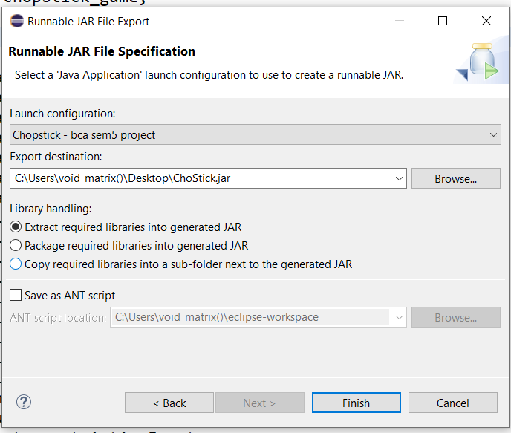

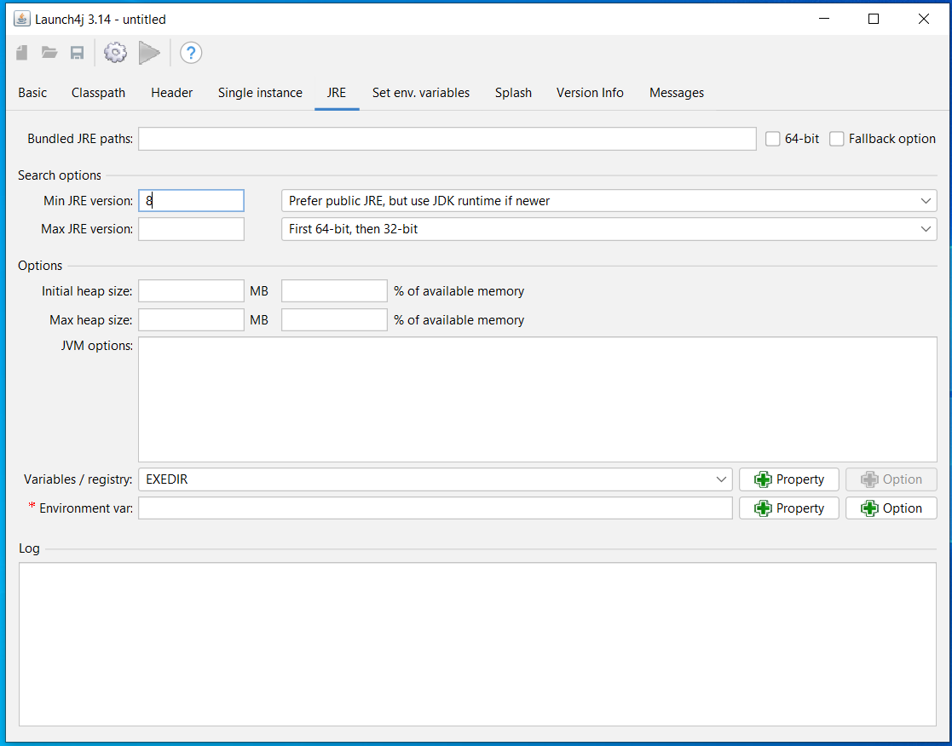**Now I am creating exe file using Launch4j**

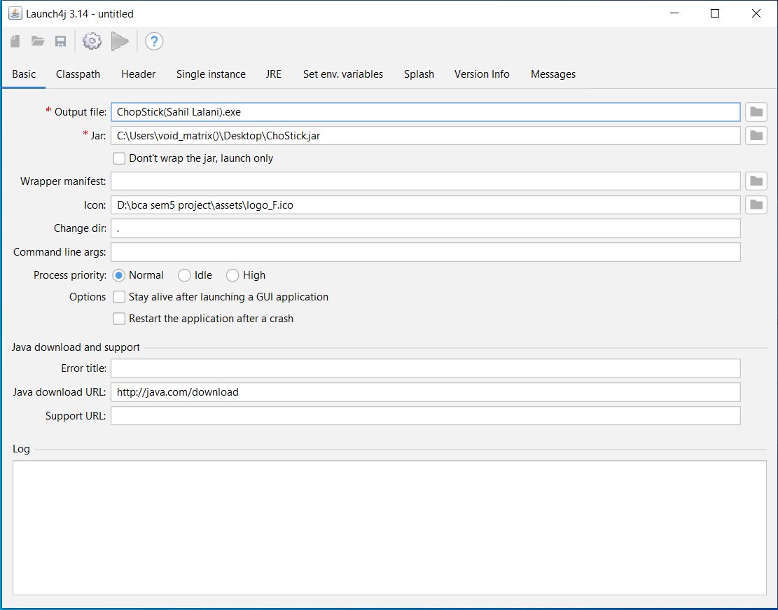

**ChopStick Game Play with Snapshots**

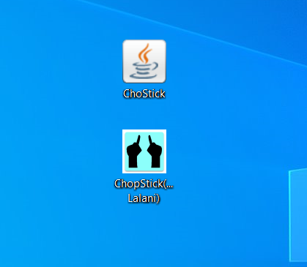

Jar & Executable file

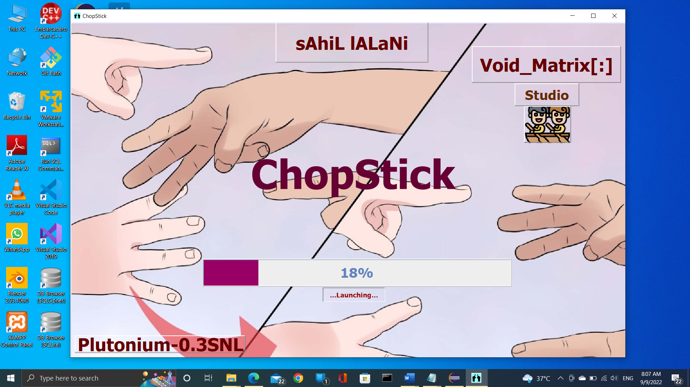

Launch frame

## 

**Void Matrix account Frame**

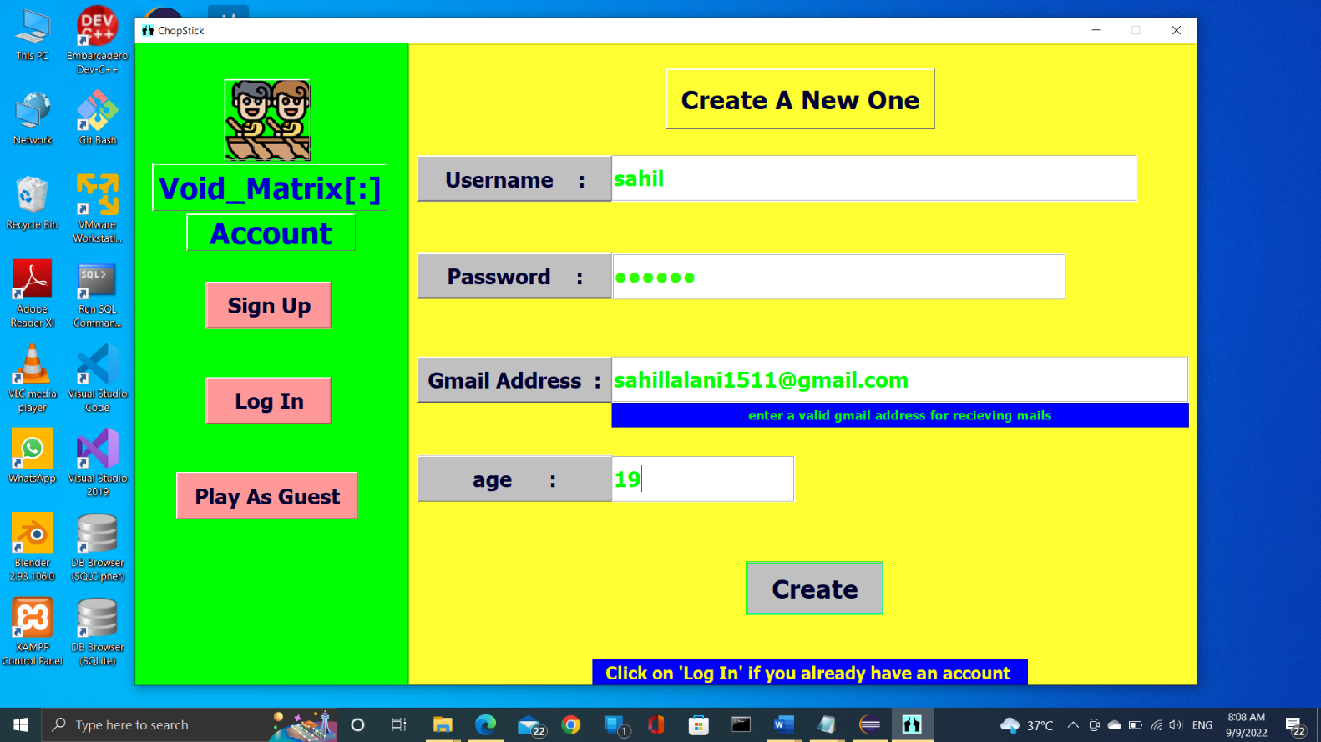

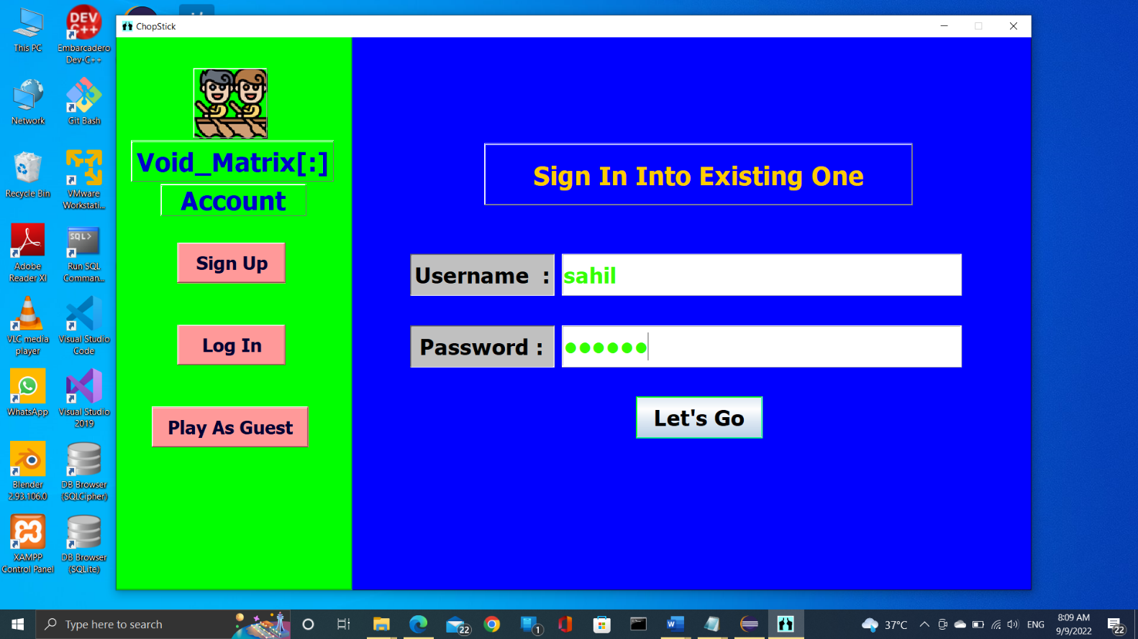

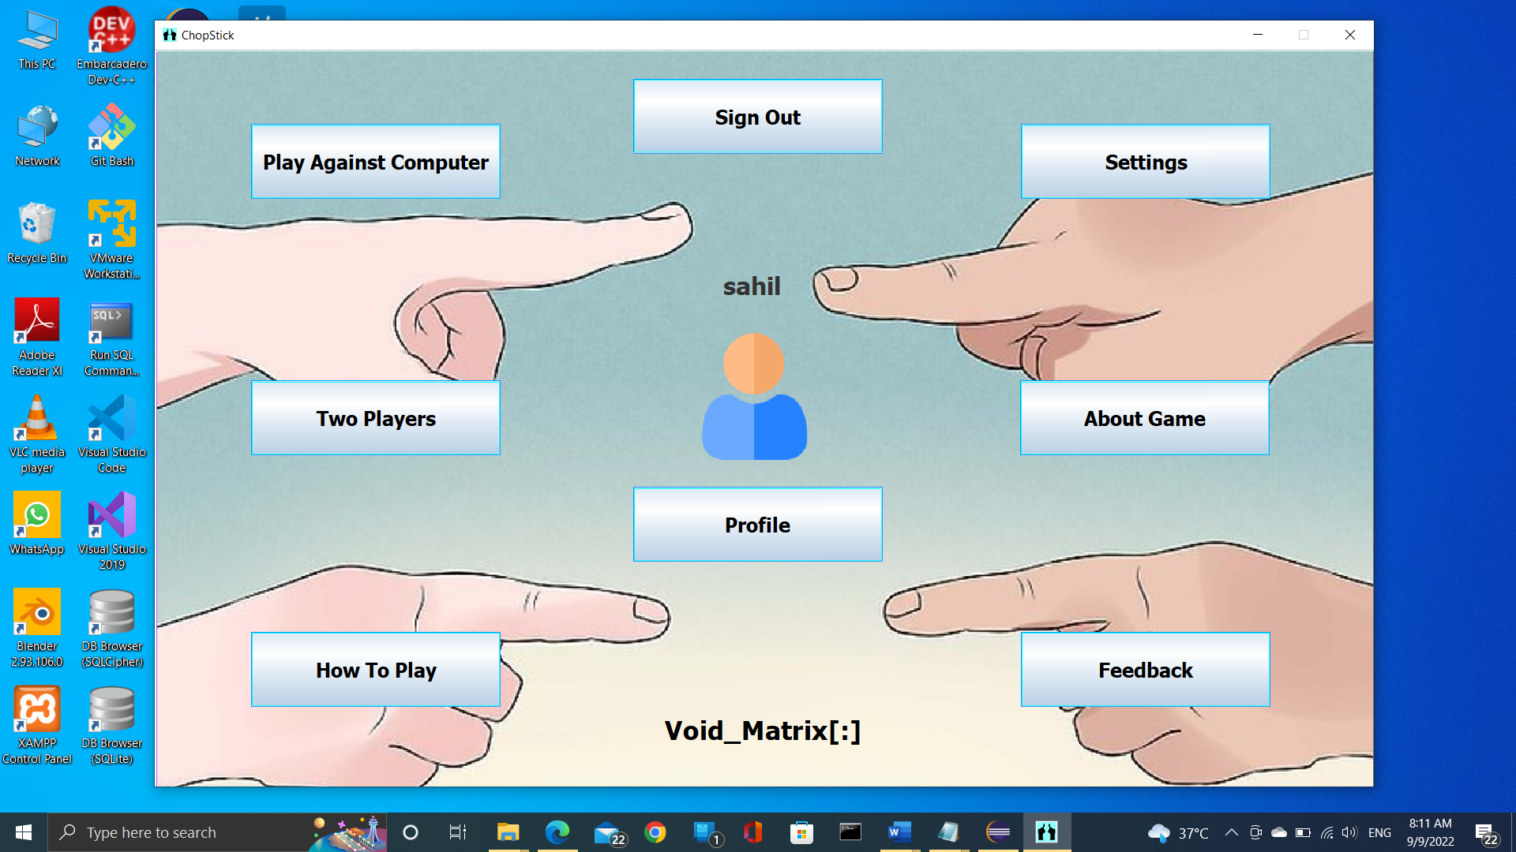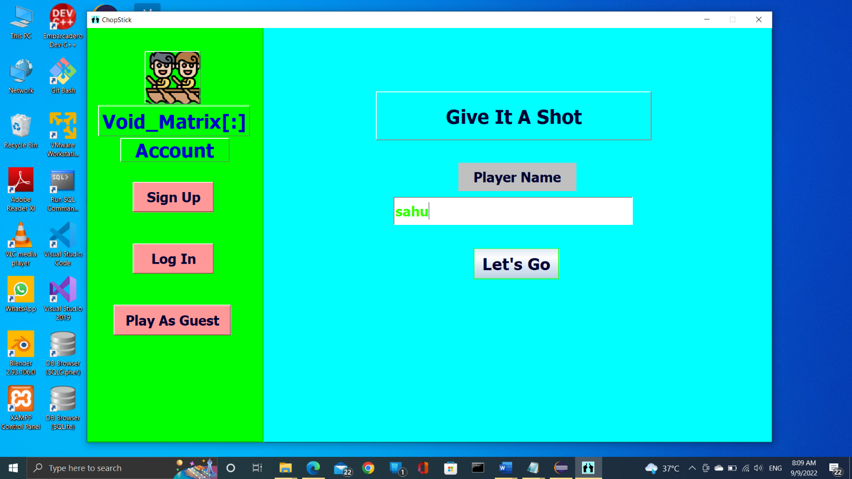

**Main Menu/Frame**

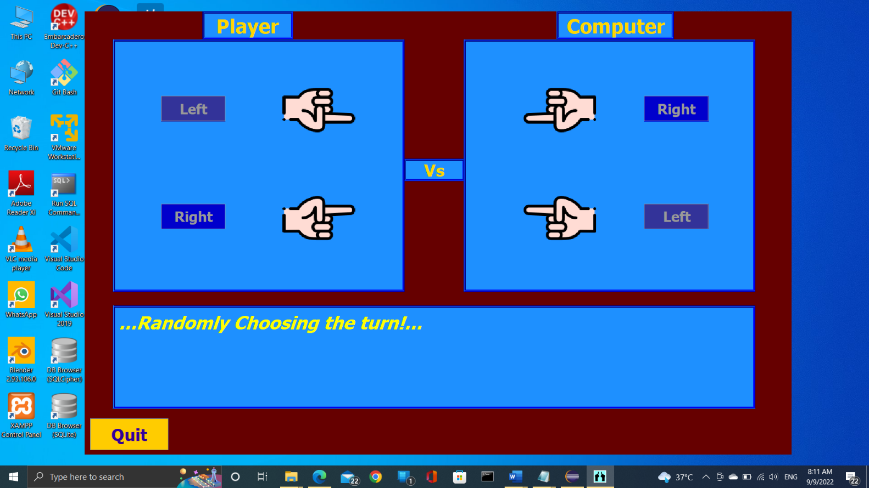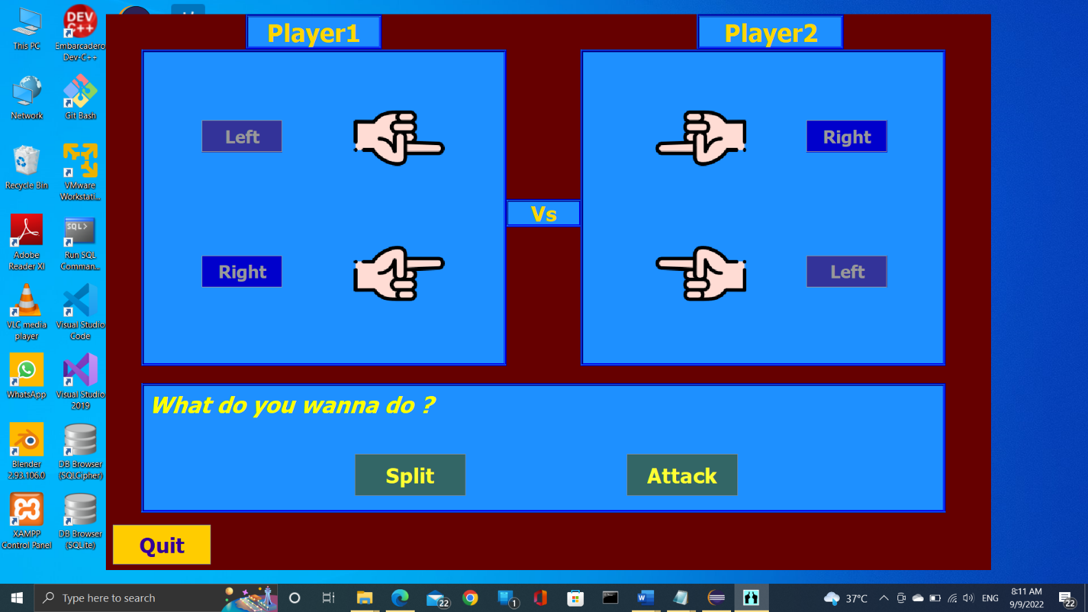

**Player vs player Frame**

**Play with computer Frame**

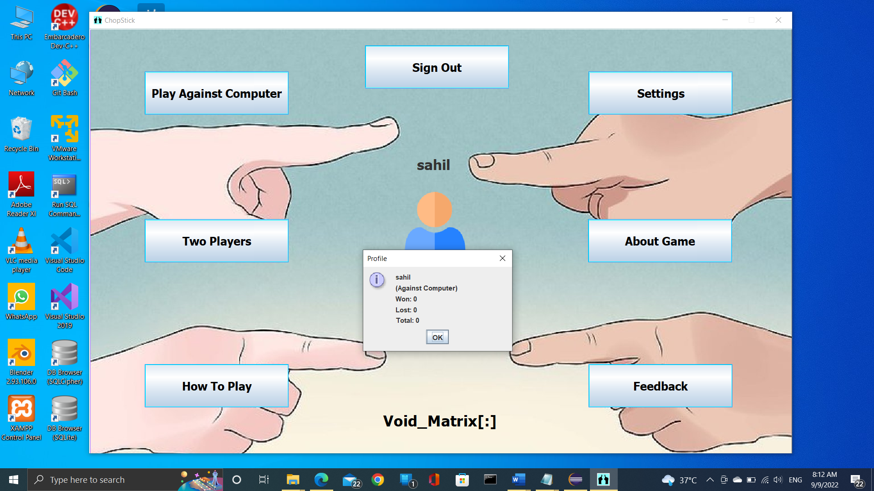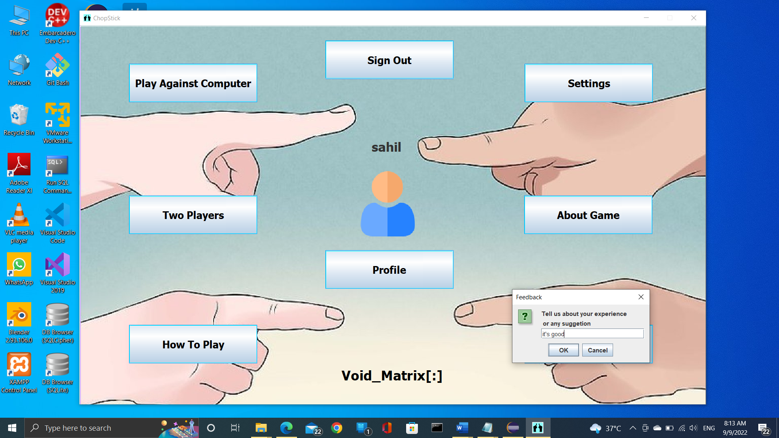

**profile**

**Feedback**

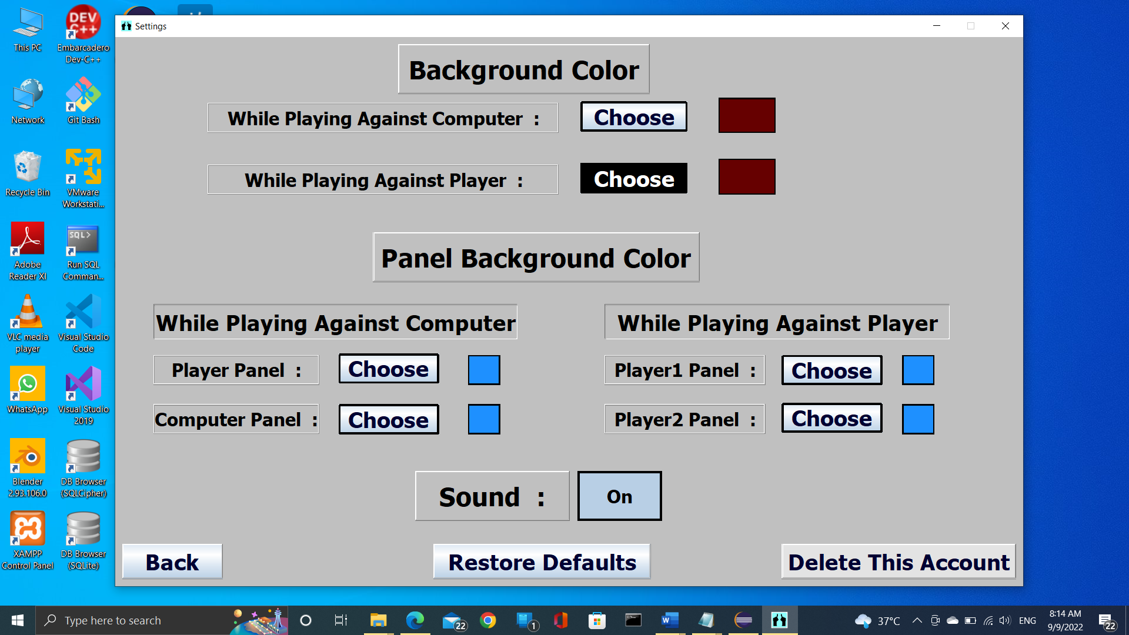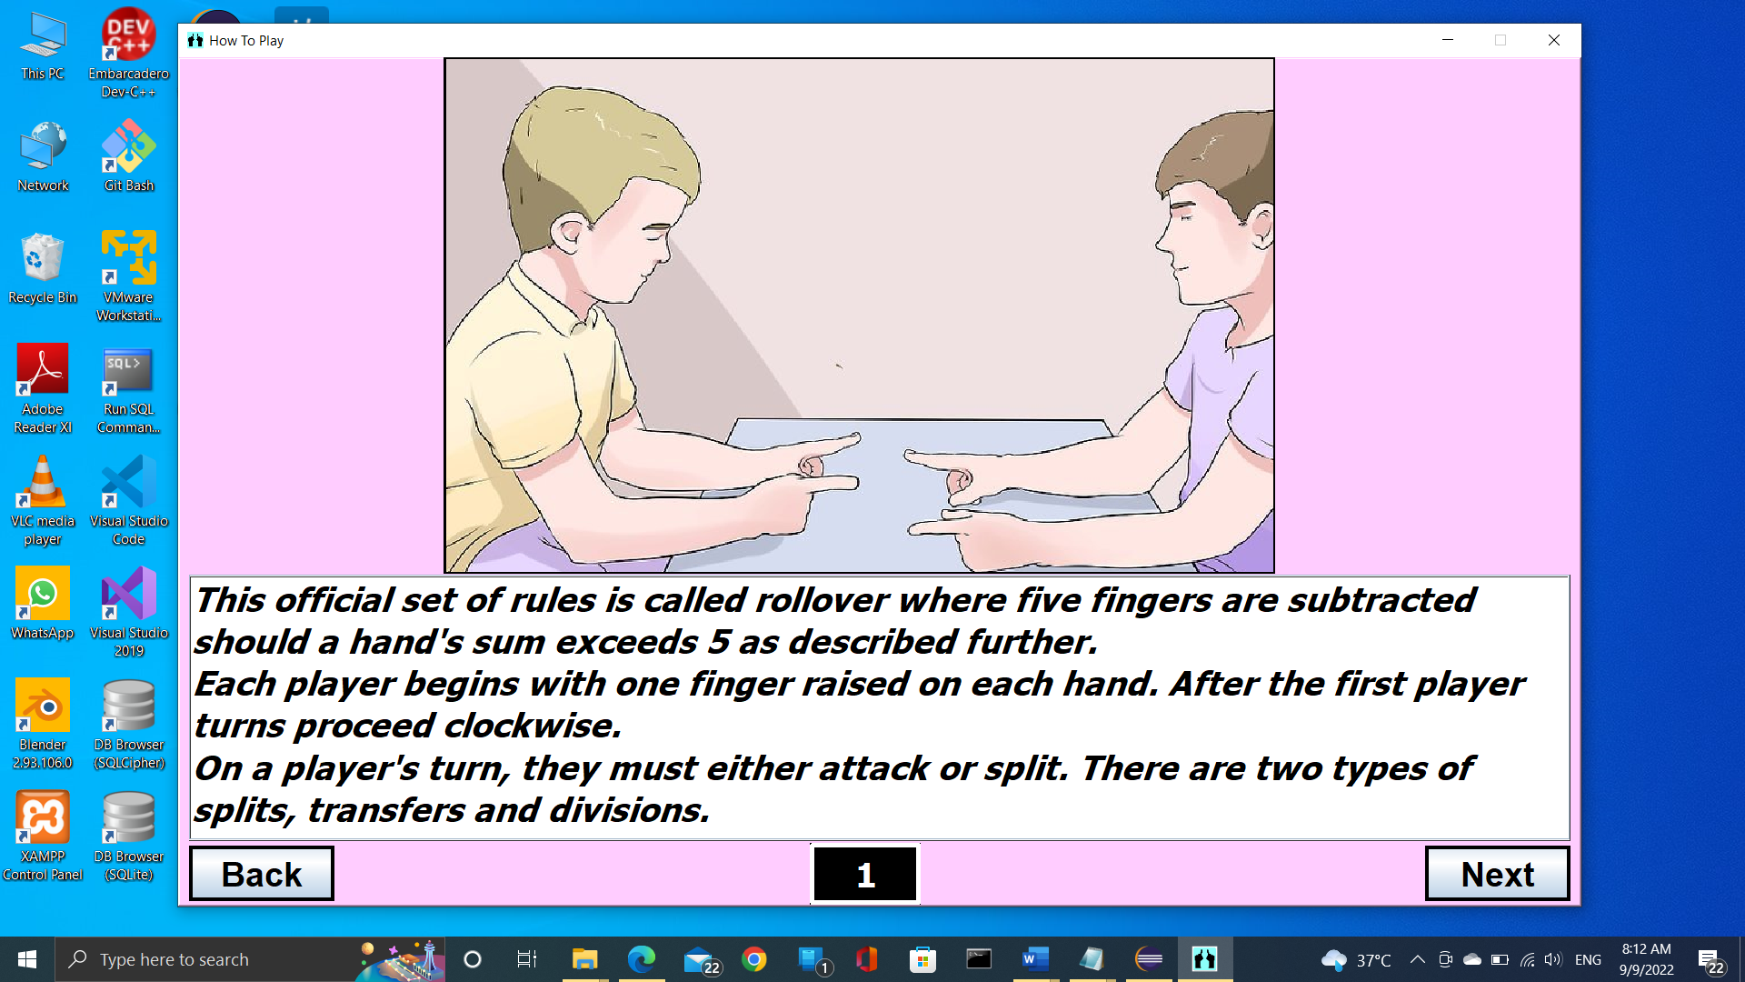

**Settings Frame**

**How to play Frame**

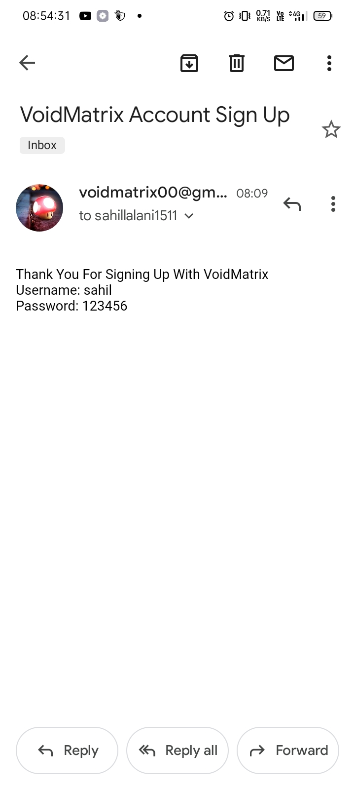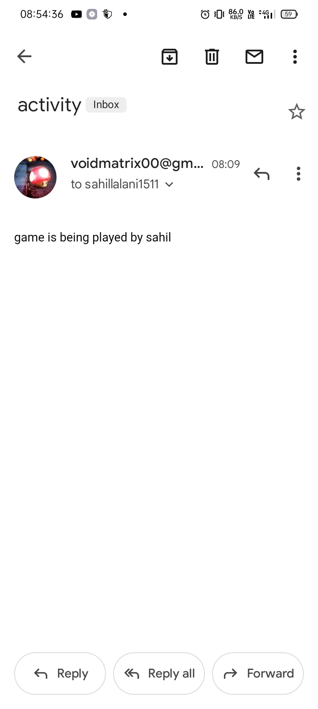

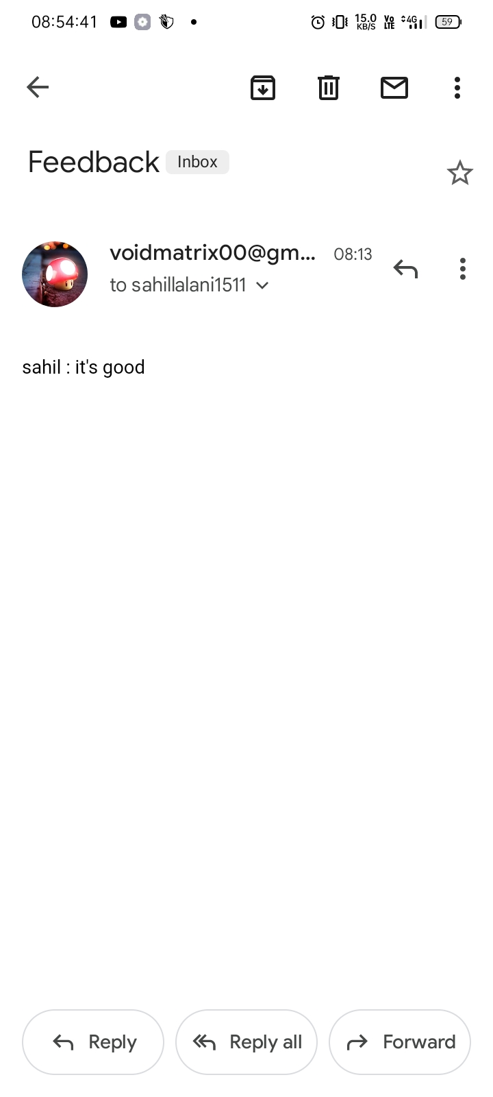

**Player receiving email**

**Me receiving feedback**

# **Section 9: Conclusion**

**The main objective of this project was to design and develop a 2D Combinatorial game without having used any game engine and learn the maximum amount of things possible while doing it.**

**For this purpose, the different graphic elements of the game were designed, allowing me to learn how to efficiently use the core java concept, Window-Builder, swing, AWT, Flaticon.com, JAVA Mail API, remote SQL, JDBC, Launch4j in order to achieve the desired results. In this manner, each design has been done faster and better than the previous one. Similarly, I have learned how to design simple albeit necessary sound effects for the game by combining audio.**

**Regarding the game itself, all of the game logic and the objects were designed and subsequently implemented using Eclipse IDE. As a result, the video-game is composed of one single perfectly playable sections which includes many different objects and obstacles to overcome. This is the part that I have most enjoyed, because I really like programming and designing game logic. Additionally, coming up with finger movements’ logic provided me a fun challenge, and gave me the opportunity to learn many different issues about game design and development.**

## **Limitations**

* **Settings are not stored permanently**
* **No functionality for playing remotely with others**
* **No dynamic resolutions’ adaption according to system**
* **Players can not set profile picture**
* **No keyboard shortcuts for buttons/processes**
* **The frame can not be resized as preferences while playing the game**

## **Future enhancements**

**Definitely the ones that are described above in limitations and furthermore trying to make a web application for this game.**

# **Section Appendix**

## **Appendix A: Abbreviation & Acronyms**

|  |  |
| --- | --- |
| **Term** | **Definition** |
| **Animation** | **the rapid display of a sequence of images to create an illusion of movement.** |
| **Scripting** | **A scripting language or script language is a programming language that supports the writing of scripts, programs written for a special runtime environment that can interpret and automate the execution of tasks which could alternatively be executed one-by-one by a human operator.** |
| **Graphics** | **visual presentations on some surface, such as a wall, canvas, screen, paper, or stone to brand, inform, illustrate, or entertain.** |
| **Sprites** | **In a computer game a sprite is the name usually given to a two-dimensional bitmap computer graphic, designed to be integrated into a level, intro or exit screen. They can be static or animated.** |
| **SRS** | **Software Requirements Specification** |
| **GDLC** | **Game Development Life Cycle** |
| **UI** | **User Interface** |
| **Gamer** | **A person who plays a game or games, typically a participant in a computer or role-playing game.** |
| **System** | **A system is a set of interacting or interdependent components forming an integrated whole or a set of elements (often called 'components) and relationships which are different from relationships of the set orits elements to other elements or sets.** |
| **JAVA Mail API** | **For sending emails.** |
| **JDBC** | **JAVA Data Base Connectivity** |
| **AWT** | **Abstract Window Toolkit** |
| **Swing** | **JAVA utility to create lightweight GUIs** |
| **Event** | **Changing the state of an object is known as an event. For example, click on button, dragging mouse etc.** |
| **Class** | **A class is a blueprint for the object.** |
| **Object** | **An instance of class that is real world and runtime entity that has state and behavior.** |
| **DFD** | **Data Flow Diagram** |
| **ERD** | **Entity Relationship Diagram** |
| **JRE** | **JAVA Runtime Environment** |
| **JVM** | **JAVA Virtual Machine** |
| **JDK** | **JAVA Development Kit** |
| **JAR** | **Java Archive File** |
| **JAVA File IO** | **For working with files and its input/output** |
| **DBMS** | **Data Base Management System** |
| **SQL** | **Structured Query Language** |
| **MySQL** | **MySQL is a RDBMS (Relational DataBase Management System).** |
| **phpMyAdmin** | **PhpMyAdmin is a web application that lets you manage (with a visual interface) MySQL Databases.** |
| **API** | **Application Programming Interface** |
| **RMI** | **Remote Method Invocation** |
| **IDE** | **Integrated Development Environment** |
| **GUI** | **Graphical User Interface** |
| **JNDI** | **JAVA Naming and Directory Interface** |

**Appendix B: References**

[**Image Icons & Symbols (flaticon.com)**](https://www.flaticon.com/free-icons/image)

[**https://www.wikihow.com**](https://www.wikihow.com)

[**https://en.wikipedia.org/**](https://en.wikipedia.org/)

[**The Community for Open Innovation and Collaboration | The Eclipse Foundation**](https://www.eclipse.org/)

**https://www.db4free.net/**

[**l0.drawio - diagrams.net**](https://app.diagrams.net/)

[**Tutorials List - Javatpoint**](https://www.javatpoint.com/)

[**Java Documentation - Get Started (oracle.com)**](https://docs.oracle.com/en/java/)

[**(15872) Bro Code - YouTube**](https://www.youtube.com/c/BroCodez)

[**Share and Discover Knowledge on SlideShare**](https://www.slideshare.net/)

[**Launch4j - Cross-platform Java executable wrapper (sourceforge.net)**](http://launch4j.sourceforge.net/)

[**Oxford Learner's Dictionaries | Find definitions, translations, and grammar explanations at Oxford Learner's Dictionaries (oxfordlearnersdictionaries.com)**](https://www.oxfordlearnersdictionaries.com/)

[**Cambridge Dictionary | English Dictionary, Translations & Thesaurus**](https://dictionary.cambridge.org/)

[**Dictionary by Merriam-Webster: America's most-trusted online dictionary**](https://www.merriam-webster.com/)